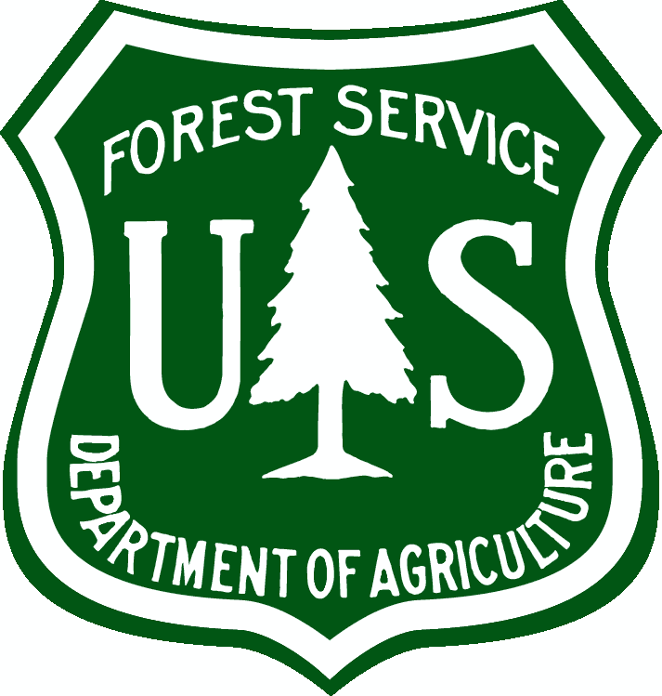
Trails Position Notice

$15,000, ($16.11/hour), June - November 2019
Two positions, Forestry Technician (Recreation)
Coronado National Forest, Nogales District
Mount Wrightson Wilderness

19-2TEMP-NAT-REC-5DT-PC, GS-5
Announcement Open Dates: March 4-6, 2019
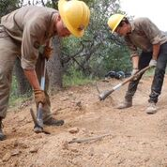
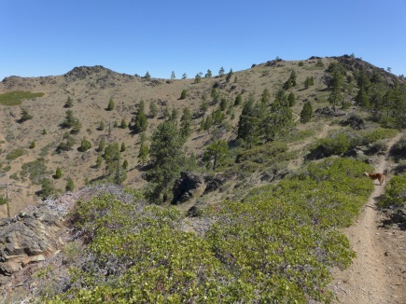
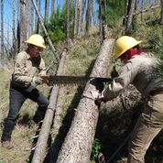

The Nogales Ranger District is advertising for a Temporary (1039 hours) position to work on removing down timber, trail improvement and routine maintenance in the Mount Wrightson Wilderness. This notification is being circulated to inform prospective and interested applicants of this opportunity. These positions are posted in the USA Jobs Website (www.usajobs.gov) between March 4 – 6, 2019. This duty station for this position will be located on the Nogales Ranger District but the work is entirely in the field.

POSITION INFORMATION:
These positions will be responsible for providing support to the District Recreation Program. The primary duties will include planning and field activities for trail improvement. The duties for these positions may include overnight camping and backpacking in remote field sites. The activities associated with these positions will involve navigating safely in rugged, variable terrain. Knowledge of fire prevention and suppression is helpful but not essential for these two opportunities.

WORKING CONDITIONS: Work requires physical exertion outdoors such as regular and recurring walking on steep slopes with using digging tools and crosscut saws. Training will be provided on health, safety, and the proper use of tools. The work may also include strenuous outdoor activity often in steep, rough terrain in isolated areas in a forest environment. The work will require the use of protective clothing and footwear.

DATES: Approximate dates of employment for these vacancies are June – November 2019. However, some flexibility can be accommodated.

HOW TO APPLY: You should set up a notification system in your USA Jobs profile that will notify you when announcements in your selected series, grade, and location open up. The vacancy number to apply to will be specified in those notifications. Set up your profile at https://www.usajobs.gov . Be sure to upload a detailed resume and any documents needed for eligibility.

TEMPORARY EMPLOYMENT HIRING PROCESS AND INFORMATION

What is Temporary Employment? A temporary appointment is work that is expected to last no more than one year. Temporary appointments can also be used for seasonal work which is needed every year when the work requires less than 1,040 hours of duty, excluding overtime and eligible training each year.

How do I apply for Temporary Employment? The US Forest Service uses a nationwide online application process that starts with www.usajobs.gov. Here you create a profile, upload a very thorough resume, and find the announcement you are interested in applying to. Each temporary position has its own announcement number, and to be eligible for multiple pay levels or grades, you must apply to each announcement number at each pay/grade level.

Once you find the position(s) you would like to apply to click “apply online” and USAJOBS will link you to our application program called eRecruit. In eRecruit you will then be prompted through the application process step by step. Be sure to upload any necessary documents that may qualify you for the position. You will be asked to choose locations that you are interested in, you can add as many locations as you like with only one application, and if you are eligible your name will appear on each certificate list that is requested by a hiring manager from that location. You must complete all of the steps and in the end submit your application.

What happens next? If you set up your USAJOBS account to send automatic email notifications, you will receive an acknowledgement email that the submission of your online Occupational Questionnaire and resume was successful, if you were referred to the selecting official for consideration, and if you were selected or not selected. If you choose not to set up automatic email notifications, you must check your USAJOBS account for the latest status of your application. Your application may be reviewed to verify that you meet the qualifications and eligibility requirements for the position prior to issuing lists to a selecting official. If further evaluation or interviews are required, you will be contacted.

If you have any further questions please contact John Titre john.titre@usda.gov at 520-308-8544.

We are a small, progressive recreation management team. We constantly innovate to do things smarter, safer and to save dollars. We provide visitors with high quality locations for rewarding, healthy and safe recreation experiences. We are creating a sustainable recreation future. We are resourceful, disciplined and adaptable professionals with ready smiles and high ethical standards. We are service and results-oriented and we measure our progress quarterly and yearly based on performance indicators. We are curious, keen and adventurous lifetime learners seeking a challenge and opportunity. We encourage an open and honest learning environment and we are expected to try approaches not done before. We are self-starters, working well on our own to get the results needed. We take pride in our work. If you are equally positive and optimistic with a good sense of humor, we would love to have you on our team! ---John

Thank you for your interest in our Vacancy

The U.S. Department of Agriculture (USDA) prohibits discrimination on all its programs and activities on the basis of race, color, national origin, gender, religion, age, disability, political beliefs, sexual orientation, and marital or family status. (Not all prohibited bases apply to all programs.) Persons with disabilities who require alternative means for communication of program information (Braille, large print, audiotape, etc.) should contact USDA's TARGET Center at (202) 720-2600 (voice and TDD). To file a complaint of discrimination, write USDA, Director, Office of Civil Rights, Room 326-W, Whitten Building, 14th and Independence Avenue, SW, Washington, DC 20250-9410 or call (202) 720-5964 (voice and TDD). USDA is an equal opportunity provider and employer.

