JOB DESCRIPTION
 |  | 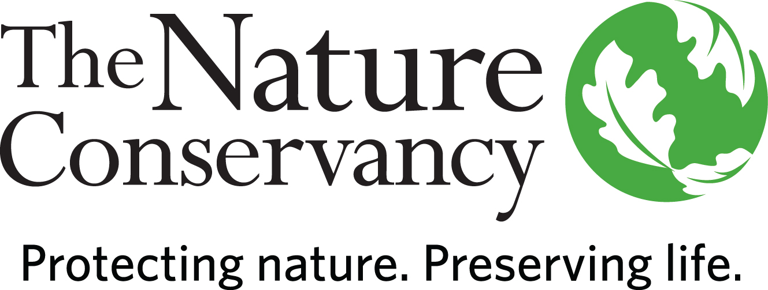
POSITION TITLE | Grasslands and Sustainable Grazing Strategy Manager
LOCATION | Hatfield, Missouri
POSITION TYPE | Full-Time, Salaried
APPLICATION DETAILS | Applications are accepted online only at www.nature.org/careers. The Job ID is 47143. All applicants will need to submit a cover letter and resume. A reference guide is available at nature.org/careers; please read and follow instructions to submit your application.
DEADLINE TO APPLY | January 7, 2019 at 10:59pm CST

A LITTLE ABOUT US

Founded in 1951, the Nature Conservancy is a global conservation organization dedicated to conserving the lands and waters on which all life depends. Guided by science, we create innovative, on-the-ground solutions to our world's toughest challenges so that nature and people can thrive together. We are tackling climate change, conserving lands, waters and oceans at unprecedented scale, providing food and water sustainably and helping make cities more sustainable. One of our core values is our commitment to diversity. Therefore, we strive for a globally diverse and culturally competent workforce. Working in 72 countries including all 50 United States, we use a collaborative approach that engages local communities, governments, the private sector, and other partners. To learn more, visit www.nature.orq or follow @nature_press on Twitter.
YOUR POSITION WITH TNC

The Grasslands and Sustainable Grazing Strategy Manager directs all aspects of The Nature Conservancy’s initiatives to improve the management and conservation of grazing lands in the Grand River Grasslands (GRG) while helping define and implement Missouri’s sustainable grazing strategy through high-level engagement with members of the agricultural sector across the state.

ESSENTIAL FUNCTIONS

The Grasslands and Sustainable Grazing Strategy Manager will work with private and public-sector partners to understand and address the challenges of adopting conservation practices in the GRG, both in Missouri and in Iowa. S/he will build a vision and direction to advance sustainable grazing practices aligned with TNC’s Shared Conservation Agenda. The Manager will lead the successful development of TNC’s working demonstration ranch, Little Creek Farm, while supervising full-time staff and conservation activities at the adjacent Dunn Ranch Prairie, which includes overseeing the reseeding of a high-quality, diverse prairie restoration, bison herd management, and prescribed fire. S/he will spearhead development of effective messaging and outreach to ranchers, agribusiness, and other members of the grazing sector to provide accurate and relevant information about conservation practices. The Manager will develop key partnerships with public and private organizations to identify and resolve technical issues and to widely communicate solutions and best practices, raise stakeholder interest in outcomes, and develop resources to support the adoption and use of conservation tools within the GRG. S/he negotiates complex and innovative solutions with government agencies and landowners to conserve and protect natural communities and develops and implements conservation relevant strategies. The Manager will also represent TNC on work groups and at conferences and field days to convey the importance of conservation grazing, soil health, water quality, greenhouse gas mitigation, and agricultural productivity.

RESPONSIBILITIES & SCOPE

- Advances existing relationships with Missouri and Iowa GRG stakeholders, including private landowners and agricultural producers, and develops partnerships to engage the ranching sector to promote and increase the adoption of conservation and sustainable grazing practices
- Supervises staff and directs conservation/outreach activities at Dunn Ranch Prairie, including native prairie restoration and bison herd management
- Facilitates and navigates partnerships to develop successful demonstration practices at Little Creek Farm
- Works in partnership with producer groups, agribusinesses, agencies, academic institutions and other non-profits in a collaborative capacity
- Positions the Conservancy as a respected and reputable voice in the Missouri ranching sector
- Designs, implements, and directs multiple complex projects, while setting and meeting deadlines, and ensuring program accountability
- Establishes ambitious and realistic goals for the strategy while controlling costs and administering budgets
- Programmatic scope requires cross-boundary work and relationships within the Missouri and Iowa business units, the Great Plains Division, North American Region, the Grasslands Conservation Network and other networks
- Leads and manages cross-functional multi-disciplinary project teams to support and improve conservation efforts
- Frequently makes independently strategic decisions based on analysis, ambiguous information and judgment
- Develops relationships and works effectively with corporate, government, community, and non-governmental organization partners
- Obtains and manages multi-scale federal, state, and private grant funding

MINIMUM QUALIFICATIONS

- BA/BS degree and 5 years of experience in conservation or agricultural practice, or equivalent combination
- Proven experience managing projects, including managing finances, with diverse partners, both internal and external
- Experience working within the agricultural/ranching community
- Experience managing complex or multiple projects, including staffing, workloads, and finances under deadlines
- Supervisory experience, including motivating, leading, setting objectives and managing performance
- Experience in partnership development with non-profit partners, community groups and/or government agencies
- Experience negotiating complex, multi-party agreements

DESIRED QUALIFICATIONS

- Experience influencing, developing and implementing conservation policy and plans with public and private entities
- Established relationships with members of the ranching community in Missouri and Iowa
- Politically savvy and experience in presenting to and communicating with business, governmental, and community leaders
- Knowledge of current trends and practices in grazing, conservation, land management, and natural resource preservation
- NWCG Burn Boss qualifications, with knowledge of Conservancy fire management Standard Operating Procedure, requirements and guidelines
- Demonstrated experience in ecological management and nature preserve stewardship, including vegetation manipulation, property stewardship, exotic species issues, boundary issues, community outreach, neighbor relations, data collection and reporting, and prevention of adverse usage
- Excellent interpersonal, and communications skills. Ability to communicate positively and effectively with people of all educational levels and backgrounds, and to clearly and effectively articulate concepts, gain consensus, and to serve as an effective representative for the Conservancy. Demonstrated ability to effectively unite diverse coalitions to achieve results
- Excellent supervisory and management skills, including volunteer supervision. Ability to lead effectively in complex and stressful situations
- Demonstrated field familiarity with general ecological principles and biological systems. Ability to provide oversight and coordinate logistical support for ongoing research activities. Familiarity with the biota and ecological systems of the Tallgrass Prairie a plus.
- Demonstrated competency in reading and interpreting maps and aerial photographs. Experience with GIS, regional biological inventories, GPS, remote sensing, and ecological restoration helpful

ORGANIZATIONAL COMPETENCIES

Builds Relationships | Builds productive relationships by interacting with others in ways that enhance mutual trust and commitment.
Collaboration & Teamwork | Works collaboratively with stakeholders across levels, geographies, backgrounds, and cultures to improve decisions, strengthen commitment, and be more effective.
Communicates Authentically | Communicates proactively and in a timely manner to share information, persuade, and influence with the appropriate level of detail, tone, and opportunities for feedback.
Develops  Others | Takes ownership to help develop others’ skills, behaviors, and mindsets to help them maximize their workplace contributions.
Leverages Difference | Demonstrates commitment to harnessing the power of differences strategically; consistently sees, learns from, and takes strategic action related to difference; and demonstrates the self-awareness and behaviors to work across differences of identity and power respectfully and effectively with all stakeholder. Actively seeks to build and retain a diverse workforce and fosters an equitable inclusive workplace by drawing upon diverse perspectives.
Systems  Leadership | Thinks and acts from a broad perspective with a long-term view and an understanding of 1) the dynamic nature of large-scale challenges and 2) the need for integrating five key practices: skillfully engaging appropriate people; providing a clear process for change; taking a holistic view of situations; focusing on a small number of strategic actions, while learning from and adapting them over time; and being aware of how one’s own thinking or patterns of behavior may be limiting change.

This description is not designed to be a complete list of all duties and responsibilities required for this job.

