
Tierra Seca
University of Arizona Student Chapter
Society for Range Management

College of Agriculture and Life Sciences
School of Natural Resources and the Environment

October 23, 2018

- Call to order: 5:00 p.m.
  - Members in attendance: Will, Cameron, Josie, Clara, James, Brian
  - Faculty in attendance: Mitch McClaran, LoriAnne Barnett

- Introductions

- President’s Report

  - Fall Meeting Schedule ~ Biweekly meetings on Tuesdays at 5:00PM
    - August 28, 2018 ~ ENR2 S120A Welcome Back!
    - September 11, 2018 ~ ENR2 S120A Welcome New Members!
    - September 25, 2018~ James K Heitholt - Coronado NF Range Program Manager Guest Speaker/ Share dream jobs
    - October 9, 2018~ Katie Mathieson and Joshua Sutter- NEON Guest Speakers/ Search for dream jobs on USAjobs.gov
    - October 23, 2018~ LoriAnne Barnett- National Phenology Network (Arizona Environmental Education Certification Program). Figure out which classes/ requirements you need to qualify for the job.
      - arizonaee.org
      - everything being shared is science based
      - Arizona Association for Environmental Education
      - have environmental educator certification program - 80 hours to get through course
      - 2018 Environmental literacy summit and AZ environmental literacy community of practice:
        - Saturday November 10
        - 9:30am - 1:30 pm
        - South Mountain Environmental Education Center, 10409 S. Central Avenue, Phoenix, AZ 85042
        - arizonaee.org/event/2018-environmental-literacy-summit/

    - November 6, 2018~ Organizational Meeting (IN A DIFFERENT ROOM ENR2 S215)
    - November 20, 2018- No meeting (week of Thanksgiving)
    - November 27, 2018~ Chipotle Percentage Night! Join us at Chipotle on University Blvd. for our last meeting!

- John Hall- Wild Horse and Burro program lead for the BLM here in Arizona
    - Tour of the wild horse and burro holding and training facility in Florence, AZ
    - Guest speaker next semester
      - Participating: Amanda S., James B., Claire B., Cameron B., Josie P., William G., Clara M.

- Study Abroad- A Special Topics, Study Abroad Course
RNR 395A - Sustaining Local Food, Biodiversity, and Livestock Grazing in the Alps
- Description of course: The Italian and Swiss Alps provide a living, and easily accessible example of how a food and livelihood system can also support increased biodiversity in grasslands (see figure). Through field trips to farms, pastures, and mountain lodges (rifugi) we will assess how the decline of human populations in the Alps leads to the abandonment of grazing, followed by declines in the biodiversity of grassland plants, insects and birds, declines in the provision of local cheeses, and declines in the associated culture of alpine pastoralism. We will also explore how new initiatives are supporting the continued grazing of the grasslands, continued support of high biodiversity in the grasslands, continued provision of local cheeses and other foods, and continued opportunity for livelihood in the alpine region. In the end, we will explore how investments from local organizations and the European Union are being used to sustain this livelihood system in order to maintain biodiversity, local food, and the mountain culture for future generations.
- When: June 17- June 30, 2019
- More information can be found in the syllabus attached to the minutes!
- LINK to STUDY ABROAD WEBPAGE: https://global.arizona.edu/study-abroad/program/sustaining-local-food-biodiversity-and-livestock-grazing-alps

- Past Events Report

- RISE Symposium Breakfast ~ $140

- Dr. McClaran’s Activity
- Think of 3 dream jobs- By the next meeting (September 25)
- Find similar jobs on USAjobs.gov (October 9)
- Figure out which classes/ requirements you need to qualify for the job (October 23)

- Fundraising Ideas
  - Feel free to jump start any of these great ideas if you have some spare time and the drive to do so. Any help is all greatly appreciated!!
- Parking Garage/Lot ticket taking * Could make $200-$400 a night for the club. Need about 15 people a night.
  - Participating: Josephine P, William G, Jeff G, Mitchell Z, James B, Austin G, Brian K, Cameron B, Claire B, Clara M, Amanda S
- Sell the remaining club merchandise
- Chipotle percentage night (more info below)
- Make and sell range calendars
- Bake sale
- ASUA
- AZ SRM
- CALS Alumni Association
- Possible car show here on campus
- Rotary club
- Club Car Wash (sell ticket stubs in advance for a later date)
- AgriLife
- Pima County Farm Bureau
- AZ Cattle Growers Association
- Marana Stockyards
- Los Charros
- AZ Cattle Industry Research and Education Foundation
- RISE Symposium
- Erosion Control Monitoring (November; you get Dean's Excuse; more info attached)
- Raffle off donation at winter meeting (Start asking around for donations sooner, rather than later to help with follow through)
- Amazon smile donation for a proportion of sale from amazon
- Collect plant specimens mount in frames and sell them; make bouquets, sell at 4th Ave, farmers markets, etc.

- Upcoming Events Report

  - Pima County Trails- Volunteer Opportunity
- Pima County is excited to be breaking ground with brand-new trail at the scenic Painted Hills property! Located just north of Tucson Mountain Park, this beautiful 289 acres of protected Sonoran Desert will offer outstanding recreational opportunities for the Tucson community. Please join us for a morning of trail building on Saturday, October 27 from 8:00 am – 12:00 pm to complete the first of a series of trails that will snake their way through the Saguaro-studded hills of this beautiful open space. No experience required and tools will be provided.
- What you’ll need:
- Plenty of water and snacks
- A backpack or bag to carry all your personal items out on the trail. We won’t return to the vehicles until the end of the work event.
- Sun protection: hat, sunscreen, sunglasses (long sleeves / long pants optional)
-Sturdy closed toed shoes (boots recommended)
-Work gloves (extra work gloves and sunglasses will be available if needed).
- Location: The Painted Hills Trailhead (on the north side of Anklam Rd., approximately 0.3 miles west of Players Club Dr.)
      - Anklam Rd, Tucson, AZ 85745.
- Please RSVP if interested: Email Neil Stitzer Trails Coordinator - Pima County at Neil.stitzer@pima.gov

  - Club Hike, Picacho Peak:
    - Saturday, November 3rd
    - 9AM
    - Meet on campus and then carpool

  - Elk/ LD Monitoring: November 2nd
    - Fundraising opportunity ($500)
    - Photo monitoring and transects
      - Participating: Claire B., Amanda S., Mitchel Z., Corwin C., Clara M. Josie P., James B., William G.

  - Chipotle Percentage Night: November 27th
    - 4:00PM- 8:00PM
    - 905 E University Blvd, Tucson, AZ 85719
    - We get 33% of total sales, but we need to bring in a minimum of $300 to receive our check!
    - Bring your friends, family, neighbors, EVERYONE! I will have flyers to give everyone to distribute to people at the next meeting.
    - REMINDER: Attending this and encouraging others to attend does count towards your mandatory fundraiser participation.

- Vice President’s Report

- Treasurer’s Report
  - Dues ($30 per semester)
  - Paid dues: Josephine Profy, Clara Miller, Cameron Burleson, Mitch McClaran, William Gray, Amanda Sacek, Brian Koppy, Sydney Hambrick, Claire Bigelow, Sarah Noelle, James Bradley, Justin Johnson, Brain Koppy, Austin Rutherford, Mitchell Zieglgansberger, Flavie Audoin
  - Account balances (Now accepting all credit cards):
    - Checking: $2583.02
    - Savings: $396.04
    - Cash: $226
    - Running total = $3205.06
  - Get VENMO or PAYPAL

- Miscellaneous
  - ** Using InvolveUA link as storage for all club information

Link to InvolveUA: https://arizona.collegiatelink.net/organization/tierraseca

- Swag
- Stickers: $1
- Koozies: $1
- T-Shirts: $5 (for plus sizes), $10 (for S, M, L)
- Hats: $15
- Bundle: T-shirt/Hat Combo = 16$ or 20$
- Need to order: stickers, small, and medium shirts

- Any Other Business?

- Adjournment: 6:10 p.m.

Facebook club link: https://www.facebook.com/uofatierraseca
President: Josephine Profy jprofy@email.arizona.edu
Vice President: Clara Miller claramiller@email.arizona.edu
Treasurer: William Gray williamgray4@email.arizona.edu
Secretary: Amanda Sacek ajsacek@email.arizona.edu

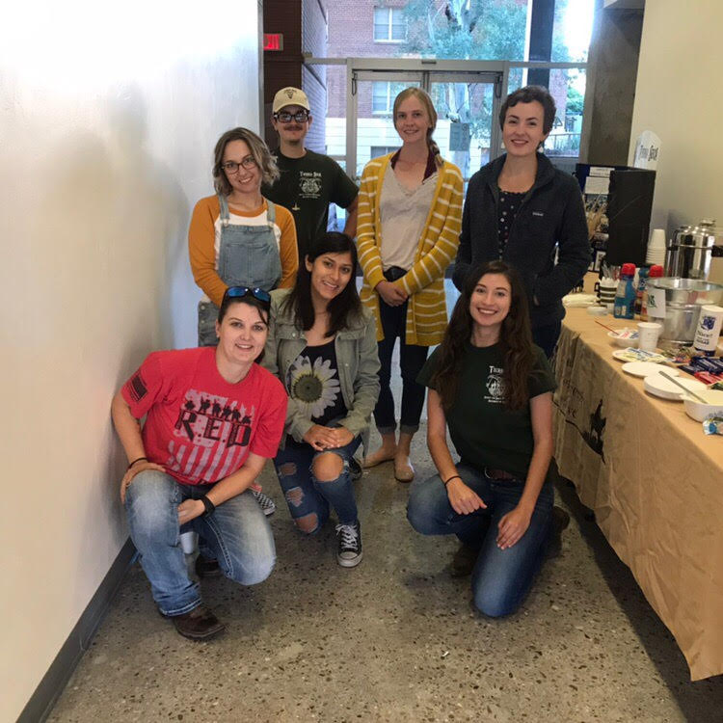
HAPPY TUESDAY! I hope everyone has a wonderful week!

