
Tierra Seca
University of Arizona Student Chapter
Society for Range Management

College of Agriculture and Life Sciences
School of Natural Resources and the Environment

August 28, 2018

- Call to order: 5:00PM.
  - Members in attendance: Alonso De La O, William Gray, Josephine Profy, Amanda Sacek, Clara Miller, Brandon Mayor, Morgan Gourley, Justin Johnson, Cameron Burleson, Brian Koppy, Austin Gonzales, Austin Rutherford, Diana Githu
  - Faculty in attendance: Mitch McClaran, Sarah Noelle, John Koprowski

- Introductions
  - Go around the circle and give your name, year, major, and what you did during the summer (job, internship, or a cool vacation, etc.)

- President’s Report
  - Fall Meeting Schedule ~ Biweekly meetings on Tuesdays at 5:00PM
    - August 28, 2018 ~ ENR2 S120A Welcome Back!
    - September 11, 2018 ~Brainstorm 3 dream jobs
    - September 25, 2018~ James K Heitholt - Cornado NF Range Program Manager Guest Speaker/Find similar jobs on USAjobs.gov
    - October 9, 2018~ Figure out which classes/ requirements you need to qualify for the job
    - October 23, 2018~ TBD
    - November 6, 2018~ TBD
    - November 20, 2018~ TBD
    - December 4, 2018~ TBD

  - Past Events Report
- AZ SRM Annual Summer Meeting:
-Aug 15-17th 2018
-Will/Clara will give a summary of that event.

- URME Team - Amanda Sacek, William Gray, Josephine Profy, Alonso De La O, Clara Miller, Cameron Burleson, Brian Koppy, Austin Gonzales
- Plant ID Team - Amanda Sacek, William Gray, Josephine Profy, Clara Miller, Cameron Burleson
-URME: Undergraduate Range Management Exam- “Students have the opportunity to go to the Society for Range Management Annual Meeting and take a written exam to test their knowledge on range management and ecology. The top 5 scoring individuals and top 5 scoring teams are recognized at the Awards Ceremony.”
-Plant ID: “Students will test their skills by identifying plants from a list of 200 important range plants. Awards will be given to top teams and the top individuals.”
- Link to the SRM Meeting Website: http://annualmeeting.rangelands.org/

- Dr. McClaran’s Activity
- Think of 3 dream jobs- By the next meeting (September 11)
- Find similar jobs on USAjobs.gov
- Figure out which classes/ requirements you need to qualify for the job

- Fundraising Ideas:
-Parking Garage ticket taking *
-Sell the remaining club merchandise
-Chipotle percentage night
-Make and sell range calendars
-Bake sale
-ASUA
-Alumni Association
-AgLife
-RISE symposium(01/20/18)
-Erosion Monitoring
-raffle off donation at winter meeting
-amazon smile donation for a proportion of sale off of amazon
-collect plant specimens mount in frames and sell them

  - Upcoming Events
- September 6: ASUA Club Fair on the Mall
- Updating tri-fold board- send me any pictures from club activities that you have!
volunteers- Amanda, Will, Josie, Clara, Sarah
- October 4: Brush Management Workshop: http://whoozin.com/H7C-WEA-ERET
- October 19 &20: Arroyo Restoration Workshop
- I will attach the flyer when I send out the minutes
- October 20: RISE Symposium Breakfast
- November 2nd: Elk/LD Monitoring

- Vice President’s Report:
  - Activity that Mitch mentioned to Clara from Seth
  - monitoring work starting sept

- Treasurer’s Report
  - Dues ($30 per semester)
  - Paid dues: Josephine Profy, Clara Miller, Cameron Burleson, Mitch McClaren, William Gray, Amanda Sacek
  - Account balances (Now accepting all credit cards):
    - Checking: $1147.10
    - Savings: $396.00
    - Cash: $20.00
  - Get VENMO or PAYPAL

- Misc.
  - *** Groupme App
    - Need everyone’s phone numbers
    - Club members need to download groupme app
  - * Using InvolveUA link as storage for all club information *
    - https://arizona.collegiatelink.net/organization/tierraseca
    - Having some issues with InvolveUA right now… In the process of getting them fixed

- Swag
- Stickers: $1
- Koozies: $5
- T-Shirts: $5 (for plus sizes), $10 (for S, M, L)
- Hats: $25
- possible bundles - tshirt/hat combo = 30$, tshirt/koozie combo = , hat/koozie/sticker combo, etc
- Justin J. wants sticker/koozie for 6$

- Any Other Business?
- Adjournment: 6:05
- possible paid field work looking for students; see Brandon Mayor and Austin Rutherford

Facebook club link: https://www.facebook.com/uofatierraseca
President: Josephine Profy jprofy@email.arizona.edu
Vice President: Clara Miller claramiller@email.arizona.edu
Treasurer: William Gray williamgray4@email.arizona.edu
Secretary: Amanda Sacek ajsacek@email.arizona.edu

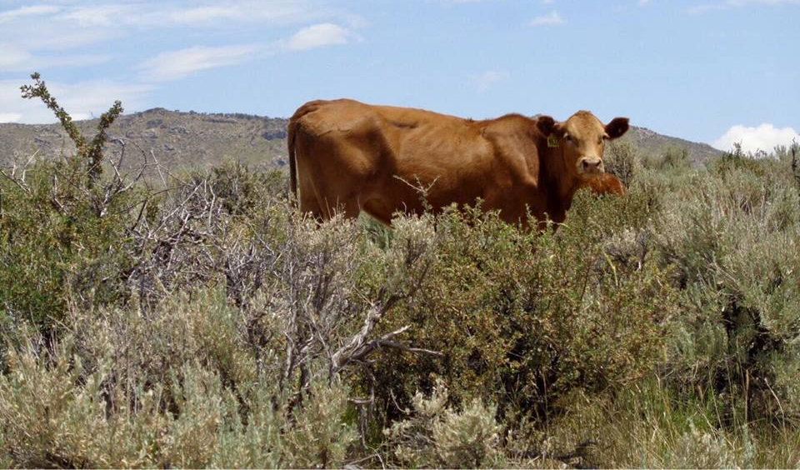
WELCOME BACK! I hope everyone had a wonderful and safe summer!

