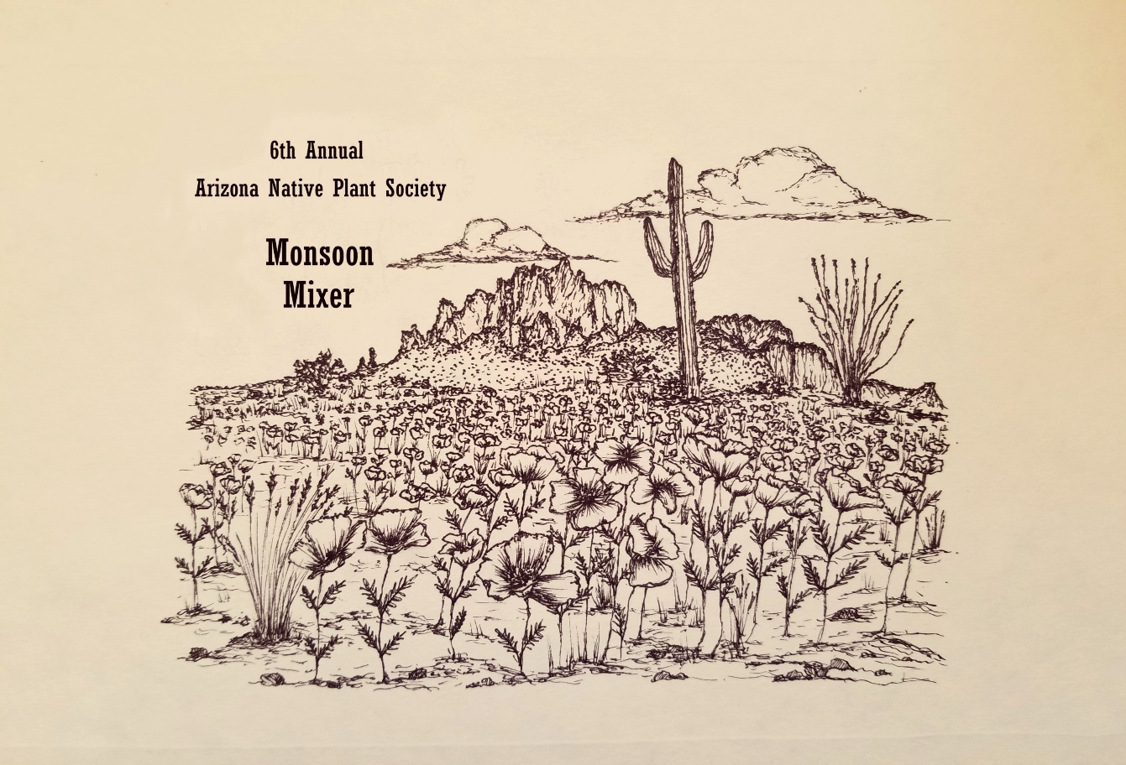
6th Annual AZNPS Monsoon Mixer
TUESDAY, AUGUST 14TH 5-10PM
La Cocina Restaurant
201 N. COURT AVE
TUCSON, AZ

SILENT AUCTION * ART * RARE PLANT BOOKS * FRIENDS *
STORIES OF SUMMER ADVENTURES

A PORTION OF THE PROCEEDS FROM FOOD AND DRINK SALES
BENEFIT THE TUCSON CHAPTER OF THE ARIZONA NATIVE
PLANT SOCIETY.

