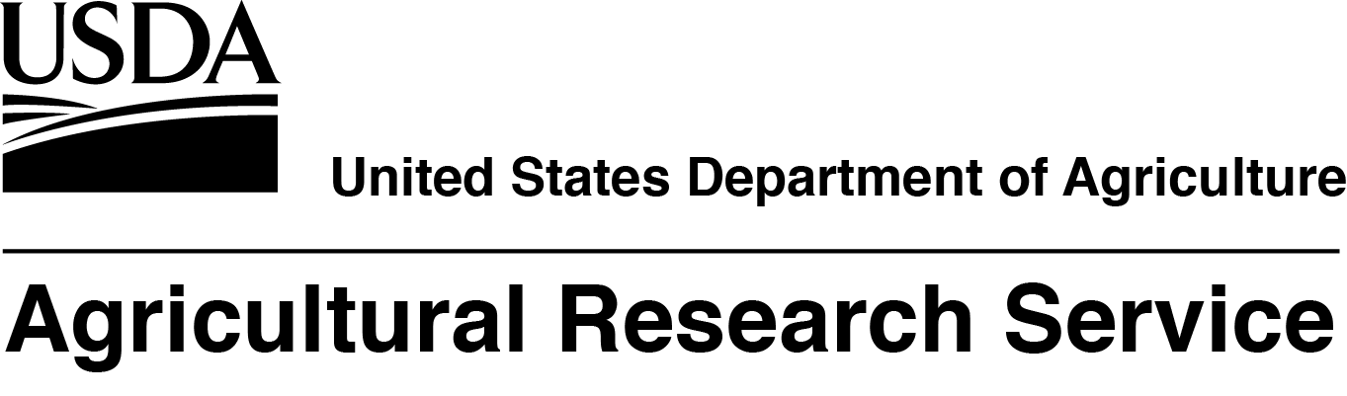
The USDA, Agricultural Research Service, Range and Meadow Forage Management Research Unit located in Burns, OR, is seeking a full time, permanent, Research Ecologist/Rangeland Management Specialist. The salary for this position is at the GS-12/13 level, $73,375.00 - $113,428.00 per year. The mission of this Unit is to provide the scientific basis for sound land and livestock management. The incumbent’s research program will focus on identifying environmental factors affecting success of rangeland vegetation management, developing ecologically-based strategies necessary to mitigate these factors, and predicting results of recommendations at the landscape scale. This announcement will open 06/13/2018 and will close on 06/26/2018. U.S. Citizenship is required. USDA/ARS is an equal opportunity provider and employer.

If you have any questions regarding the additional duties of this position please contact Dr. Chad Boyd at 541-573-8939 or chad.boyd@ars.usda.gov.

If you have any questions regarding the application process for this position please contact
Heather Lee, Human Resources Specialist, at 301-504-1410 or heather.lee@ars.usda.gov.

To view additional details about this position and complete application instructions, go to the USAJobs Web site: https://www.usajobs.gov/ and refer to announcement number ARS-D18W-0090. Please note that the announcement number will not be accessible until 6/13/18.

