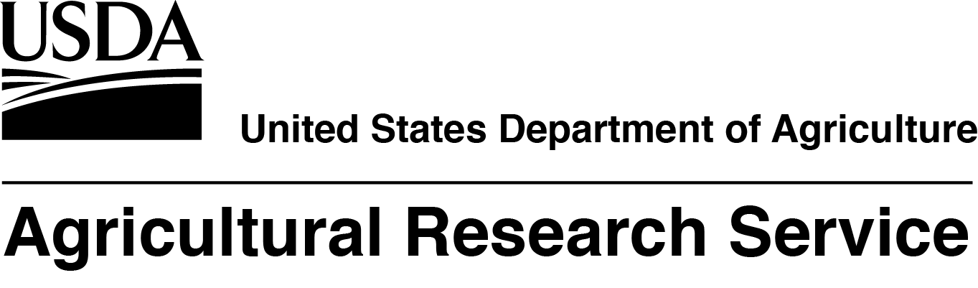
The USDA, Agricultural Research Service, Range and Meadow Forage Management Research Unit located in Burns, OR, is seeking a full time, permanent, Research Rangeland Management Specialist/Research Ecologist. The salary for this position is at the GS-12/13 level, $73,375.00 - $113,428.00 per year. The mission of this Unit is to provide the scientific basis for sound land and livestock management. The incumbent’s research program will focus on understanding ecological processes and factors limiting rangeland seeding success and how technology can be used to help ameliorate those limitations. This announcement will open 06/14/2018 and will close on 06/27/2018. USDA/ARS is an equal opportunity provider and employer.

If you have any questions regarding the additional duties of this position please contact Dr. Chad Boyd at 541-573-8939 or chad.boyd@ars.usda.gov.

If you have any questions regarding the application process for this position please contact
Amanda Wilkerson, Human Resources Specialist, at 301-504-7266 or amanda.wilkerson@ars.usda.gov.

To view additional details about this position, click on the following link: (link will not be live until 6/14/18) https://www.usajobs.gov/GetJob/ViewDetails/500619600

