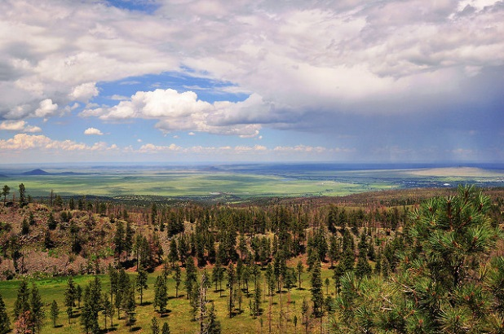
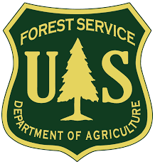
Outreach Notice
  - R3 – Apache-Sitgreaves National Forests
DUTY STATION: Alpine, Arizona

Information Receptionist

GS-0304-04

The Apache-Sitgreaves National Forests – Alpine Ranger District is looking for a motivated individual to serve as a Front Desk Information Receptionist for the summer.
ABOUT THE JOB
This position serves as the Alpine Ranger District’s Front Desk Information Receptionist. You will be the first Forest Service representative who greets visitors to our District office. The position is a temporary position for the summer of 2018; starting in mid-May and lasting approximately 4-6 months. Your work hours will be Monday – Friday from 8am – 4:30pm. This is a great opportunity to get into the Federal employment system and gain valuable experience with the Forest Service.

Required for the Position:
- Basic customer service skills to include answering telephones, transferring calls, answering a variety of questions, controlling inventory, receiving payments and making change.
- Knowledge of the local area and recreation opportunities.
- Ability to communicate effectively, both orally and in writing.
- Ability to learn in order to develop knowledge and understanding of basic rules, procedures, and operations common to the work of the unit.
- Ability to work as a member of a team.
- Use of basic word processing, spreadsheets and databases.
- Use of printer, copier and fax machine.
- Must be 18 years and qualify for a Federal position.

Our District includes:
- The District Ranger and eight Staff Officers.
- An average of twenty various permanent employees.
- Approximately twenty seasonal employees (this is where you’d fall in).
- Your team would include the Support Services Specialist, Visitor Information Assistant and Resource Clerk.

This job will be advertised and filled only through USAJobs (USAJobs.gov). Get your resume and required supporting documents prepared and create your account so you are ready to submit your application when the job opens (expected to be open March 25-31st).

If you have any questions about the position please contact Catherine Gillund at cgillund@fs.fed.us , 928-339-5020, or Kylie Pena at kyliepena@fs.fed.us, 928-339-5000.

For information about how to apply for a federal job, the salary, or job series, visit the
US Office of Personnel Management website.

