Job Opportunity at Mid-Columbia River National Wildlife Refuge Complex!

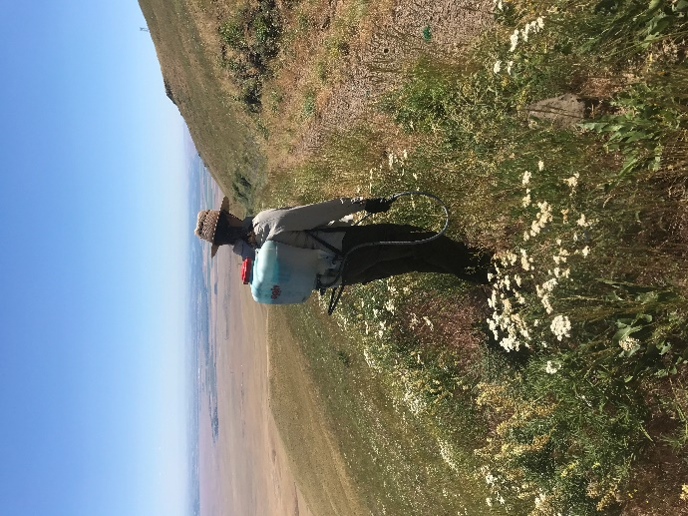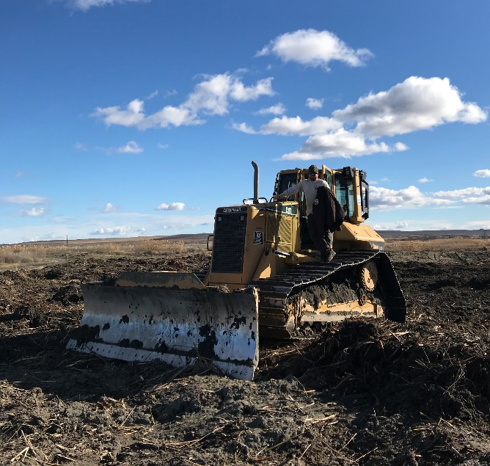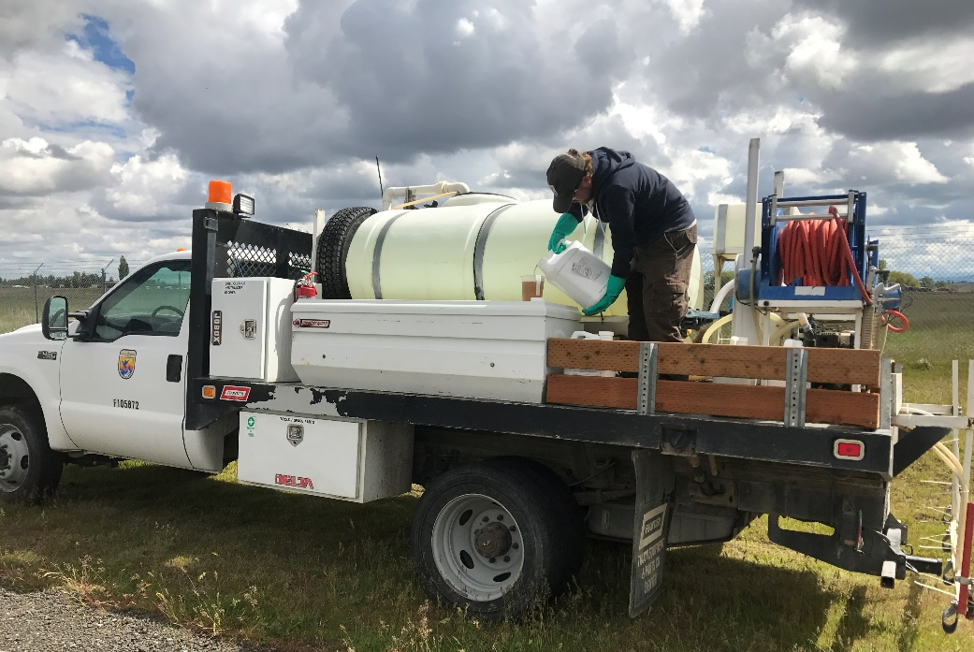

We are pleased to announce an exciting job opportunity for a hard-working, motivated, and detail-oriented individual ready to put their field leadership skills to the test. This is a full-time TERM Biotechnician position for the Mid-Columbia River National Wildlife Refuge Complex (“Complex”) in Burbank, Washington. The opportunity will provide broad experience in Refuge operations, integrated pest management, crew leadership, and application of mobile GIS mapping technologies.

The incumbent will serve as the Crew Leader for the Complex’s Invasive Species Strike Team. Leading a crew of 3-4 Strike Team members, you will work with a variety of Fish and Wildlife Service staff, cooperators, and partners to support long-term invasive species control work and carry out early-detection/rapid response operations around the Complex. The team also travels four times per year to military bases in Idaho and NE Washington to support noxious weed control projects.

The ~300,000-acre Complex includes seven National Wildlife Refuges and Hanford Reach National Monument and spans from central and southeastern Washington to northcentral Oregon. A place full of diverse habitats and equally diverse weed communities, there is never a dull moment. The Strike Team engages in a variety of projects, including mechanical removal of invasive trees and shrubs, spot-spraying invasive plants in wetland habitats, broadcast spraying weeds in reclaimed farm fields, treating phragmites from airboats, and mapping and inventorying invasives. From biocontrols to boom sprayers and everything in between, the Complex offers one of the most diverse suites of mechanical equipment and herbicide options for invasive plant control in the entire Refuge system. This job will be an amazing opportunity to receive training and experience operating a variety of equipment (including excavators, skid steers, tractors, spray trucks, and a variety of vegetation removal attachments) and implementing an integrated pest management approach across multiple management units.

Desired qualifications:
- Experience mapping and treating invasive plant populations, ability to use keys, manuals, and other guides to identify native and non-native plants in multiple life stages
- Leading crews in rugged or remote environments
- Experience mixing and applying herbicides; experience operating, calibrating, and maintaining herbicide delivery systems from back sprayers to tractor mounted boom sprayers
- Operating and maintaining motorized and non-motorized equipment, such as chainsaws, backpack sprayers, gas-powered pumps and generators
- Excellent verbal and written communication skills; aptitude in logistics management and scheduling
- Experience using GIS software to map and monitor plant or wildlife populations; willingness to embrace new technology in mobile applications for treatment tracking and weed mapping.

USA Jobs Link: https://www.usajobs.gov/GetJob/ViewDetails/492882000
Open to: all US Citizens and accepting applications starting March 5, 2018
Annual salary: $41,365-$53,773, full federal health and retirement benefits available
Estimated time balance: 70% field operations and travel/30% office
Overnight travel: 15-20% of time

Interested candidates should please call Meg Duhr to learn more about the position.
Meg Duhr, Wildlife Refuge Specialist
Office: 509-546-8314

