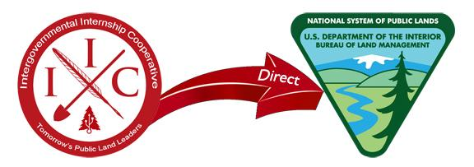
PAID BLM INTERNSHIP OPPORTUNITIES!!!
Intergovernmental Internship Cooperative - BLM Direct Hire
The Intergovernmental Internship Cooperative (IIC) at Southern Utah University is seeking qualified applicants for internships under the BLM Direct Hire Authority-Resource Assistant Internship Program. These internships are competitive and rigorous project-based experiences and will be at least 11 weeks during summer 2018. The target participants for the program are current college students or recent college graduates (seniors/graduates preferred). The BLM is committed to attracting, recruiting, and hiring qualified candidates for mission critical and hard-to-fill occupations. The BLM Direct Hire Internship Program invites women and students from diverse backgrounds to apply. Upon successful completion, the intern may be eligible for the Resource Assistant Direct Hire Authority, a direct springboard into a career with the Bureau.
2018 Available Positions - Multiple Locations
Administrative Support Assistant: Bishop, CA
Archaeologist/Archeology Specialist: Bakersfield, CA, Palm Springs CA Little Snake, CO
Civil Engineering: Denver, CO
Hydrologist Geologist: Marina, CA
Land Surveyor: Montrose, CO
Natural Resource Specialist: Yuma AZ, Bishop, CA, Ukiah, CA, Kremmling, CO, Reno, NV
Outdoor Recreation Planner: Lake Havasu, AZ, Bakersfield, CA, Moreno Valley, CA, Ukiah, CA
Park Ranger: Arcata CA, Redding, CA
Petroleum Engineer: Silt, CO
Physical Scientist or Geologist: Las Vegas, NV
Rangeland Management Specialist: Safford, AZ
Watershed Technician: Gunnison, CO
Wildlife Biologist/Technician: Bakersfield, CA, Grand Junction, CO, Monte Vista, CO, Salt Lake City, UT

First Consideration February 28, 2018 Full Position Descriptions and Application procedure are available online at: http://iicinternships.com/blm-direct/

