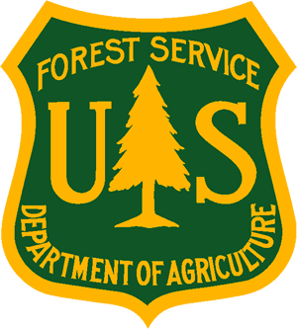
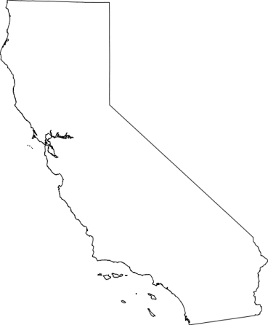
USDA Forest Service

Pacific Southwest Region
_______________________________
Outreach Notice-Term Appointment Job Opportunity
San Bernardino National Forest
Mountaintop Ranger District, Fawnskin, CA
___________________________________

Biological Science Technician (2 positions)
GS-0404-07

The San Bernardino National Forest is currently seeking two candidates for TERM Biological Science Technician (Plants) positions, GS-0404-07, for a minimum of 13 months and Not-To-Exceed (NTE) 1-4 years, located on the San Bernardino National Forest, Fawnskin, California. The purpose of this Outreach Notice is to inform prospective applicants of this upcoming opportunity. To express interest in this position, please complete the attached voluntary Outreach Interest Form and resume, return to Deveree Kopp at dkopp@fs.fed.us by close of business on December 16, 2017.

Two TERM job opportunities will be filled with this outreach.

DUTIES ASSOCIATED WITH THIS POSITION:

This position serves as a technical assistant responsible for the collection, organization, and analysis of data for botanical species and plant habitats on the Forest.

Independently, or as a crew leader, plans, participates, and conducts a variety of field studies of native and non-native botanical species and their habitats. Coordinates with resource specialist in planning work. Develops plans to collect data for use in habitat and species condition analyses. Collects survey and inventory data to determine species identity, population characteristics, environmental conditions, and factors affecting the vigor and extent of the species and their habitat. Keeps records of all data and produces maps of survey areas.

Schedules, organizes, and executes botanical projects involving native and/or non-native species. Resolves common administrative and safety concerns related to the projects. Compiles and summarizes the data obtained from surveys, inventories, biological evaluations, and monitoring. Uses computer systems and associated software for recording, organizing, storing, and analyzing data. Provides detailed reports on work methods, data collected, and project monitoring. Evaluates data and makes recommendations for improvement of habitat. Provides data to resource specialist after checking for discrepancies and inconsistencies. Assists with analysis, interpretation, and refinement of botanical data, and development of reports.

Source: Standard PD: FS3086

For more information on the position, contact Deveree Kopp (909) 382-2831 or dkopp@fs.fed.us

ABOUT THE FOREST:
San Bernardino Community
The San Bernardino National Forest, one of 18 National Forests in the State, is located in the counties of San Bernardino and Riverside. The Forest covers approximately 670,000 acres and lies above the surrounding cities of Ontario, Rancho Cucamonga, Fontana, Rialto, San Bernardino, Redlands, Mentone, Yucaipa, Banning, Beaumont, Apple Valley, Victorville, Lucerne Valley and the resort communities around Palm Springs. Several mountaintop communities, including Idyllwild, Lake Arrowhead, Wrightwood, and Big Bear are surrounded entirely by the National Forest. The Forest encompasses all or portions of several high elevation mountain ranges, including the eastern portions of the San Gabriel Mountains, the San Bernardino Mountains, and the Santa Rosa and San Jacinto Mountains. Major interstates cross the Forest, including I-10 and I-15.
The Forest and surrounding areas offer a wide variety of recreational opportunities for hunting, hiking, backpacking, fishing, sightseeing, off-highway vehicles, mountain biking, winter recreation, and horseback riding. Significant visitor attractions include the Big Bear Discovery Center, National Children’s Forest, and the Santa Rosa and San Jacinto Mountains National Monument. The Forest is one of the four forests in southern California that are part of the National Forest Adventure Pass Program (a Recreation Fee Demonstration Project). The Forest has numerous recreation and non-recreation special uses, including significant transportation and utility corridors that feed the Inland Empire and LA Basin. The many urban communities along the foothills of the San Bernardino and San Gabriel Mountains together with the mountain communities surrounded by the National Forest add complexity to the management environment of the wildland urban interface.
Additional Information:
San Bernardino Chamber of Commerce (909) 885-7515 www.chamberofcommerce.com/san-bernardino
Riverside Chamber of Commerce (951) 683-7100 www.riverside-chamber.com/
More information on the San Bernardino National Forest is on our website: www.r5.fs.fed.us/sanbernardino

Please submit completed outreach form and resume to Deveree Kopp, Botanist at dkopp@fs.fed.us by 12/16/2017

The U.S. Department of Agriculture (USDA) prohibits discrimination on all its programs and activities on the basis of race, color, national origin, gender, religion, age, disability, political beliefs, sexual orientation, and marital or family status. (Not all prohibited bases apply to all programs.) Persons with disabilities who require alternative means for communication of program information (Braille, large print, audiotape, etc.) should contact USDA's TARGET Center at (202) 720-2600 (voice and TDD). To file a complaint of discrimination, write USDA, Director, Office of Civil Rights, Room 326-W, Whitten Building, 14th and Independence Avenue, SW, Washington, DC 20250-9410 or call (202) 720-5964 (voice and TDD). USDA is an equal opportunity provider and employer.

OUTREACH RESPONSE FORM
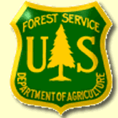
Biological Science Technician (Plants) GS-0404-07
Please submit outreach response and a detailed resume by December 16, 2017
to Deveree Kopp at dkopp@fs.fed.us
San Bernardino National Forest, Fawnskin, California

NAME:

E-MAIL ADDRESS:

MAILING ADDRESS:

TELEPHONE NUMBER:
 | {USFS |  | {BLM |  | {OTHER

AGENCY EMPLOYED WITH:

 | {PERMANENT |  | {TEMPORARY |  | {TERM
TYPE OF APPOINTMENT:

 | {VRA |  | {PWD |  | {OTHER

 | {REGION |  | {FOREST

CURRENT:
{DISTRICT

 | {SERIES |  | {GRADE

CURRENT:
{POSITION TITLE

CURRENT:

HOW DID YOU FIND OUT ABOUT THIS OUTREACH NOTICE?

IF NOT A CURRENT PERMANENT (CAREER OR CAREER CONDITIONAL) EMPLOYEE
ARE YOU ELIGIBLE TO BE HIRED UNDER ANY OF THE FOLLOWING SPECIAL AUTHORITIES:

PERSON WITH DISABILITIES

VETERANS READJUSTMENT

DISABLED VETERANS W/30% COMPENSABLE DISABILITY

VETERANS EMPLOYMENT OPPORTUNITIES ACT OF 1998

FORMER PEACE CORPS VOLUNTEER

STUDENT CAREER EXPERIENCE PROGRAM
Thank you for your interest in our Vacancy!

