
Tierra Seca
University of Arizona Student Chapter
Society for Range Management

College of Agriculture and Life Sciences
School of Natural Resources and the Environment

October 11, 2017

- Call to order: 6:00 p.m.
  - Members in attendance: William, Flavie, Cameron, Daniel, Emma, Adnan Ali, Brandon, Clara, Dustin, Amber
  - Faculty: Mitch Mcclaran
- President’s Report
  - Introductions
  - Semester meeting dates:
    - October 11, 2017: 6-7 p.m. (ENR2 ROOM DIFFERENT S210) ~ Dr. Mcclaran speaking today
    - October 25, 2017: 6-7 p.m. (ENR2 Room S120A)
    - November 8, 2017: 6-7 p.m. (ENR2 Room S120A) ~ Elise Gornish speaking today
    - November 22, 2017: 6-7 p.m. (ENR2 Room S120A) ~ Vanessa Prileson speaking today
  - Past Events Report
  - Upcoming Events
    - October 21, 2017 – Rise Symposium (Bring breakfast foods for donations) 8:30-3:00 p.m.
      - Zach and Alonso will bring coffee makers
      - Be there at 7:15 to start coffee and get set up ~ be ready by 8am
      - Mitch will arrive at 7:30 (NEED TO GET KEY FROM MITCH IF ARRIVE EARLIER?)
      - Info pasted below…
      - Marley Building Room 230
      - Serving approx 60 people
      - Club will reimburse people for food
      - Volunteers:
        - Amanda (orange juice)
        - Clara (club supplies, coffee grounds + filters, tea, donut holes, paper products etc from club closet + 2 cartons of Dunkin Donuts coffee (NEED TO ORDER AHEAD) + BUY THICK PAPER CUPS as backups for machines)
        - William (donuts)
        - Zach (thermos for hot water to make tea)
        - Marquel (small Muffins)
        - Justin (Apples + cuties)
        - Brandon (cheese sticks, Orange Juice?)
        - Dustin (milk)

    - November 3, 2017: Elk/LD fall monitoring
      - Will be reserving cars + deans excuses next week ~ so let me know if you’d like to go before then
      - Will send out email the week of with info on where meeting etc.
      - Monitoring: 8:30 -1 (Time we will be leaving campus TBA)
      - Volunteers: Josie, Emma, Flavie, Marquel, Zach, Amanda?, Alonso?
      - Bring LOTS of water + Food, proper attire ie long pants and close toed shoes….

- Club Activity
        - Date: November 4th
        - Shooting Day…? OK?
-Red Rock? Etc?
        - Interested: William, Amanda, Daniel, Justin, Zach, Clara, Emma, etc
- Wildlife/ Range kickball game:
      - Mansfield Park: 2200 N 4th Ave
      - Wildlife and Tierra Seca will split food cost
        - Be sure to order vegetarian option…
      - NEED A PERMIT, because public park
      - November 11 in the morning
      - can bring beer – NO HARD ALCOHOL OR GLASS…
      - Interested? Josie, Emma, Flavie, Daniel, Cameron, Austin, Justin, William, Zach, Amanda, Alonso, Marquel, Tyra, etc

- Club Social
        - Date: TBD early December? 9th, 2nd, etc?
        - Bonfire/potluck – Zach volunteered his house…
        - Reminders will be sent when the date gets nearer.
        - Interested: William, Zach, Amanda, Josie, Alonso, Clara,
    - AZ SRM Winter Meeting: January 3-5, 2018. Globe, AZ.
    - 2018 SRM conference Sparks, NV Jan 28-Feb 2
      - make sure people purchase SRM membership: http://srm.allenpress.com/srm/MEMBERSHIP.aspx

      - register for conference!!! http://srm.allenpress.com/srm/ANNUALMEETINGS.aspx

    - March 2018 – Buenos Aires needs volunteers for Pima Pineapple cactus surveys- Date: TBA
- Vice President’s Report:
  - VOLUNTEER!
- Treasurer’s Report
  - Dues ($10 per semester)
  - Paid dues:
  - Account balances (Now accepting all credit cards):
    - Checking: $3258
    - Savings: $395
    - Cash: $30

- Misc.
- Aaron Lien amlien@cals.arizona.edu : Rangeland Cup for SRM Conf – Info.
      - Anyone Interested?
  - Volunteer Opportunity Ideas???
  - Koprowski Red Squirrel Surveys
          - Starts in Nov
  - marymcarroll@email.arizona.edu - Nov. 3rd Volunteer Opportunity, Page Ranch clean up (FYI SAME day as AVCA erosion monitoring day which club has committed to…)
  - * Using InvolveUA link as storage for all club information *
    - https://arizona.collegiatelink.net/organization/tierraseca
  - Community garden plot – Interest? Possibly joint plot with wildlife…
    - Email Betsy Grube if interested: ergrube@email.arizona.edu
  - Plant ID / URME Interest?
Plant ID: 100+ minute long test in order to test knowledge on plant species. Doodle poll will be sent out to determine a meeting time.
URME: Under Graduate Range Management Exam.
- Tuesdays from 6-8pm. ENR2 S120
Comprehensive exam including all aspects of range management. 2 credit hours are available- must be earned!

  - Pathways NRCS, BLM
    - USA Jobs, Indeed, American Conservation Experience
  - Arroyo Chico Wash cleanup led by Katie Hughes
    - Date:
    - Location: Highland and 14th (across from a little grassy park) and head down into the wash and east from there.
  - Club Member Recruitment Ideas / Fundraising Ideas?
    - Percentage night at a restaurant.
    - Native plant sale? – ask local nurseries to donate?
    - Bake sale

  - SNRE Seminars:
    - Every Wednesday in S107 – ENR2 from 3:00-4:00 p.m.
  - Link to 2018 SRM Annual Meeting Website: http://annualmeeting.rangelands.org

- Any Other Business?
Guest Speakers: Clara is hoping to have guest speakers come and give presentations.
- In the works for the Spring…
  - Dan Robinett and Linda Kennedy – Spring Semester…
  - Talk to Justin ~ NEON Guy
- Adjournment: 7:00 pm
Swag
- Stickers: $1
- Koozies: $3
- T-Shirts: $10
- Hats: $20

Facebook club link: https://www.facebook.com/uofatierraseca
President: Clara Miller claramiller@email.arizona.edu
Vice President: Alonso De La O AGD1@email.arizona.edu
Secretary: Josephine Profy jprofy@email.arizona.edu
Treasurer: Zach Winston Winston@email.arizona.edu

RISE SYMPOSIUM

Research Insights in Semiarid Ecosystems (RISE) Symposium Saturday, 21 October 2017, 8:30 AM to 3:00 PM University of Arizona Marley Auditorium (Room 230), Tucson, Arizona

The 14th annual Research Insights in Semiarid Ecosystems (RISE) Symposium will feature invited speakers and posters presenting recent research on the USDA-ARS Walnut Gulch Experimental Watershed, the University of Arizona Santa Rita Experimental Range and other outdoor laboratories in the region. There will be time available for questions from the audience. There will also be a poster session where students and researchers are encouraged to report on and discuss completed or in-progress studies.

Student Poster Contest Awards:
Through a generous contribution from long-time supporter Mr. Malcolm McGregor, we are able to grant awards for outstanding student posters. A single award will be granted in each of the following categories: Best Graduate Student Poster ($500), Honorable Mention Graduate Student Poster ($200), Best Undergraduate Student Poster ($300), Honorable Mention Undergraduate Student Poster ($100). To qualify for a poster award, the work presented on the poster must have been conducted in or have used data from the Walnut Gulch Experimental Watershed (WGEW), the Santa Rita Experimental Range (SRER), or both. Entry to the contest can be made via the Symposium registration web page. Note: Students in the competition will be asked to identify at least a 30-minute window in which they will be at their poster during the poster session.

Registration (includes lunch): $10 for students; $25 for all others The deadline for registration (as a courtesy for catering plans) is 10 October 2017. Late registrations will be accepted at the Symposium on 21 October from 8:30 to 9:00 AM.

Five Continuing Education Units will be awarded from the Society for Range Management Certified Professional Rangeland Managers.

Submission deadline for poster presentation is 10 October 2017. Note: Space may be limited; if this is the case, priority will be based on order of abstract submission. Please use the web site http://www.tucson.ars.ag.gov/rise/ to view the RISE program, to register for the symposium, and to submit poster abstracts and to enter the student poster contest.
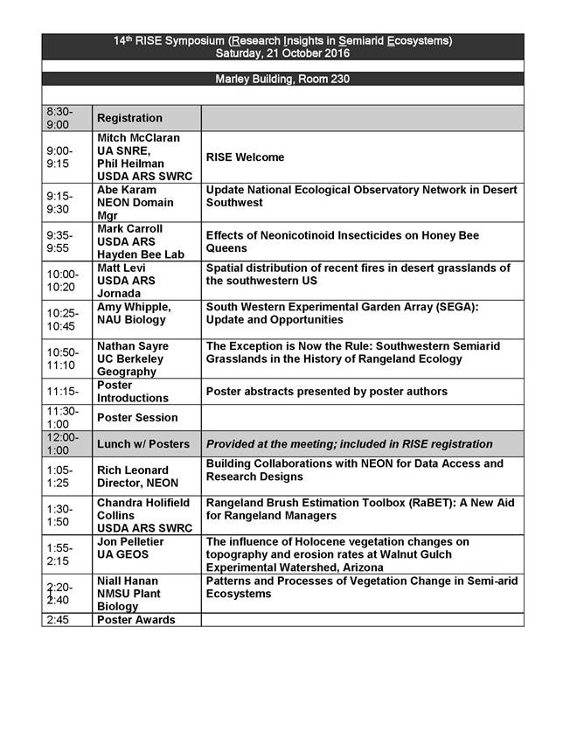
Dr. McClaran
Degree Checklist

29 elective units and how to use them for Federal Employment

The coursework requirements are based on the September 2005 revision of Professional Work in Natural Resources Management and Biological Sciences Group 0400 (http://www.opm.gov/fedclass/gs0400p.pdf), and the specific criteria identified for the Individual Occupational Requirements for GS-454 Rangeland Management Series (http://www.opm.gov/qualifications/SEC-IV/B/GS0400/0454.HTM).

Template: https://rangesec.files.wordpress.com/2014/05/template_describing_qualifying-courseworkver_2.doc

