JOB DESCRIPTION
 |  |  |  | 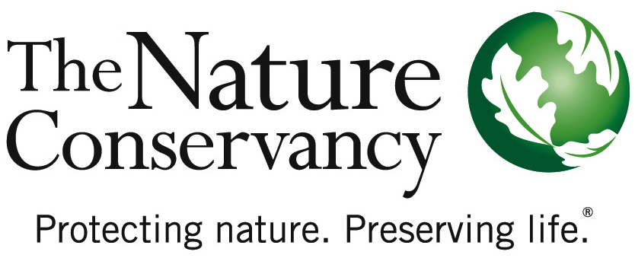
JOB TITLE | Director of Forest Management
JOB FAMILY | Conservation
JOB NUMBER | 250005
SALARY GRADE | 7
STATUS | Salaried
DATE | September 22, 2017
SUMMARY | The Director of Forest Management (DFM) provides strategic vision, direction and oversight for The Nature Conservancy’s forest management and restoration work in Alabama. The DFM leads some or all aspects of conservation science, restoration including prescribed fire, ecological monitoring and community relations for TNC’s terrestrial priorities in Alabama and assists in Longleaf Pine Whole System efforts and other initiatives as assigned. The DFM also serves as a key contact to government agencies, other conservation organizations, foundations and the academic community in regards to forest management work statewide.
ESSENTIAL  FUNCTIONS | The Director of Forest Management establishes the Conservancy as a major leader in forest restoration efforts in Alabama, defines conservation priorities and long-term conservation strategies, builds strategic, scientific, and technical capacity in the field and develops key partnerships with public and private organizations to identify and resolve technical issues and to widely communicate solutions and best practices. S/he develops innovative scientific methods, analyses, tools and frameworks to address the natural system needs, engages local community support for local conservation efforts, and negotiates complex and innovative solutions with government agencies and landowners to conserve, restore and protect natural communities.
RESPONSIBILITIES & SCOPE | - Oversees all components of forest restoration including the prescribed fire program for the Alabama Chapter.  - Programmatic scope of this work may require cross-boundary work and relationships.  - Leads and manages teams and projects to support and improve forest restoration efforts.  - Manages multi-disciplinary administrative and professional staff, with responsibility for performance management, training and career development. Establish clear directions and set stretch objectives.  - Establishes and maintains optimal standards of performance for the program while controlling costs and administering budgets.  - Responsible for ensuring that public and private funds are raised to meet program needs.  - Builds cooperation from outside parties to accomplish program goals  - May work in variable weather conditions, at remote locations, on difficult and hazardous terrain and under physically demanding circumstances.  - Frequently makes independent decision based on analysis, experience, and judgment.
MINIMUM QUALIFICATIONS | - Bachelor’s degree and at least 5 years’ experience in fire management or natural resource management or similar field or equivalent combination of education and experience.  - Experience managing complex or multiple projects, including staffing, workloads and finances under deadlines.  - Supervisory experience, including motivating, leading, setting objectives and managing performance.  - Experience completing tasks independently with respect to timeline(s).  - Excellent communication skills via written, spoken and graphical means in English and other relevant languages.  - Experience using common software applications such as Word, Excel, web browsers, etc.  - Experience developing partnerships (NGOs, community, government.).  - Must achieve physical fitness standards as set by local Fire Manager and TNC Fire Manual.  - Negotiation skills.
PREFERRED KNOWLEDGE, SKILLS & EXPERIENCE | - 7+ years’ experience in forestry, fire, and/or natural resource management or combination of education and experience.  - Qualified as an NWCG RXB2 Prescribed Fire Burn Boss.  - Demonstrated experience influencing, developing and implementing conservation policy and plans.  - Knowledge of current trends and practices in relevant discipline(s) and regions.  - Experience using Global Positioning System (GPS) and Geographic Information System (GIS) technologies for data collection, downloading and processing/manipulation.  - Experience in all aspects of forestry including timber harvest, site preparation, reforestation, pre-commercial thinning, insect and disease management and coordinating multiple use management  - Experience with all aspects of timber procurement (stand assessment, volume calculations, timber sale prospectus generation, bid advertisement, contractor selection, contractor management and quality control).  - Knowledge of methods and standards of biodiversity information systems and initiatives.  - Communicating clearly via written, spoken, and graphical means in English and other relevant languages.  - Demonstrated experience in grant writing.  - Politically savvy and experienced in partnership development (partners, community, government)
ORGANIZATIONAL COMPETENCIES | Accountability for Outcomes | Pushes for excellence. Establishes challenging goals for self and others to drive performance in support of the Conservancy’s mission. Rewards behavior that achieves these standards and is aligned with the organization’s mission/ values. Takes action to address performance problems in a timely and appropriate manner.
ORGANIZATIONAL COMPETENCIES | Builds Organizational Capability | Builds or adapts organizational structures to accomplish the mission and to improve performance. This includes reorganizing organizational systems, structures, processes, procedures, communication channels or reporting relationships. With the Conservancy’s strategic filter in mind, determines who can contribute, gets the right people involved, and builds bench strength for the future.
ORGANIZATIONAL COMPETENCIES | Collaboration & Teamwork | Shows a willingness to put the needs and goals of a global organization before personal/local/departmental needs. Works with others across organizational boundaries. Makes decisions, sets priorities, and allocates resources to help the organization as a whole achieve results.
ORGANIZATIONAL COMPETENCIES | Communications | Effectively expresses messages verbally and in writing. Actively listens to others. Fosters open exchange of issues. Is timely with information.
ORGANIZATIONAL COMPETENCIES | Courage & Decisiveness | Makes decisions and stands by them. Makes timely decisions even under pressure and when lacking complete information. Has the courage to modify decisions and admit why and how they were wrong.
ORGANIZATIONAL COMPETENCIES | Flexibility & Innovation | Flexible to changing circumstances. Takes innovative approaches towards work. Takes calculated risks and makes dependable decisions in the fact of uncertainty.
ORGANIZATIONAL COMPETENCIES | Influences for Results | Achieves results by persuading, convincing, or influencing others. Adapts approach to the individual or group and knows how and when to use complex influence strategies. Uses success stories and passion for the mission to generate enthusiasm and support.
ORGANIZATIONAL COMPETENCIES | Open to Learning | Versatile learner and committed to self-improvement. Employs strengths effectively. Willingly shares knowledge with others. Seeks coaching on areas needing improvement. Adjusts behavior/performance as needed. Views mistakes as learning opportunities.
ORGANIZATIONAL COMPETENCIES | Organizational Awareness | Understands the basics of our business. Knows how local job relates to the big picture & contributes to the overall strategy. Knows how/why things work inside TNC. Easily moves through internal networks and channels for success.
This description is not designed to be a complete list of all duties and responsibilities required for this job.

