
College of Agriculture and Life Sciences
School of Natural Resources and the Environment

Tierra Seca
University of Arizona Student Chapter
Society for Range Management

September 13, 2017

- Call to order: 6:00 p.m.
  - Members in attendance: Clara Miller, Alonso De La O, Josie Profy, Maria Johnson, Emma Froehlich, William Gray, Dustin Curley, Amber Ford, Brandon Mayer, Justin Johnson, Amanda Sacek, Kayla Kersey, Flavie Audoin, James Pagan.
  - Faculty: Dr. Larry Howery, Dr. Mitch McClaran, Sarah Noelle,
- President’s Report
  - Introductions
  - Semester meeting dates:
    - August 30, 2017: 6-7 p.m. (ENR2 Room S120A)
    - September 13, 2017: 6-7 p.m. (ENR2 Room S120A) – Dr. Marsh Speaking in beginning – Director of SNRE
    - September 27, 2017: 6-7 p.m. (ENR2 Room S120A)
    - October 11, 2017: 6-7 p.m. (ENR2 ROOM DIFFERENT S210)
    - October 25, 2017: 6-7 p.m. (ENR2 Room S120A)
    - November 8, 2017: 6-7 p.m. (ENR2 Room S120A)
    - November 22, 2017: 6-7 p.m. (ENR2 Room S120A)
  - Past Events Report
  - Upcoming Events
    - Fall club social: date TBA:
      - Saturday vs. Sunday?
      - Doodle poll for date will be sent with minutes
      - Ideas: shooting, hike, santa rita range picnic…
    - October 21, 2017 – Rise Symposium (Bring breakfast foods for donations) 8:30-3:00 p.m.
      - Arrive at 7:30 to be set up by 8:00
      - Info pasted below…
      - Volunteers: ?
    - 2 club hikes OR Social Events (Sometime during fall semester)
      - Doodle poll will be sent out with minutes
      - Hikes, campfire, shooting day???
    - November 3, 2017: Elk/LD fall monitoring
      - Volunteers:
Wildlife/ Range kickball game: Date TBA
    - AZ SRM Winter Meeting: January 3-5, 2018. Location TBA.
    - 2018 SRM conference Sparks, NV Jan 28-Feb 2
    - March 2018 – Buenos Aires needs volunteers for Pima Pineapple cactus surveys- Date: TBA
    - Baseball games?
- Vice President’s Report:
  - VOLUNTEER!
- Treasurer’s Report
  - Dues ($10 per semester)
  - Paid dues:
  - Account balances (Now accepting all credit cards):
    - Checking: $3,595.40
    - Savings: $300.76
    - Cash: $46.25
- Misc.
  - Volunteer Opportunity – see below
    - Let Katie know if anyone is interested…
    - Volunteers: ?
  - Empire Ranch Volunteer opportunity – pasted in minutes below…
  - * Using InvolveUA link as storage for all club information *
    - https://arizona.collegiatelink.net/organization/tierraseca
  - Community garden plot – Interest? Possibly joint plot with wildlife…
    - Email Betsy Grube if interested: ergrube@email.arizona.edu
  - Plant ID / URME Interest?
Plant ID: 100+ minute long test in order to test knowledge on plant species. Doodle poll will be sent out to determine a meeting time.
URME: Under Graduate Range Management Exam.
- Tuesdays from 6-8pm. ENR2 S120
Comprehensive exam including all aspects of range management. 2 credit hours are available- must be earned!

  - Pathways NRCS, BLM
    - USA Jobs, Indeed, American Conservation Experience
  - Arroyo Chico Wash cleanup led by Katie Hughes
    - Date:
    - Location: Highland and 14th (across from a little grassy park) and head down into the wash and east from there.
  - Club Member Recruitment Ideas / Fundraising Ideas?
    - Percentage night at a restaurant.
    - Native plant sale? – ask local nurseries to donate?
    - Bake sale

  - SNRE Seminars:
    - Every Wednesday in S107 – ENR2 from 3:00-4:00 p.m.
  - Link to 2018 SRM Annual Meeting Website: http://annualmeeting.rangelands.org

- Any Other Business?
Aaron’s Announcement: Advertising campaign for SNRE: Any pictures? Clara will be sending out an e-mail.
Guest Speakers: Clara is hoping to have guest speakers come and give presentations.
- In the works…
  - Vanessa Prielson (manages Pima County Ranches)
  - Dan Robinett and Linda Kennedy – Spring Semester
- Adjournment:
Swag
- Stickers: $1
- Koozies: $3
- T-Shirts: $10
- Hats: $20

Facebook club link: https://www.facebook.com/uofatierraseca
President: Clara Miller claramiller@email.arizona.edu
Vice President: Alonso De La O AGD1@email.arizona.edu
Secretary: Josephine Profy jprofy@email.arizona.edu
Treasurer: Zach Winston Winston@email.arizona.edu

KATIE EMAIL:
Hello Agvisors –

Nutritional Sciences was invited to the first annual Santa Rita’s College, Career and Community Fair on Friday, September 22nd from 12:30pm to 3:30pm. I would like to extend the invitation to you all to attend the event. We will have two tables reserved for CALS. Please follow up to let me know if you plan on attending. If you are not able to attend, please drop off any materials you have in Shantz 238 and I will bring them to the event.

Location: Santa Rita High School
3951 South Pantano Road
Tucson, AZ 85730

Date: Friday, September 22nd from 12:30pm to 3:30 PM

Sincerely,

Michelle Mendoza, MA, RDN

EMPIRE RANCH:
Hello all,

It's fall upland monitoring time again on the Empire Ranch! This year will be fun because we are focusing our monitoring efforts on key areas that were burned in the Sawmill fire. If you want to check out how the grass is coming back after the fire here is your chance! We will be meeting each day at the Empire Ranch Headquarters at 8am and will be done around 4pm. Please fill out the Doodle poll if you're available to help and pass the attached flyer onto anyone you know that might be interested in helping with this year's monitoring effort. Remember you don't have to know your grasses to be able to help out with monitoring; we need people who can record data as well.
The link to your poll is: https://doodle.com/poll/444qz9acug8edqb6

I apologize for the delay in sending this out; I've been out of the office the last two weeks recovering from a UTV accident. Let me know if you have an issues with the Doodle Poll link.

Hope to see you in October!
Kristen

--
Kristen L. Duarte
Rangeland Management Specialist
Bureau of Land Management Tucson Field Office
3201 E. Universal Way Tucson, AZ 85756
Ph. (520) 258-7215 Fax: (520) 258-7238
email: kduarte@blm.gov
http://www.blm.gov/az/st/en.html

LAS CIENEGAS UPLAND MONITORING 2017
Come help BLM with Upland Monitoring and practice range monitoring skills
What: Annual Upland Monitoring on Las Cienegas National Conservation Area.
When:
Tuesday, October 3rd
Thursday, October 5th
Tuesday, October 10th
Thursday, October 12th
Tuesday, October 17th
Thursday, October 19th
Tuesday, October 24th
Thursday, October 26th
Wednesday, November 1st
Friday, November 3rd
8:00 a.m. to 4:00 p.m.
Where: We will meet at Empire Ranch Headquarters at 8am in Sonoita, AZ. (see attached map for directions)
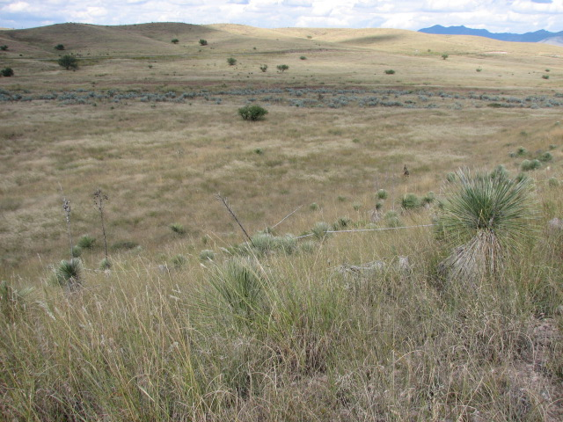

Experience identifying range grasses is a plus but not required. Assisting with data recording and tape layout does not require any formal skills. It will be a full day of field work in the sun involving mostly standing or walking.
To sign up to volunteer for one of more of our upland monitoring days, or for more information including detailed time and place instructions, please contact Kristen Duarte at the Tucson BLM office at (520)258-7215 or kduarte@blm.gov. Each volunteer will need to complete an individual volunteer agreement with BLM. For volunteers under age 18, a parent or guardian must sign the form.
What to bring:
Hat, sunscreen, plenty of water, and a lunch. Sturdy shoes that can withstand prickly grass seeds. Long pants and shirt recommended. You might also want your camera, binoculars, etc. We'll provide maps, instructions, pencils and other field equipment.

Directions to Empire Ranch Headquarters from I-10 East:
- Exit 281, to Sonoita, Hwy 83
- Head south on Hwy 83 to the Las Cienegas National Conservation Area entrance, which is just after mile marker 40, about 19 miles south of the I-10 exit.
- The entrance is to the left (east) and is a graded dirt road. Look for the Highway sign for Historic Empire Ranch which directs you to the entrance road.
- Follow entrance road (LC900) for about 3 miles to the Empire Ranch Headquarters. These are 1st buildings you see to your left. Park in large parking area near public restrooms.

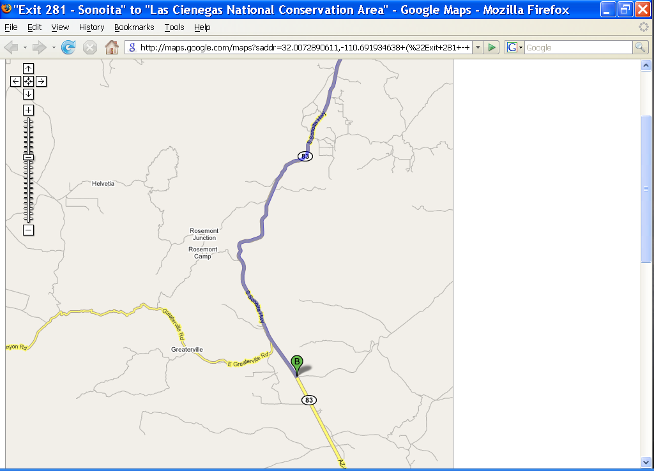
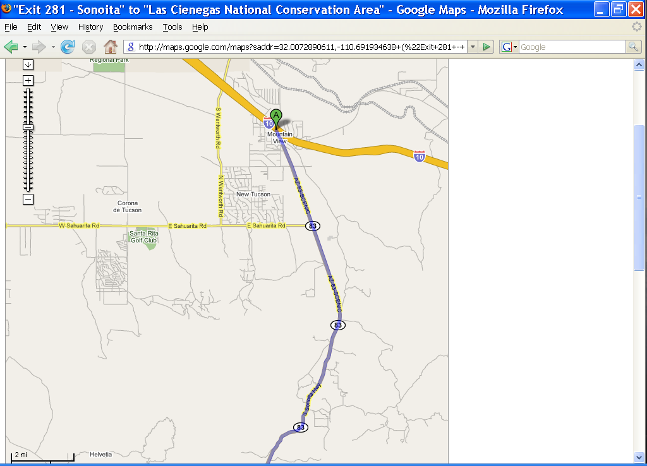

Las Cienegas NCA – Empire Ranch HQ

RISE SYMPOSIUM

Research Insights in Semiarid Ecosystems (RISE) Symposium Saturday, 21 October 2017, 8:30 AM to 3:00 PM University of Arizona Marley Auditorium (Room 230), Tucson, Arizona

The 14th annual Research Insights in Semiarid Ecosystems (RISE) Symposium will feature invited speakers and posters presenting recent research on the USDA-ARS Walnut Gulch Experimental Watershed, the University of Arizona Santa Rita Experimental Range and other outdoor laboratories in the region. There will be time available for questions from the audience. There will also be a poster session where students and researchers are encouraged to report on and discuss completed or in-progress studies.

Student Poster Contest Awards:
Through a generous contribution from long-time supporter Mr. Malcolm McGregor, we are able to grant awards for outstanding student posters. A single award will be granted in each of the following categories: Best Graduate Student Poster ($500), Honorable Mention Graduate Student Poster ($200), Best Undergraduate Student Poster ($300), Honorable Mention Undergraduate Student Poster ($100). To qualify for a poster award, the work presented on the poster must have been conducted in or have used data from the Walnut Gulch Experimental Watershed (WGEW), the Santa Rita Experimental Range (SRER), or both. Entry to the contest can be made via the Symposium registration web page. Note: Students in the competition will be asked to identify at least a 30-minute window in which they will be at their poster during the poster session.

Registration (includes lunch): $10 for students; $25 for all others The deadline for registration (as a courtesy for catering plans) is 10 October 2017. Late registrations will be accepted at the Symposium on 21 October from 8:30 to 9:00 AM.

Five Continuing Education Units will be awarded from the Society for Range Management Certified Professional Rangeland Managers.

Submission deadline for poster presentation is 10 October 2017. Note: Space may be limited; if this is the case, priority will be based on order of abstract submission. Please use the web site http://www.tucson.ars.ag.gov/rise/ to view the RISE program, to register for the symposium, and to submit poster abstracts and to enter the student poster contest.
