LAS CIENEGAS UPLAND MONITORING 2017
Come help BLM with Upland Monitoring and practice range monitoring skills
What: Annual Upland Monitoring on Las Cienegas National Conservation Area.
When:
Tuesday, October 3rd
Thursday, October 5th
Tuesday, October 10th
Thursday, October 12th
Tuesday, October 17th
Thursday, October 19th
Tuesday, October 24th
Thursday, October 26th
Wednesday, November 1st
Friday, November 3rd
8:00 a.m. to 4:00 p.m.
Where: We will meet at Empire Ranch Headquarters at 8am in Sonoita, AZ. (see attached map for directions)
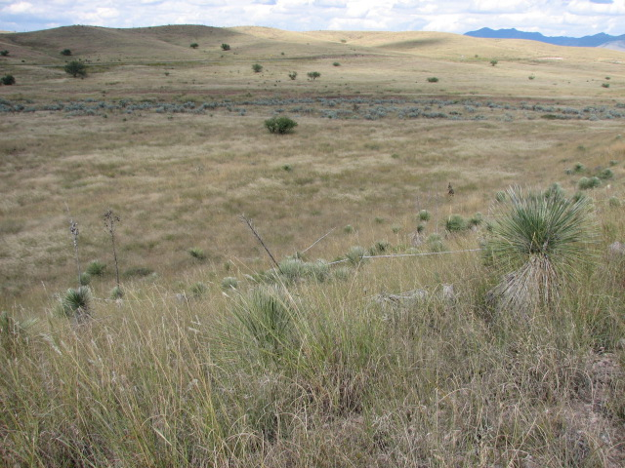

Experience identifying range grasses is a plus but not required. Assisting with data recording and tape layout does not require any formal skills. It will be a full day of field work in the sun involving mostly standing or walking.
To sign up to volunteer for one of more of our upland monitoring days, or for more information including detailed time and place instructions, please contact Kristen Duarte at the Tucson BLM office at (520)258-7215 or kduarte@blm.gov. Each volunteer will need to complete an individual volunteer agreement with BLM. For volunteers under age 18, a parent or guardian must sign the form.
What to bring:
Hat, sunscreen, plenty of water, and a lunch. Sturdy shoes that can withstand prickly grass seeds. Long pants and shirt recommended. You might also want your camera, binoculars, etc. We'll provide maps, instructions, pencils and other field equipment.

Directions to Empire Ranch Headquarters from I-10 East:
- Exit 281, to Sonoita, Hwy 83
- Head south on Hwy 83 to the Las Cienegas National Conservation Area entrance, which is just after mile marker 40, about 19 miles south of the I-10 exit.
- The entrance is to the left (east) and is a graded dirt road. Look for the Highway sign for Historic Empire Ranch which directs you to the entrance road.
- Follow entrance road (LC900) for about 3 miles to the Empire Ranch Headquarters. These are 1st buildings you see to your left. Park in large parking area near public restrooms.

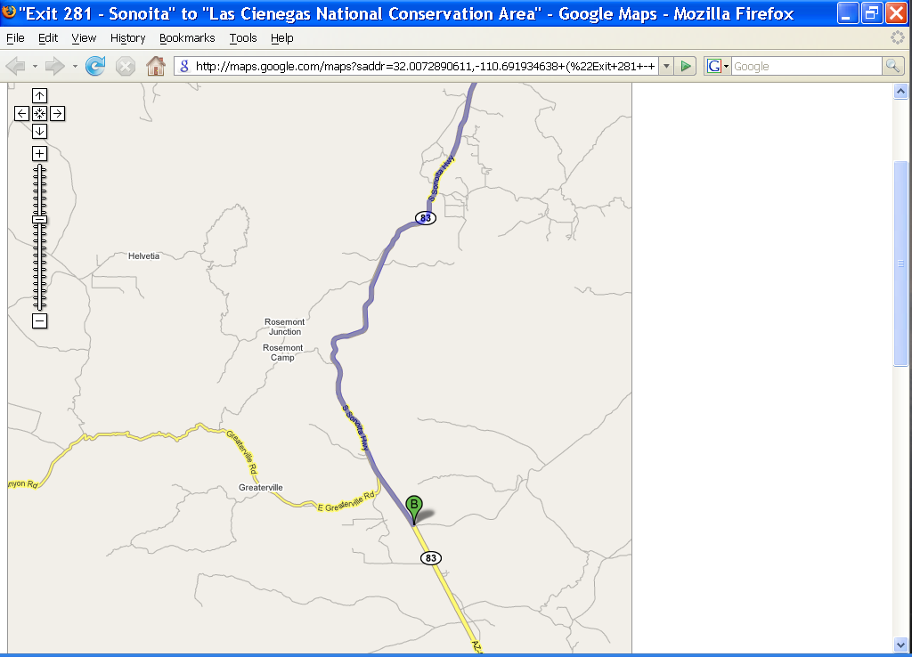
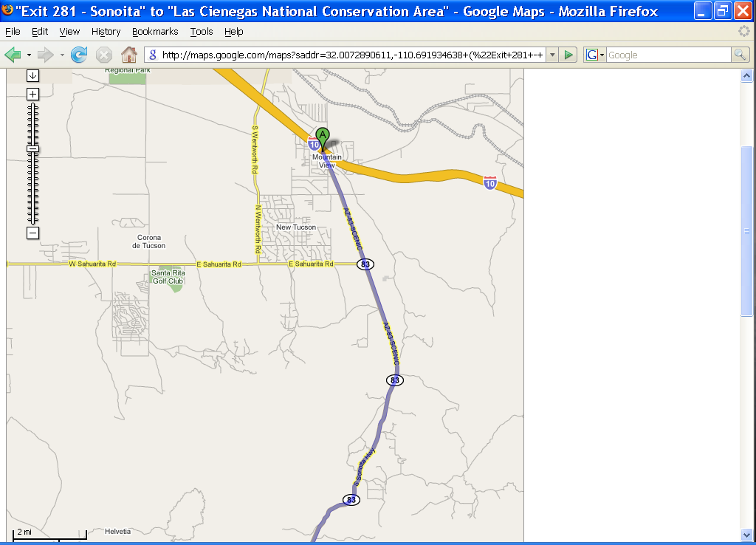
Las Cienegas NCA – Empire Ranch HQ

