Outreach
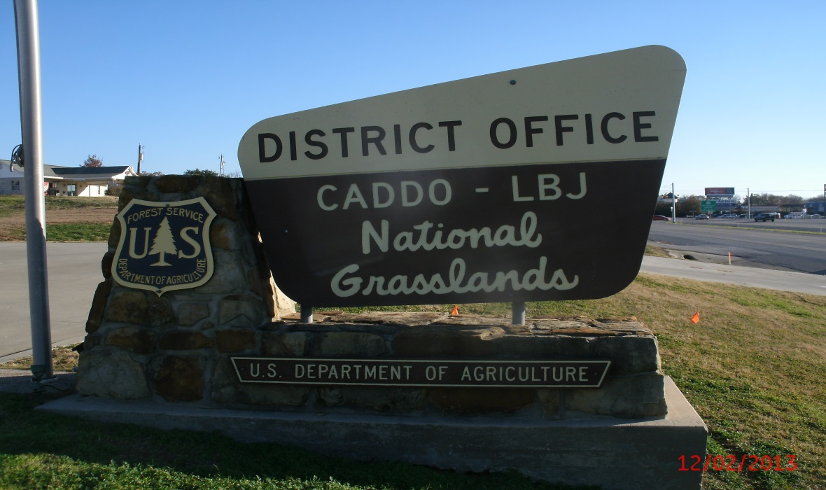GS-454-9 Rangeland Management Specialist
About the Position:
The Caddo/LBJ National Grasslands (CLBJ) has an active range program with very strong growth potential. It has the distinction of being the only National Grasslands in Region 8 and is home to a large percentage of the region’s active range allotments. Currently there are a total of 120 allotments on the district with only 50 currently under permit. The remaining 70 are in need of additional administration, which can be accomplished with additional district range and wildlife focus. The program direction is to increase the amount of allotments that are permitted, improving planning and NEPA coordination, increasing the amount of in-kind range improvement work with greater permit compliance enforcement and monitoring, and increased capacity to utilize stewardship contracting authority.
Responsibilities include permit administration, permit actions, rangeland monitoring and analysis, design/implementation of range and watershed improvement projects, and some NEPA planning and writing.
About the Grasslands:
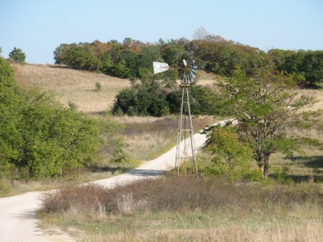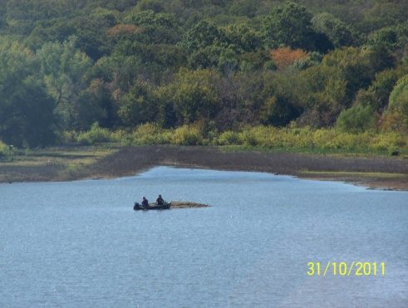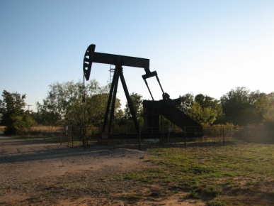
Since the 1930s, Wise, Montague, and Fannin County have been home to a unique natural resource, the Caddo-LBJ National Grasslands (CLBJ). The District hosts a complex plan of work to include 53% of the region’s grazing program, a burgeoning oil & gas program, the potential acquisition of a land donation totaling nearly 15,000 acres, wildlife habitat improvement projects in partnership with the National Wild Turkey Federation, a National Historic Site, and a very busy recreation program serving over 7-million people within an hour of Caddo-LBJ National Grasslands.
The District Office located in Decatur, Texas is approximately 240-miles from the Supervisor’s Office in Lufkin, TX. Additionally, the two combined Districts Caddo and LBJ are over 130-miles apart.
The CLBJ is approximately 38,000 acres (LBJ National Grassland = 20,300 + acres, Caddo National Grassland =17,800 + acres). Due to the proximity to the Dallas/Fort Worth metroplex and the small percentage of public lands in Texas, recreation and special uses are exponentially growing and complex programs.
On the LBJ National Grassland, hunters can find whitetail deer, Rio Grande turkey, and small game such as rabbits, squirrel, and a few quail. While much of the acreage is open to hunters, families looking for a place to picnic and camp can venture out to one of the area’s small lakes and ponds. There is over 75-miles of multiple-use trails.
The Caddo National Grassland, located in Fannin County, offers the same recreational opportunities as the LBJ; however, the lakes are much larger in size and the Eastern turkey represented. Paved boat ramps and fishing piers are available from the campground’s parking area. There are over 25-miles of multiple-use trails which see a large amount of use.
About the Area:
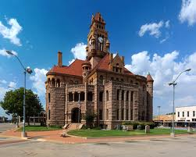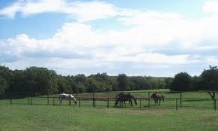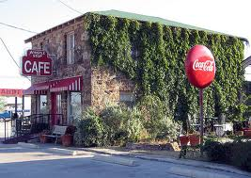
The community of Decatur, Texas is 38 miles north of the Fort Worth, Texas metropolitan area and less than an hour from the DFW International Airport. The population as of 2015 was 6,339, an increase of 27% since 2000. The area is a combination of rural and urban communities which make Decatur’s community culture “out of the ordinary” but an ideal place to call home. Decatur holds dearly to its western heritage as a stop on the famed Chisholm Trail. Decatur is the county seat for Wise County. The county’s current population is 59,127.
Agriculture and the oil and gas industry are the biggest private industries today in the Decatur area but several other major employers make their home in Decatur. Other industries are within a 30-minute commute to Denton, Dallas, or Fort Worth without the hassle of big city traffic.
Traffic problems, violent crime and fear are virtually nonexistent. Children are safe without having to sacrifice a quality education. Families are moving here because of award-winning schools and an outstanding regional health facility. Churches of most denominations are located in Decatur and Wise County. Decatur is home to several major hotel chains with numerous restaurants and fast food chains.
Decatur has experienced phenomenal growth in the past several years. Average prices for a three bedroom, two baths home are $145,000. Rental homes average $900-$1,300 a month and government housing is not available.
http://www.areavibes.com/decatur-tx/cost-of-living/
The climate in Decatur has relatively moderate winters and warm summers. The average winter temperature is around 45 degrees while the summers average 10-12 days above 100 degrees. The annual average precipitation is 42 inches and average snowfall 3.9 inches. Spring and fall seasons provide beautiful weather. Decatur’s elevation is 1,111 feet above sea level which is the second highest elevated county seat in the state of Texas.
Helpful Links:
National Forests and Grasslands in Texas  http://www.fs.fed.usda.gov/texas | Wise County Messenger  http://www.wcmessenger.com
State of Texas  http://www.texas.gov/ | Wise County Directory of Area Churches  http://www.wcmessenger.com/church
City of Decatur  http://www.decatur.org/ | Decatur Independent School District  http://www.decaturisd.us/
Decatur Chamber of Commerce  http://www.decaturtx.com/ | Wise Regional Health System  http://www.wiseregional.com./

Contact Information:

If you are interested in the position and want to receive more information, please complete the attached form and send it via email to Austin Sewell (rasewell@fs.fed.us) with a cc to Jeff Stoney (jstoney@fs.fed.us) at the National Forests and Grasslands in Texas-Caddo/LBJ Grasslands Ranger District. You can also call 940-627-5475.

The form may also be mailed to:

National Forests and Grasslands in Texas
Caddo/LBJ Grasslands Ranger District
Attn: Austin Sewell
1400 N. Highway 81/287
Decatur, Texas 76234

