Tierra Seca
University of Arizona Student Chapter
Society for Range Management


College of Agriculture and Life Sciences
School of Natural Resources and the Environment

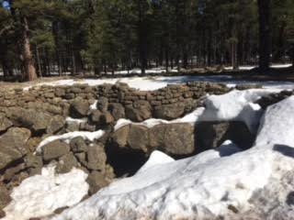
- Tierra Seca Meeting Agenda 3/22/2016

- Call to Order: 12:00 PM
  - Members in attendance: Rachel, Clara, Maria, Josh, James, Brett, Austin, Ben, Zach, Adrianne,Brandon
  - Faculty: Mitch McClaran
- President’s Report:
  - Introductions
  - Semester meeting dates: 3/22, 4/5, 4/19

  - Events report
Flagstaff Arizona, Highway 180

  - Upcoming Events

1) Geo Week/ SNRExpo
1) When March 27th – 31st
2) March 30th: Table set up
Volunteers? 9:00 -12:00pm, 1:00 -3:00pm

2) Raffle:
1) Ends April 27th at the awards ceremony
2) Sell your heart out

3) Possible ranch tour with the Pima County Natural Resource parks and Rec:
1) Canoa Ranch tour morning tour, Austin, James
2) April 15th

4) Elections of new officers for 2017-2018:
1) Nominations Vote: 4/5th

5)Agricultural Inter-Club Event
1) April 22nd, 10:30am – 2:30pm

- Vice President’s Report:
  - Adaptive Management
(1) Las Cienegas

- Treasure’s Report:
  - Dues ($10 per semester)
    - Paid dues: Josh (Full year), James, Morgan, Brett, Damian (Full Year), Amber, Flavie, Clara, Maria, Rachel (Full year)
  - Account balances: Checking:3875.78 Savings:395.67 Cash: 126.00 Now accepting all credit cards.

- Miscellaneous:
  - Work with Austin over the summer
    - Interested
  - Club hike:
    - When: March 25th? 8:00AM Babadoa? Contact Clara for details
    - Meeting in ENR2 garage

  - Arroyo Chico Wash cleanup led by Katie Hughes
    - Sat March 27th 830
    - Thursday April 13th
Times:
11:15-11:50 am Brandon
1-1:35pm
3:50-4:25pm

  - Facebook committee:
    - Alonso took over
  - T-shirts
  - Tierra Seca items:
    - Stickers $1
    - Koozies $3
    - T-Shirts $10
    - Hats $20
  - SNRE seminars
    - Every Wednesday in S107- ENR2 from 3:00-4:00pm
  - Fundraising: Agri-life counsel
    - Fridays with Agri-life at campus farm:
      - Split up shifts for fundraising
      - Volunteers:

  - Other new business or discussion?
- Wildlife Club Fence project looking for volunteers 14-16 April with Arizona Antelope foundation Contact Josh or Ben Morrison
- Possible fundraising to help Producers affected by the wildfires in partnership with SRM Student Conclave and SRM young Professionals Conclave contact James at jpagan@email.arizona.edu

7) Adjournment: PM

Facebook club link: https://www.facebook.com/uofatierraseca
President: Joshua Sutter joshuasutter@email.arizona.edu
Vice President: Clara Miller claramiller@email.arizona.edu
Secretary: James Pagan jpagan@email.arizona.edu
Treasurer: Rachel Turner rachelturner@email.arizona.edu
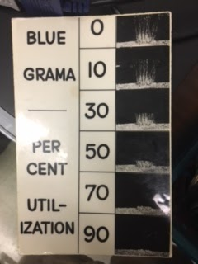

Grama Grama Grama……… Grama….

