Tierra Seca
University of Arizona Student Chapter
Society for Range Management
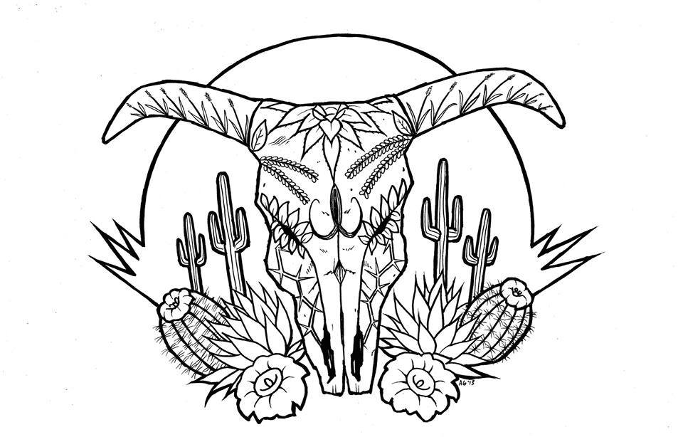

College of Agriculture and Life Sciences
School of Natural Resources and the Environment

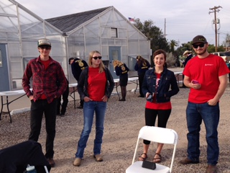

- Tierra Seca Meeting Agenda 3/08/2016

- Call to Order: 12:00 PM
  - Members in attendance: Rachel, Clara, Maria, Josh, James, Brett, Austin, Alonso, Zach
  - Faculty: Mitch McClaran
- President’s Report:
  - Introductions
  - Semester meeting dates: 3/8, 3/22, 4/5, 4/19
CDE Day 2017: U of A Campus Farm
Photo cred: Dr. Howery

  - Events report
1) Social on ENR 2
2) CDE Day

  - Upcoming Events

1) Geo Week
1) When March 27th – 31st
2) March 30th: Need some kind of activity, Ideas?

2) Raffle:
1) Start March 8th,
2) Ends in April 27th at the awards ceremony

3) Possible ranch tour with the Pima County Natural Resource parks and Rec:
1) April?

4) Spring Break!

f) Elections of new officers for 2017-2018:
(1) Nominations: 4/5th
(2) Speech/vote: 4/19th

- Vice President’s Report:
  - Adaptive Management
(1) Las Cienegas

- Treasure’s Report:
  - Dues ($10 per semester)
    - Paid dues: Josh (Full year), James, Morgan, Brett, Damian (Full Year), Amber, Flavie, Clara, Maria, Rachel (Full year)
  - Account balances: Checking:3875.78 Savings:395.67 Cash: 196.00

- Miscellaneous:
  - Work with Austin over the summer
    - Interested
  - Club hike:
    - When: March 25th? 8:00AM Babadoei? Contact Clara for details meeting in ENR2 garage
  - Arroyo Chico Wash cleanup led by Katie Hughes
    - Saturday April 8th at 9am
  - Facebook committee:
    - Alonso took over
  - T-shirts
  - Tierra Seca items:
    - Stickers $1
    - Koozies $3
    - T-Shirts $10
    - Hats $20
  - SNRE seminars
    - Every Wednesday in S107- ENR2 from 3:00-4:00pm
  - Fundraising: Agri-life counsel
    - Fridays with Agri-life at campus farm:
      - Split up shifts for fundraising
      - Volunteers:

  - Other new business or discussion?

7) Adjournment: PM

Facebook club link: https://www.facebook.com/uofatierraseca
President: Joshua Sutter joshuasutter@email.arizona.edu
Vice President: Clara Miller claramiller@email.arizona.edu
Secretary: James Pagan jpagan@email.arizona.edu
Treasurer: Rachel Turner rachelturner@email.arizona.edu
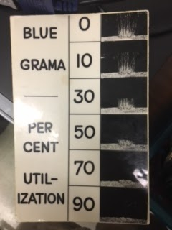

Grama Grama Grama……… Grama….

