Tierra Seca
University of Arizona Student Chapter
Society for Range Management
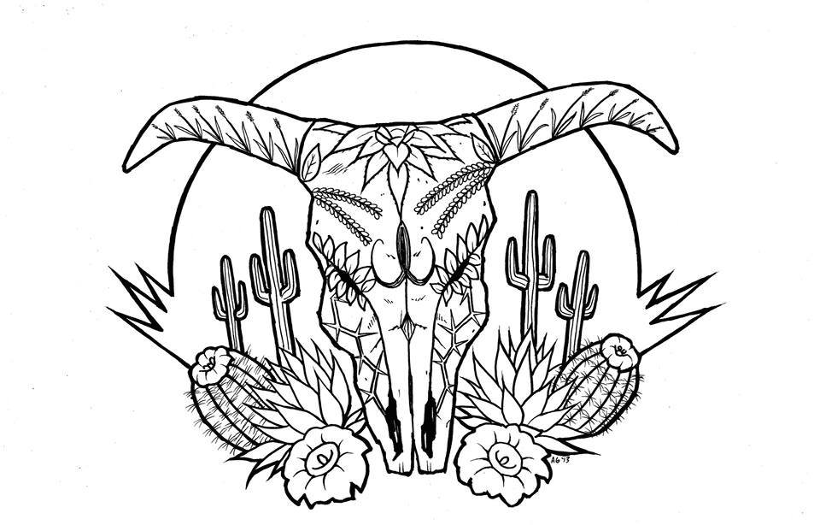

College of Agriculture and Life Sciences
School of Natural Resources and the Environment

- Tierra Seca Meeting Agenda 2/08/2016

- Call to Order: 12:00 PM
  - Members in attendance: Rachel, Clara, Maria, Josh, James, Brett, Adriane, Austin, Damian, Alonso,
  - Faculty: Mitch McClaran
- President’s Report:
  - Introductions
  - Semester meeting dates: 2/8, 2/20, 3/8, 3/22, 4/5, 4/19

  - Events report
1) 2017 SRM meeting in St. George, Utah
Picture credit: A nice friendly SRM professional.
Taken at the St. George SRM meeting
  - Upcoming Events

1) Geo Week
1) When March 27th – 31st
2) March 30th: Need some kind of activity, Ideas?

2) Raffle:
1) Emailed Betsy: End of February Beginning of March

3) CDE day:
1) March 3rd

f) Elections of new officers for 2017-2018:
(1) Nominations: 4/5th
(2) Speech/vote: 4/19th

- Vice President’s Report:
  - Adaptive Management
(1) Las Cienegas

- Treasure’s Report:
  - Dues ($10 per semester)
    - Paid dues: Josh (Full year), James, Morgan, Brett, Damian (Full Year), Amber, Flavie, Clara, Maria, Rachel (Full year)
  - Account balances: Checking: Savings: Cash:

- Miscellaneous:
  - Club hike: ?
    - When:
  - Arroyo Chico Wash cleanup led by Katie Hughes
i) Saturday at 9am
  - Facebook committee:
i) Alonso took over
  - T-shirts
  - Tierra Seca items:
    - Stickers $1
    - Koozies $3
    - T-Shirts $10
    - Hats $20
  - SNRE seminars
    - Every Wednesday in S107- ENR2 from 3:00-4:00pm
  - Fundraising: Agri-life counsel
    - Fridays with Agri-life at campus farm:
      - Split up shifts for fundraising
      - Volunteers:

  - Other new business or discussion?

7) Adjournment: PM

Facebook club link: https://www.facebook.com/uofatierraseca
President: Joshua Sutter joshuasutter@email.arizona.edu
Vice President: Clara Miller claramiller@email.arizona.edu
Secretary: James Pagan jpagan@email.arizona.edu
Treasurer: Rachel Turner rachelturner@email.arizona.edu
I love Buffelgrass!.......... Wait what?

