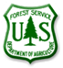
Coronado National Forest
Outreach Notice
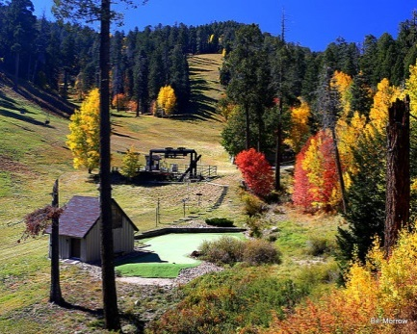
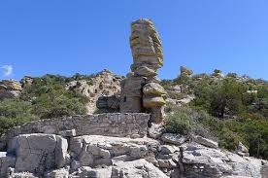
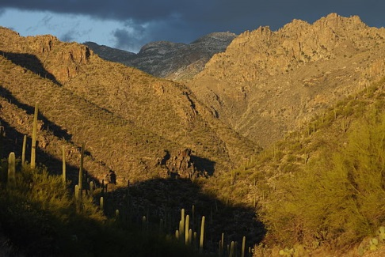

Join our team on the Coronado National Forest!
17-TEMP-S3-0455-4RNGT-DT, GS-0455-04 Range Technician
17-TEMP-S3-0404-4BSNR-DT, GS-0404-04 Biological Science Technician
17-TEMP-S3-0455-3RA-DT, GS-0455-03 Range Aid

The Coronado National Forest will soon be filling multiple temporary positions to assist the Range and Watershed Programs on the Forest. The duty station for all of the positions will be in Tucson, AZ at the Supervisor’s Office. The announcement numbers and the opening and closing dates are below.

General Duties:
These positions will be assembled to conduct field validations of range and non-range water developments across the forest. In conjunction with this work a variety of other data would be collected to include: Checks range allotments to assess appropriate time to graze, compliance with management plans and operating instructions, number of livestock, herding procedures, salting, range improvement, maintenance, and the need for additional range improvements such as fences or water development. Inspects allotments before and after grazing for trespass stock and if found, gathers necessary brands, numbers, dates, and locations. Reports non-compliance or other management needs to the supervisor. Performs a variety of tasks relating to natural resources, i.e., water, land, food, plants, animals, and soils. Assignments are performed within established methods, techniques, and procedures. Utilizes topographic maps; photographs, and data that identify a variety of natural resource areas and conditions. Transfers data from field notes to maps or aerial photos to show vegetation types, conditions and trends, and soil types. Compiles data for use in plans and records.

ABOUT THE FOREST
The Coronado National Forest covers 1,780,000 acres of southeastern Arizona and southwestern New Mexico. Elevations range from 3000 feet to 10,720 feet in twelve widely scattered mountain ranges or "sky islands". These mountains rise dramatically from the desert floor, supporting plant communities as biologically diverse as those encountered on a drive from Mexico to Canada.

Views are spectacular from these mountains, and visitors may experience all four seasons during a single day's journey, wandering through the desert among giant saguaro cactus and colorful wildflowers in the morning, enjoying lunch beside a mountain stream, and playing in the snow later in the afternoon. The sky islands of the Coronado National Forest are unique and surprising, offering year-round recreation opportunities.

GS-0455-04 Range Technician
Announcement: 17-TEMP-S3-0455-4RNGT-DT, GS-0455-04 Range Technician

Opens: 3/9/2017 - Closes: 3/13/2017

You can access this announcement on the date the job opens which is indicated above with the number listed as the announcement # or the USAjobs control # 465054300 in USAjobs.

GS-0404-04 Biological Science Technician
Announcement: 17-TEMP-S3-0404-4BSNR-DT, GS-0404-04 Biological Science Technician

Opens: 3/9/2017 - Closes: 3/13/2017

You can access this announcement on the date the job opens which is indicated above with the number listed as the announcement # or the USAjobs control # 465046200 in USAjobs

GS-0455-03 Range Aid
Announcement: 17-TEMP-S3-0455-3RA-DT, GS-0455-03 Range Aid

Opens: 3/9/2017 - Closes: 3/13/2017
You can access this announcement on the date the job opens which is indicated above with the number listed as the announcement # or the USAjobs control # 465051500 in USAjobs.

Contact Info:
For Additional information please contact: James Heitholt, Forest Range Program Manager 520-388-8372, jheitholt@fs.fed.us

