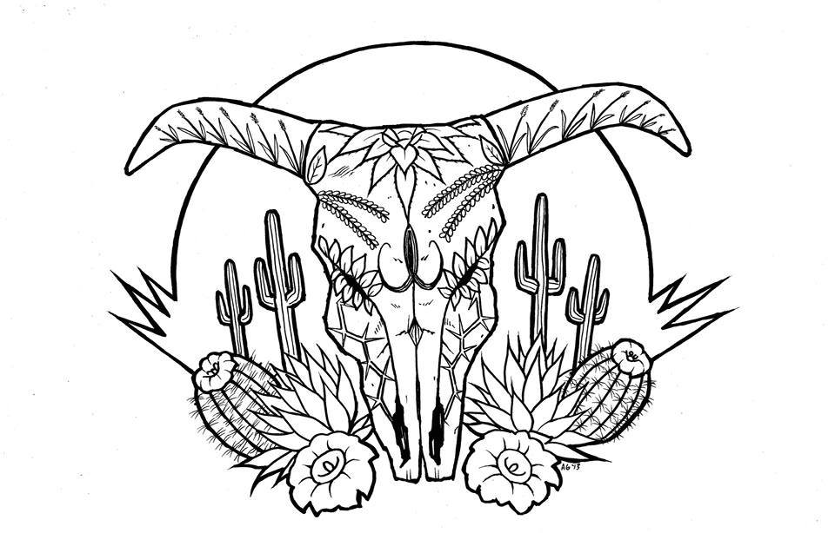
Tierra Seca invites you to the 3rd annual Range Management Social!
- Get together with your fellow students and faculty of SNRE
- Open to any interest students of any major, not just range!
- Tierra Seca will be providing food.
- Great opportunities with great events coming up
Where: The roof of Environment and Natural Resources 2
When: Monday, February 20th from 2pm to 4pm
Contact Josh with any questions: joshuasutter@email.arizona.edu
Hope to see you there!

Range Management Social
Hosted by: Tierra Seca

