Tierra Seca
University of Arizona Student Chapter
Society for Range Management


College of Agriculture and Life Sciences
School of Natural Resources and the Environment

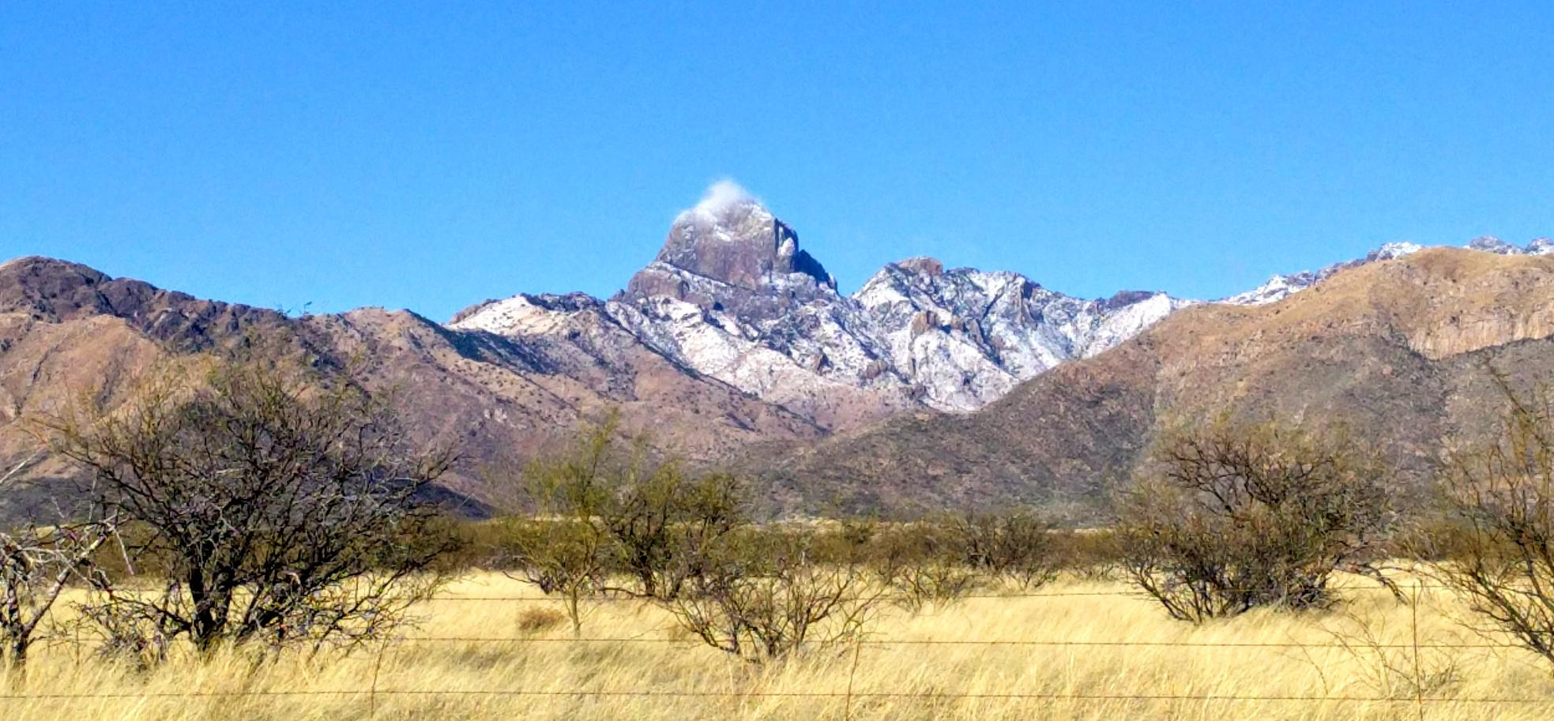
- Tierra Seca Meeting Agenda 10/10/2016

- Call to Order: 12:00 PM
  - Members in attendance:
  - Faculty: Mitch McClaran
- President’s Report:
  - Introductions
  - Semester meeting dates: 1/25, 2/8, 2/22, 3/8, 3/22, 4/5, 4/19

  - Earth/Geo week
1) Guest speaker: Karla Vargas
Picture credit: Hennessy Miller: South of Tucson near AZ Pipeline

  - Events report
1) Winter meeting in Tucson

  - Upcoming Events

1) URME
1) St George: Leave on Sunday
2) 1/29 - 2/02/2017
3) Any questions?

2) Buffel grass pull:
1) Saturday, February 11th- 8am to Noon
2) Saturday, March 11th- 8 am to Noon

3) SNRE Social hosted by Tierra Seca:
1) When: February 20nd 2pm-4pm
2) Where: ENR 2, BSE

4) Geo Week
1) When March 27th – 31st
2) March 30th: Need some kind of activity, Ideas?

5) Raffle:
1) Emailed Betsy: will set up time to start and end

f) Elections of new officers for 2017-2018:
(1) Nominations: 3/22nd
(2) Speech/vote: 4/19th

- Vice President’s Report:
  - SNRE Social

- Treasure’s Report:
  - Dues ($10 per semester)
    - Paid dues: Josh (Full year), James, Morgan, Brett, Damian (Full Year), Amber, Flavie, Clara, Maria, Rachel (Full year)
  - Account balances: Checking: 3771.69 Savings: 395.59 Cash: 335.25

- Miscellaneous:
  - Club hike: 3/4th
    - Mt. Lemon?
  - Arroyo Chico Wash cleanup led by Katie Hughes
  - Facebook committee
  - T-shirts
  - Tierra Seca items:
    - Stickers $1
    - Koozies $3
    - T-Shirts $10
    - Hats $20
  - SNRE seminars
    - Every Wednesday in S107- ENR2 from 3:00-4:00pm
  - Fundraising: Agri-life counsel
    - Fridays with Agri-life at campus farm:
      - Split up shifts for fundraising
      - Volunteers:

  - Other new business or discussion?

7) Adjournment: PM

Facebook club link: https://www.facebook.com/uofatierraseca
President: Joshua Sutter joshuasutter@email.arizona.edu
Vice President: Clara Miller claramiller@email.arizona.edu
Secretary: James Pagan jpagan@email.arizona.edu
Treasurer: Rachel Turner rachelturner@email.arizona.edu
Buffelgrass… … … ... … … … … … … …

