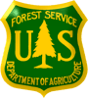
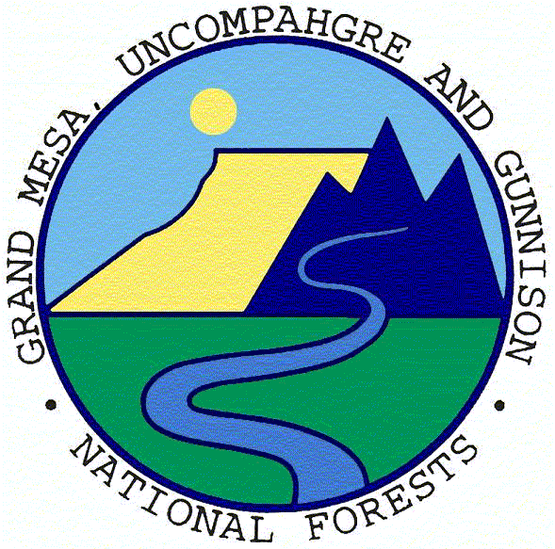
Outreach Notice

USDA Forest Service -R2 Rocky Mountain Region
Grand Mesa, Uncompahgre and Gunnison NF

Gunnison, Colorado

Rangeland Management Specialist

GS-0454 -9 Permanent (potential 2 positions)

Reply by: January 8, 2017

The Grand Mesa, Uncompahgre and Gunnison (GMUG) National Forest (NF), will be advertising to fill a permanent Rangeland Management Specialist position. The duty station is located at the Gunnison Ranger District Office in Gunnison, Colorado. This outreach notice is being circulated to inform prospective applicants of the upcoming opportunity and to identify the level of interest for this position.

Rangeland Management Specialist GS-9: The rangeland management specialist assists with developing rangeland management plans, utilizing resource management goals and objectives and implementing on the ground management decisions. The Gunnison Ranger District multiple-use rangeland resource area consists of 39 permittees, 54 active allotments, in which three are domestic sheep and the remaining are cattle. The rangeland specialist will work independently administering an ecosystem based rangeland management program and related resource coordination with other specialists as well as administration of permits. The incumbent will assist with preparing long and short-term plans based on rangeland resource needs and helping plans rangeland improvement projects. This individual will also serve as an interdisciplinary team member and occasional leader of planning teams for management activities and will provide support to forest plan monitoring and forest plan revision. The rangeland management specialist needs to have strong written and verbal communication skills, and the ability to represent the range resource in a team environment. Horsemanship skills and ATV/UTV skills are highly desirable. This position should have the ability to manage and account for project-level budgets and have some working knowledge of geographic information systems and statistical database systems. Challenging work assignments await the future occupant of this position. If you are interested in working with partnerships, reaching beyond boundaries and continuing a legacy of community involvement and accomplishment, this position is for you!

Assists in range billing, permittee meetings, AOI development and annual mailings. Expected to design, estimate materials/cost, procure materials, implement, and inspect various types of range improvement projects. Gathers and assembles data concerning rangeland health, trends, and ecological status of vegetation communities, site potential and desired plant community.
Compiles material and supply estimates, or oversees compilation of estimates for facilities construction and maintenance of rangeland projects Prepares rangeland improvement maintenance schedules and keeps records of existing and proposed improvements, maintenance needs, and accomplishments.
Assists in the administration of grazing permits by consulting, coordinating and cooperating with permittees and other rangeland users. Prepares and/or revises annual rangeland user instructions. Makes recommendations for improved rangeland and livestock administration and provides input into the development of subsequent rangeland and livestock management decisions.
Determines rangeland readiness for various rangeland uses, inspects rangeland uses for compliance with permits, and monitors the results of the rangeland uses that are permitted or allowed. Determines permittee compliance with permits and makes recommendations to correct discrepancies. Investigates unauthorized livestock uses and takes direct action for removal of unauthorized/trespass livestock. Works closely with permittees and other livestock owners to prevent further unauthorized use.
Surveys for the presence of noxious weeds and documents such occurrence. Informs supervisor of unusual or important situations such as new invader species, major population changes, and other significant changes. Treats noxious weeds using chemical, manual, and/or biological control. Keeps records of all treatment applications, monitors effectiveness, and enters information into the database of record (daily spray activity, accomplishments, problem areas, and herbicide usage).
Coordinates with adjacent private landowners; county weed superintendents; and state, local and other federal agencies to further integrate comprehensive weed control measures. Identifies potential treatment sites and possible courses of action to control or eradicate noxious weed populations in given locations.
About the GMUG Forest: The GMUG National Forest encompasses 5,000 square miles on the Western Slope of the Colorado Rockies, about 250 miles west of Denver, in west-central Colorado. This forest has five Ranger Districts: Grand Valley with offices in Collbran and Grand Junction, Paonia office is located in Paonia, Gunnison office is located in Gunnison, Ouray office is located in Montrose, and Norwood office is located in Norwood. The Supervisor's Office is located in Delta, Colorado.

The GMUG NF contains 3,163,131 acres with some of the most spectacular scenery in the Rockies with elevations ranging from 6,000 feet to over 14,000 feet. The climate at lower elevations is warm and arid while the high country is cold in the winter and warm most of the summer months. The Forest is an ideal winter and summer recreation area. The Forest has three ski areas, 43 communities, and a 12,000 square mile area of influence that includes a 250,000 population. Cost of living is one of the lowest in the country in lower elevations and among the highest in the country near the ski areas. For additional forest information, visit the internal website: http://fsweb.gmug.r2.fs.fed.us/ and external web site: http://www.fs.fed.us/r2/gmug/

What we are looking for in a Candidate: The Gunnison Ranger District of the Grand Mesa, Uncompahgre, and Gunnison National Forests in Gunnison, Colorado is looking for enthusiastic, self-motivated, outdoor-oriented people to join our team. The physical setting is stunning and the work is diverse and challenging. To be successful in this job you must be a self-starter and have a demonstrated track record of leading people in an ever-changing environment. You must be willing to take on challenges and provide innovative solutions to complex problems. Successful candidates must have excellent communication skills and be able to work collaboratively with external partners. We are looking for candidates who can lead a team of dynamic and creative leaders. Applicants should be willing to invest in the coaching, mentoring and development of our employees.

Community Information: Gunnison is located close to the middle or Colorado, but is in the southwestern part. Gunnison is approximately 30 miles west of the Continental Divide and is at the confluence of the Gunnison and Tomichi Rivers. Gunnison is 200 miles from Denver and 180 miles from Colorado Springs, which are the two major metropolitan areas of the state. The Gunnison District is a playground for enthusiasts of all kinds from many places. There is backcountry hiking, mountain biking, downhill skiing, motorized OHV’s are very common recreation activities, along with guided and self-guided rafting on the Taylor River, and many other activities. The 2 ski resorts close by are Crested Butte ski area, which is about 28 miles north, and Monarch Mountain Ski Resort, that is about 48 miles east.

The Gunnison Ranger District is comprised of 1,354,870 acres on lands within Gunnison, Saguache, and Hinsdale Counties and includes all or part of eight wilderness areas and a Congressionally-designated Recreation Management Area. Gunnison sits at an elevation of 7,703 feet and it encompasses 3,239 square miles. Gunnison has a continental climate, boasting an average of 266 days of sunshine annually and four distinct seasons. The city averages 10.4 inches of liquid precipitation annually, of which 51 inches fall as snow. The surrounding mountains average between 300 and 350 inches of snow annually. The average July high in the city is 81 degrees and the average January low is -7 degrees. Snow is typically on the ground continuously from December through mid-April.

The City of Gunnison is located in west-central Colorado approximately a four hour drive (200 miles) southwest of Denver and a 2 ½ hour drive (125 miles) southeast of Grand Junction. Gunnison is approximately 30 miles west of the Continental Divide at the confluence of the Gunnison River and Tomichi Creek. The Crested Butte Ski Area resides on the Gunnison Ranger District.

78% of Gunnison County is Federal Land. The U.S.F.S. owns 1,220,035 acres, the BLM owns 355,350 acres, and Curecanti National Recreation Area owns 40,000 acres, and equals a total of 2,526 square miles. The population for Gunnison is about 5,900 people in the city and around 15,500 people in the county.

The Gunnison area—locally known as Gunnison Country--is widely known for its outdoor recreation opportunities. Such activities include: hiking; mountain biking; dirt biking; horseback riding; rock climbing; rafting; kayaking; skiing (both downhill and cross country); fishing; golfing; and hunting. Gunnison is a full service community with a local hospital.

More information about the Gunnison area can be obtained from the Gunnison Chamber of Commerce at http://www.gunnison-co.com/. You can also contact the Gunnison Country Chamber of Commerce at 970-641-1501 or 800-274-7580. Additional information about Gunnison: http://www.colorado.com/cities-and-towns/gunnison.

Responding to Outreach: If you are interested in this position, complete the attached outreach response form and please send to electronically to Dan Perez at dlperez@fs.fed.us or fax to 970-642-4425. You may also mail it to 216 N. Colorado Street, Gunnison, CO 81230. You may contact Dan Perez at 970-641-0471 for specific questions about the position.

* Please note: The purpose of this Outreach Notice is to determine the potential applicant pool for this position and to establish the appropriate method and area of consideration for the advertisements. Responses received from this outreach notice will be relied upon to make this determination.
OUTREACH RESPONSE FORM

Rangeland Management Specialist, GS-0454-9
USDA Forest Service, R2-Rocky Mountain Region
Grand Mesa, Uncompahgre and Gunnison NF
Please respond by January 8, 2017 to:
Daniel Perez at dlperez@fs.fed.us or fax 970-642-4425 or mail:
216 N. Colorado Street, Gunnison, CO 81230
You may also contact Daniel Perez at 970-641-0471, for specific questions about this position.

Name: |  | Phone W:
Email: |  | Phone H:
 |  | Phone C:

Current Employer
USDA FS Unit:
Other:
Location:

If Federal Employee, Type of Appointment
Permanent |  | Temporary |  | Student/  Intern |  | Contractor |  | Other
Current Position Title: |  |  |  |  | Series/Grade:

How did you hear about this position?
Agency Contact:
Other:

If not a current permanent employee, are you eligible to be hired under any of the following special authorities?
☐ Schedule A (persons with disabilities)
☐ Veterans Recruitment Act (VRA)
☐ Veterans with 30% Compensable Disability
☐ Veterans Employment Opportunities Act (VEOA) of 1998
☐ Former Peace Corps Volunteer
☐ Pathways Program (Students, Interns and Recent Graduates)
☐ Public Land Corps (PLC)
☐ Land Management Workforce Flexibility Act (Temporary/Term Land Management Agency Employees)
☐ Other: <please elaborate>

Submission of this form is voluntary – Thank you for your interest

