Tierra Seca
University of Arizona Student Chapter
Society for Range Management
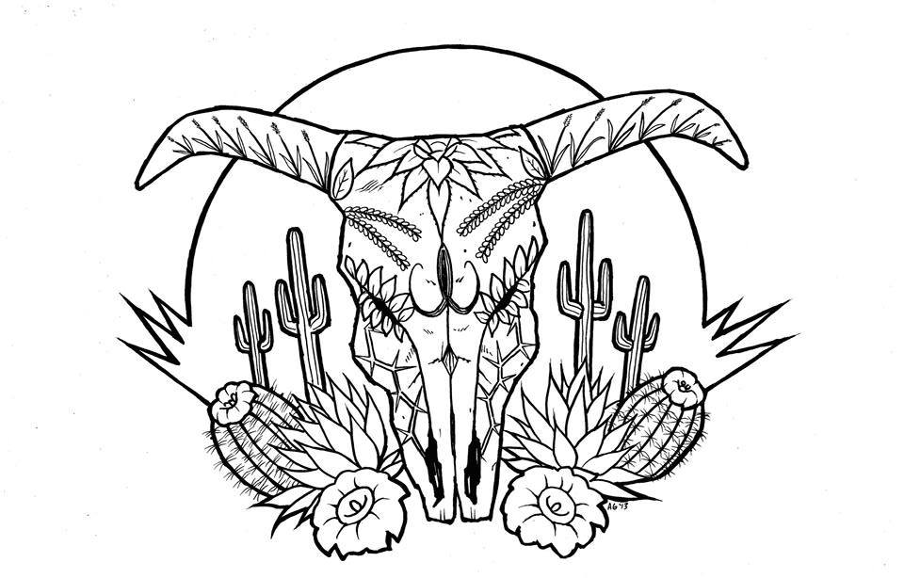

College of Agriculture and Life Sciences
School of Natural Resources and the Environment

- Tierra Seca Meeting Agenda 9/12/2016

- Call to Order: 12:00 PM
  - Members in attendance: James ,Rachel, Morgan, Bret, Flavia , Amber, Damien, Austin, Maria, Alonso, Clara, Janie, Adriane, Josh,
  - Faculty: Mitch McClaran
- President’s Report:
  - Introductions
  - Semester meeting dates: 9/26, 10/10, 10/24, 11/7, 11/21
  - Upcoming Events
    - Range Meet-up 9/16 10-1230
AZ pipeline, past Three point. 2016
Set up starts 0930
      - Planning: Video in loop
      - Food: Mama’s
    - Rise Symposium 10/8 Potential for serving breakfast/coffee volunteer opportunity
      - Volunteers:
    - Elkhorn Ranch with Kyle Thompson monitoring Fri 11/4 (BSE at 830? Tentative meetup)
      - Volunteers: Flavie, Bob, Alonso, Maria, Amber, Tony, Josh
    - Dennis Moroni
    - V Bar V (TBD)
    - Dr. Marsh/ CALS Career Center:
      - Interested: Resume workshop for the Nat. Resources clubs info session for resume Building

- Vice President’s Report:
  - Morgan: URME/Plant ID
    - Dr. Howery, Sarah Noelle

- Treasure’s Report:
  - Dues ($10 per semester)
    - Paid dues: Josh, James, Bret, Damian, Flavia
  - Account balances: Checking: 4087.27 Savings: 395.55 Cash: 144.00

- Miscellaneous:
  - Field work at Rosemont copper mine:
    - Re-veg monitoring: Line point, cut/dry/weigh of plants, data entry
    - Contact Dr. Fehmi: jfehmi@email.arizona.edu
  - Field work with Sarah Noelle:
    - Contact Sarah Noelle: smnoelle@email.arizona.edu
  - Dean’s Breakfast burrito 10/29
  - Kickball with Wildlife/SNRE 10/22(depending on schedules)
    - Where: Hemil park
Funding request for the kickball
  - Club hike: 9/25, 11/12
    - Seven Falls 9/25, Mt. Lemmon 11/12 meet at BSE 0700
    - Bear Canyon
  - Arroyo Chico Wash cleanup led by Katie Hughes
    - Saturday (tbd)
  - Garden Plot: http://tierrasecauofa.wix.com/tierra-seca-garden
    - Clara is interested, Kelsey, Damien maybe.
  - T-shirt
Ideas: Josh put to vote possibly changing the color/shirt type for TS/URME
Voted on green color for the T-shirt URME shirt type color still undecided

  - Tierra Seca items:
    - Stickers $1
    - Koozies $3
    - T-Shirts $10
    - Hats $20
  - SNRE seminars
    - Every Wednesday in S107- ENR2 from 3:00-4:00pm
  - Fundraising: Agri life counsel
  - Other new business or discussion?
  - Mexican Baseball League Kino sorts complex
Club going to a Game possibly 1OCT

7) Adjournment: PM

Facebook club link: https://www.facebook.com/uofatierraseca
President: Joshua Sutter joshuasutter@email.arizona.edu
Vice President: Morgan Gourley mjgourle@email.arizona.edu
Secretary: James Pagan jpagan@email.arizona.edu
Treasurer: Rachel Turner rachelturner@email.arizona.edu

Lost coast trail, California. Summer 2016

