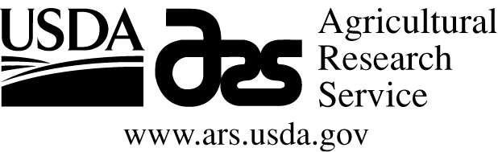

Career Opportunity at the Rangeland Resources Research Unit, Fort Collins, Colorado

The USDA, Agricultural Research Service, Rangeland Resources Research Unit, headquartered in Cheyenne, WY, is seeking a RESEARCH ECOLOGIST (Ecohydrologist, GS-0408-12), with a duty station of Fort Collins, CO, to serve on an interdisciplinary research team. Ph.D. is required. Salary range is $76,341.00 to $99,243.00 annually plus benefits. The Research Unit mission is to develop science-based management strategies for the provision of ecosystem goods and services from semiarid rangeland ecosystems. These strategies will be used to enhance decision-making by land managers using monitoring-informed adaptive management to improve resiliency and reduce risk for rangelands in a variable and changing climate. The incumbent’s specific objectives will be to understand soil to plant to ecosystem level water dynamics in the context of energy/carbon/water balances, ecosystem productivity, nutrient cycling, plant community dynamics, and associated linkages to livestock production related to1) management practices (e.g., livestock grazing, prescribed fire), 2) weather/climatic variability (including increased frequency and intensity of extreme events such as droughts and deluges, and changes in precipitation seasonality), and 3) topoedaphic variability. The incumbent will lead efforts at the Central Plains Experimental Range (a Long-Term Agro-ecosystem Research network (www.ars.usda.gov/ltar) site) regarding the acquisition and analysis of data from a network of soil moisture sensors, Eddy Covariance flux towers, and instrumented microwatersheds. The incumbent will be expected to 1) communicate technical information on ecohydrological processes related to livestock production and the provisioning of other ecosystem services within semiarid rangelands to improve predictions of how management and climatic variability interact to influence soil to plant to ecosystem level water dynamics at multiple temporal and spatial scales, 2) develop collaborations and lead projects that are integrated across the Long-Term Agro-ecosystem Research network which address ARS Grand Challenges, and 3) develop collaborations with other large-scale networks. Expectations of research are the improvement of predictions of how management and climatic variability interact to influence soil to plant to ecosystem level soil water dynamics at multiple temporal and spatial scales, ranging from plant-level physiology through ecosystem-level water and energy exchange, to landscape-level patterns of water movement, storage and use that affect livestock production. Interested? Go to www.usa.jobs.gov and search ARS-D16W-0428; applications MUST be received no later than 11:59 p.m. Eastern Time on the Closing Date (August 12, 2016) of the Vacancy Announcement.

U.S. Citizenship is required for all positions.
USDA/ARS is an Equal Opportunity Employer and Provider

