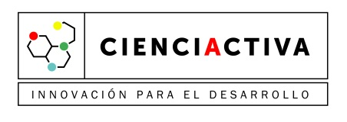



Universidad Nacional Agraria La Molina (Lima – Perú)
Rangeland Ecology and Utilization Laboratory

CALL FOR RESEARCHERS

Description:
The Rangeland Ecology and Utilization Laboratory (LEUP) ⁽¹⁾ of La Molina University (Lima - Peru) is seeking Adjunct and Postdoctoral Researchers to consolidate the research line “Ecology and Nutritional Management of Grazing Animals in Rangelands”.

Our Research Group is interested in studying the key aspects of nutritional ecology of high Andean livestock, with emphasis on South American camelids, and how this knowledge can be used to diminish the impacts of climate change on Andean rangeland.

Professional Profile:

Research experience and academic training in the following areas:

- Nutrition of Domestic and Wild Ruminants
- Nutritional Ecology of Herbivores
- Plant – Animal Interactions and Modelling
- Nutritional Behavior

Requirements:

- PhD in Ecology, Animal Science, Rangeland Science, Biology or related sciences
- Leading/ Participating experience in research projects
- Willingness to work on a full-time basis in Peru for 2 to 3 years

Salary (US Dollars):

- Adjunct Researcher: up to $ 5,000 monthly
- Postdoctoral Researcher: up to $ 3,000 monthly

Selected applicants will work in the contractual modality "Project Appointment", they will be hired by UNESCO and they will be part of the research staff of La Molina University.

Information:

For detailed position description or more information, interested applicants can send a mail to: efm@lamolina.edu.pe or lab_pastizales@lamolina.edu.pe

