Tierra Seca
University of Arizona Student Chapter
Society for Range Management
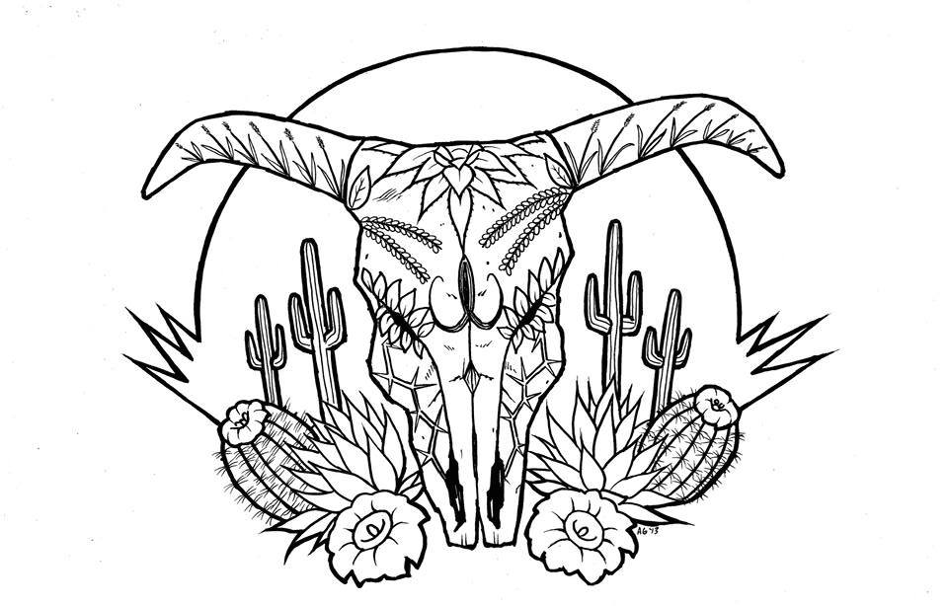

College of Agriculture and Life Sciences
School of Natural Resources and the Environment

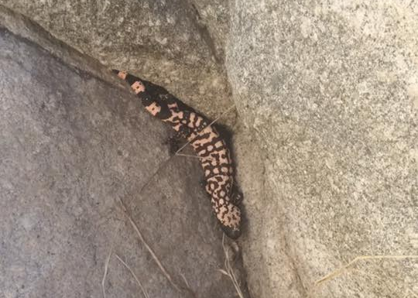
- Tierra Seca Meeting Agenda 4/6/2016

- Call to Order: 5:06 PM
  - Members in attendance: Sarah, Aaron, Rachel, Joey, James, Toby, Josh, Morgan, and Jennifer
  - Faculty: Dr. Larry Howery and Dr. Mitch McClaran
- President’s Report:
Adventurous gila monster on Arizona State
Trust Land near Saddlebrooke, AZ March 27, 2016
  - Introductions
  - Semester meeting dates: 4/6, 4/20
  - Upcoming Events
    - April 12th - Award ceremony 3:30 PM in ENR2-350
    - April 23rd – Camping – tagalong Dr. McClaran’s field trip
      - Talk to Morgan if you want to come!!!
    - May 14th – CALS Graduation
- Vice President’s Report:
  - Baseball Game
- Treasure’s Report:
  - Dues ($10 per semester)
    - Paid dues:
Gerry, Leland, Josh, Damien, Morgan, Jenn, James, Rachel, Joey, Toby
  - Account balances: Checking: $4194.10; Savings: $395.10 Cash: $233.00
- Miscellaneous:
  - Sheep and goat fecal samples – ask Joey to come help out!
  - Arroyo Chico Wash cleanup led by Katie Hughes
    - Saturday April 16th
  - 50/50 raffle – Ends April 12th at Awards Ceremony
    - $1 for a ticket; $5 for 6 tickets
  - Officer elections for 2016-17
    - President: Josh Sutter
    - Vice President: Morgan Gourley
    - Secretary: James Pagan
    - Treasurer: Rachel Turner
  - Garden Plot: http://tierrasecauofa.wix.com/tierra-seca-garden
    - Contact – Kelsey
  - T-shirt, hat, and sticker orders
  - Tierra Seca items:
    - Stickers $1
    - Koozies $3
    - T-Shirts $10
    - Hats $20
  - SNRE seminars
    - Every Wednesday in S107- ENR2 from 3:00-4:00pm
  - Fundraising
  - Other new business or discussion?
- Adjournment: 6:05 PM

Facebook club link: https://www.facebook.com/uofatierraseca
President: Leland Sutter lelandsutter@email.arizona.edu
Vice President: Rachel Turner rachelturner@email.arizona.edu
Secretary: Morgan Gourley mjgourle@email.arizona.edu
Treasurer: Joey Dahms dahmsjo@email.arizona.edu

