Tierra Seca
University of Arizona Student Chapter
Society for Range Management
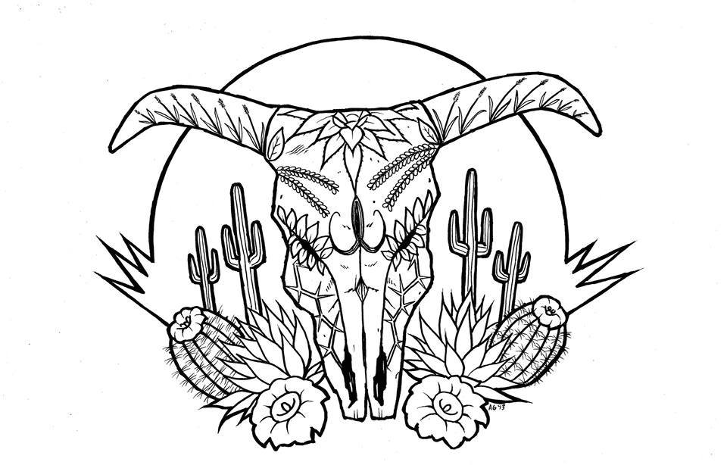

College of Agriculture and Life Sciences
School of Natural Resources and the Environment

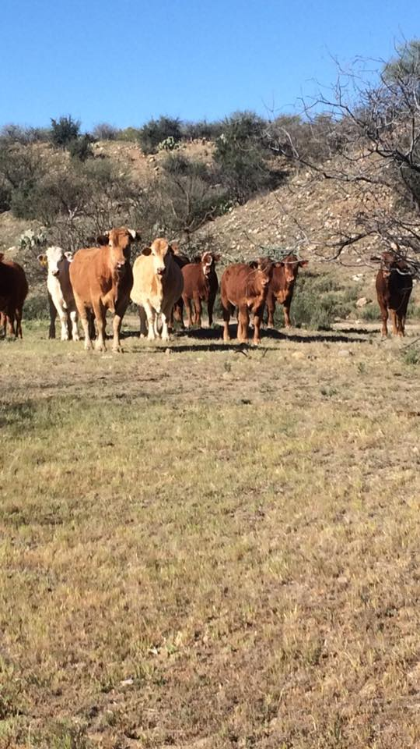
- Tierra Seca Meeting Agenda 3/23/2016

- Call to Order:
  - Members in attendance:
- President’s Report:
  - Introductions
  - Semester meeting dates: 3/23, 4/6, 4/20
  - Upcoming Events
Curious cattle on Arizona State Trust Land
near Saddlebrooke, AZ March 9, 2016
    - Kickball April 2nd
  - Cienega Club Sabino Creek invasive plant removal
  - Bufflegrass pull
  - Club steer
- Vice President’s Report:
- Treasure’s Report:
  - Dues ($10 per semester)
    - Paid dues: Gerry, Leland, Josh, Damien, Morgan, Jenn, James, Rachel, Joey
  - Account balances: Checking: $3663.10 ; Savings: $395.10 Cash: $238.00
- Miscellaneous:
  - Sheep and goat fecal samples
  - April 23rd – Camping
    - Mt. Graham – before and after Dr. McClaran’s fieldtrip
  - Arroyo Chico Wash cleanup led by Katie Hughes
    - Saturday March 26th
  - 50/50 raffle
  - Officer nominations
  - Garden Plot: http://tierrasecauofa.wix.com/tierra-seca-garden
    - Contact – Kelsey
  - T-shirt, hat, and sticker orders
  - Tierra Seca items:
    - Stickers $1
    - Koozies $3
    - T-Shirts $10
    - Hats $20
  - SNRE seminars
    - Every Wednesday in S107- ENR2 from 3:00-4:00pm
  - Fundraising
  - Other new business or discussion?
- Adjournment:

Facebook club link: https://www.facebook.com/uofatierraseca
President: Leland Sutter lelandsutter@email.arizona.edu
Vice President: Rachel Turner rachelturner@email.arizona.edu
Secretary: Morgan Gourley mjgourle@email.arizona.edu
Treasurer: Joey Dahms dahmsjo@email.arizona.edu

