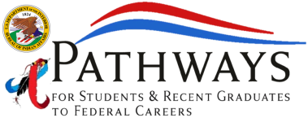
1849 C Street, NW
MS-4620-MIB
Washington, DC 20240

CURRENT JOB OPPENING

Bureau of Indian Affairs
Office of Trust Services
Internship Program

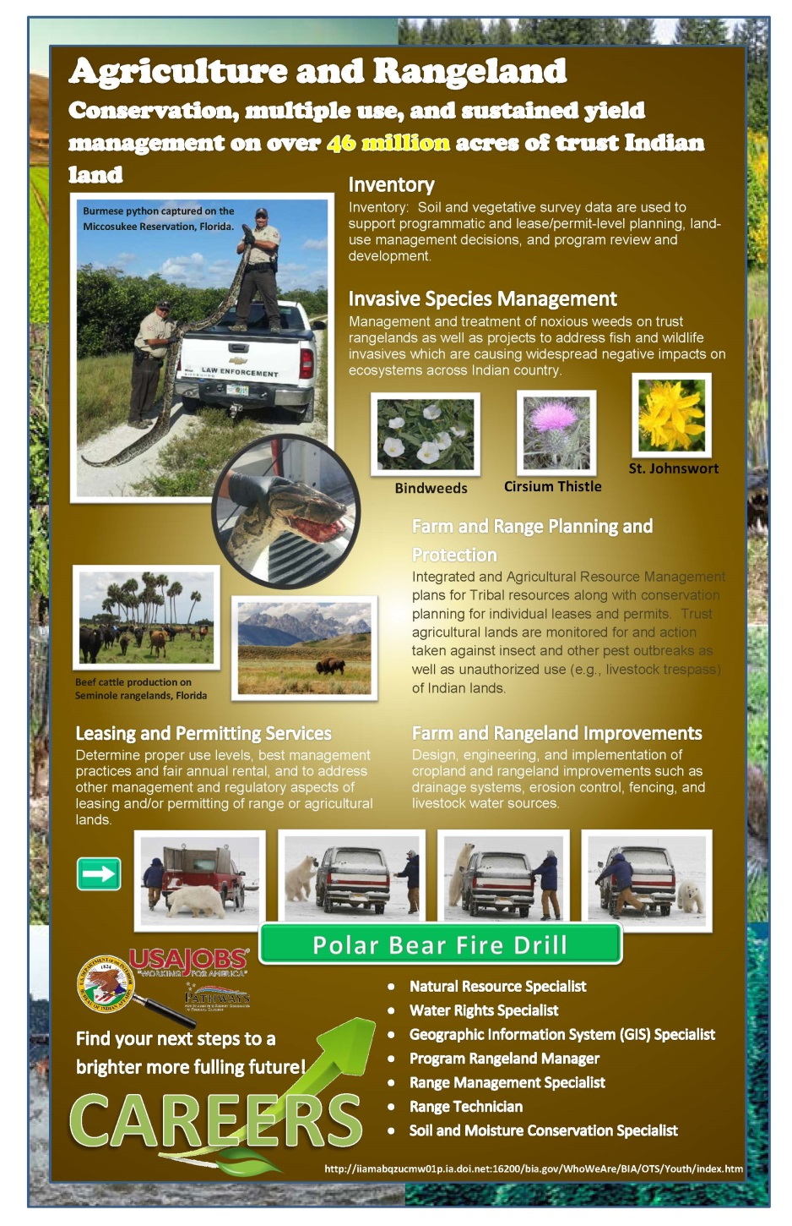
Job Title: Student Trainee (Rangeland Management), GS-0499-3/4
Department: Department Of The Interior
Agency: Interior, Bureau of Indian Affairs
Job Announcement Number: CO-16-32
https://www.usajobs.gov/GetJob/ViewDetails/431748300/

SALARY RANGE:
$25,731.00 to $37,551.00 / Per Year

OPEN PERIOD:
Friday, March 4, 2016 to Friday, March 25, 2016

POSITION INFORMATION:
Multiple Schedules - Internships NTE 1 YEAR, Option to extend 1 additional year

DUTY LOCATIONS:
Many vacancies in the following location: Location Negotiable After Selection, United States.
WHO MAY APPLY: ALL INDIAN PREFERENCE STUDENT/INTERNSHIP PROGRAM ELIGIBLES

PATHWAYS INTERNSHIP PROGRAM REQUIREMENTS:
- Must be at least 18 years of age.
- Enrolled in an accredited college or university seeking a bachelor's degree in agriculture resources or natural resources management academic program directly related to the position including, agricultural engineering, agricultural economics, animal husbandry, animal science, biological sciences, geographic information Systems, horticulture, range management, and soil science.
- Must have a cumulative GPA of 2.0 or higher.
- Must be taking a full time course load.
- Maintain a valid Pathways Program Participant Agreement.

1849 C Street, NW
MS-4620-MIB
Washington, DC 20240

CURRENT JOB OPPENING

Bureau of Indian Affairs
Office of Trust Services
Internship Program

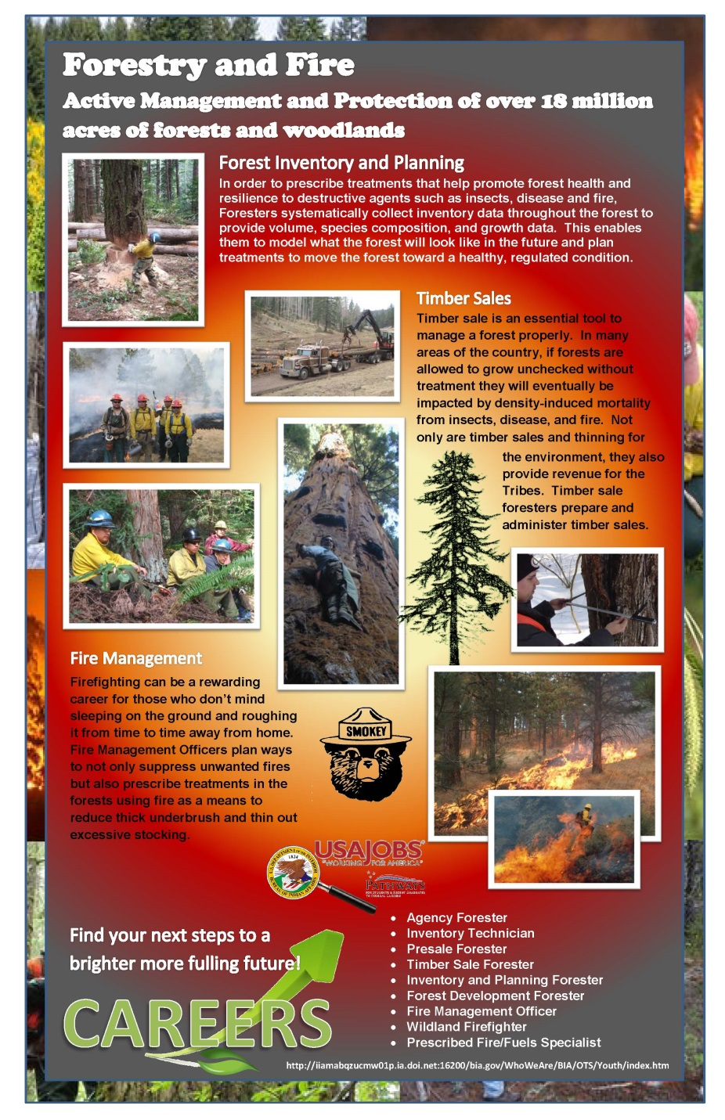
Job Title: Student Trainee (Forestry), GS-0499-3/4
Department: Department of The Interior
Agency: Interior, Bureau of Indian Affairs
Job Announcement Number: CO-16-29
https://www.usajobs.gov/GetJob/ViewDetails/429713100/

SALARY RANGE:
$25,731.00 to $37,551.00 / Per Year

OPEN PERIOD:
Tuesday, February 16, 2016 to Thursday, March 17, 2016

POSITION INFORMATION:
Multiple Schedules - Internships

DUTY LOCATIONS:
Many vacancies in the following location: Location Negotiable After Selection, United States.
WHO MAY APPLY: ALL INDIAN PREFERENCE STUDENT/INTERNSHIP PROGRAM ELIGIBLES

PATHWAYS INTERNSHIP PROGRAM REQUIREMENTS:
- Must be at least 18 years of age.
- Enrolled in an accredited college or university seeking a bachelor's degree in Must be enrolled full-time as a degree seeking student in a forestry or natural resources management related academic program.
- Must have a cumulative GPA of 2.0 or higher.
- Must be taking a full time course load.
- Maintain a valid Pathways Program Participant Agreement.

