

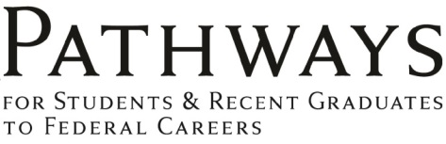
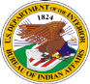

INTERNSHIPS

For American Indian and Alaska Natives Student

INTERNSHIP POSITIONS
Intern with the Bureau of Indian Affairs and expand your knowledge and networking possibilities in natural resources management, forestry, range, fire ecology and other related environmental and biological science fields.


PROGRAM BENEFITS
- Paid employment related to academic field of study

- Up to $5,000 tuition / education assistance *
- Rotational work assignments
- Travel and transportation
- Students are recruited nationally across Indian Country
- Do not have to have prior work experience
- Mentoring, training and career development opportunities
https://www.usajobs.gov/studentsandgrads/
- Flexible schedules
- Vacation, sick and holiday pay
- Life insurance, flexible spending accounts, health and retirement benefits
- Job-shadow with industry professionals
- Potential for non-competitive placement after graduation into a permanent professional entry-level BIA or tribal position.

* Not all internships offer tuition support, some internships are for summer employment only.

STUDENT ELIGIBILITY  - Be at least 18 years of age  - Show they are enrolled in a federally recognized tribe using Form BIA - 4432  - Must maintain a security clearance  - Sign and maintain a Participant Agreement  - Good academic standing and performance ratings  - Fully Successful or above performance ratings  - Some positions may also require a medical exam, drug testing, and a valid driver license and specific education certification or degree requirements. | AREAS OF STUDY (Not all listed)  - Biological Sciences  - Forestry  - Wildland Fire  - Agriculture and Rangeland  - Engineering and Architectural  - Physical Science  - Legal and Business
EDUCATION REQUIREMENTS  Students must be accepted for enrollment or enrolled and seeking a degree (diploma, certificate, etc.) in a qualifying educational institution, on a full or half-time basis. Because internship varies; please refer to the job vacancy announcement on USAJOBS for positions qualifications and requirements.  - GS-2 grade level: Completion of high school or GED diploma.  - GS-3 grade level: Completion of 1 academic year of post-high school study.  - GS-4 grade level: Completion of 2 academic years of post-high school study or associate's degree leading to a bachelor's degree in related academic discipline.  - GS-5 grade level: Completion of 4 academic years of post-high school leading to a bachelor's degree or equivalent degree.  One year of education is defined as 30 semester hours or 45 Quarter hours. | INTERN SALARY  Hourly Rate - Rest of United States Locality Pay Table  Previous education and/or experience may be evaluated to determine the highest grade / step level for which the individual is qualified.
  Grade | Step 1 |  | Step 10
  2 | $ 11.30 | - | $ 14.22
  3 | $ 12.33 | - | $ 16.03
  4 | $ 13.84 | - | $ 17.99
  5 | $ 15.49 | - | $ 20.13

