Tierra Seca
University of Arizona Student Chapter
Society for Range Management
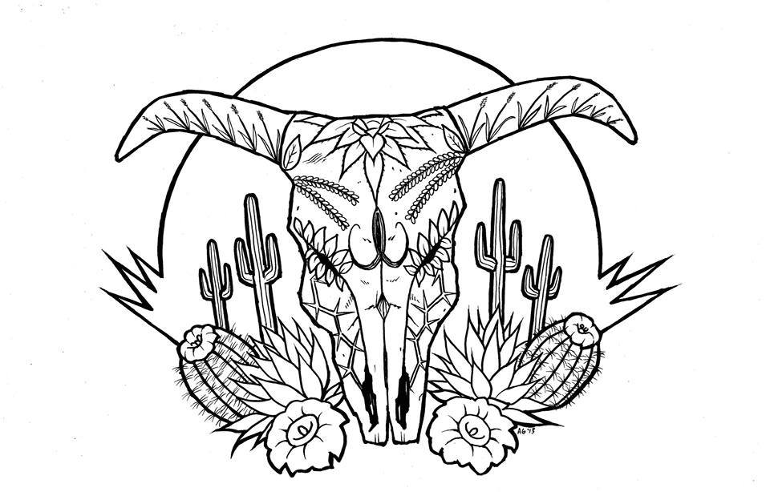

College of Agriculture and Life Sciences
School of Natural Resources and the Environment

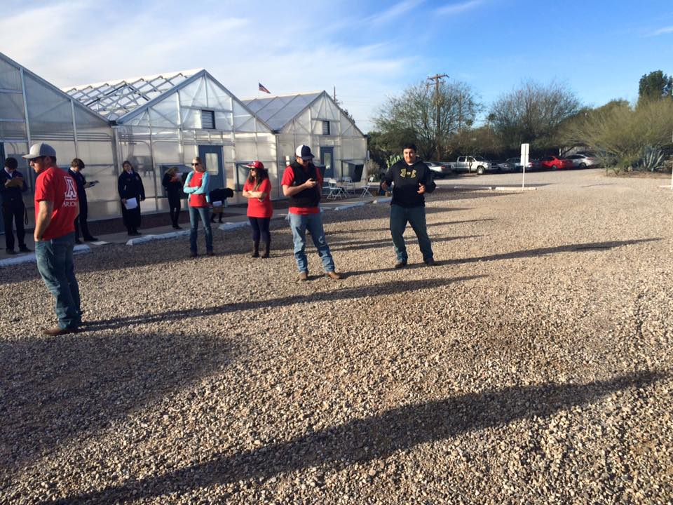
- Tierra Seca Meeting Agenda 3/9/2016

- Call to Order: 2:05 PM
  - Members in attendance: Joey, Josh, James, Brett, Sara, Rachel and Morgan
    - Dr. Mitch McClaran
- President’s Report:
  - Introductions
  - Semester meeting dates: 3/9, 3/23, 4/6, 4/20
  - Upcoming Events
Tierra Seca members working at the range competition at the FFA CDE Day
March 4, 2016
    - Kickball April 2nd
      - Evening after McClaran’s field trip
      - Where (TBD)
    - Sheep and goat fecal samples
    - March 26th – Hiking Saturday
    - April 23rd – Camping
      - Options: Dragoon, Mt. Lemmon, Sonoita, Wet Beaver Creek
      - Mt. Grahm – before and after Mitch’s field trip – FAVORABLE
    - Wildcat baseball game!
- Vice President’s Report:
  - Barb needs social media work – interested talk to Sara or Rachel
  - Short fun fact contest – on website
  - Meme campaign – “We Are Rangelands”
    - Take pictures of landscapes and talk to Sara
- Treasure’s Report:
  - Dues ($10 per semester)
    - Paid dues: Gerry, Leland, Josh, Damien, Morgan, Jenn, James, Rachel, Joey
  - Account balances: Checking: $3663.10 ; Savings: $395.10 Cash: $238.00
- Miscellaneous:
  - Range meet-up – Thank you everyone for coming, we had a lot of fun!
  - Arroyo Chico Wash cleanup led by Katie Hughes
    - Saturday March 26th
  - Garden Plot: http://tierrasecauofa.wix.com/tierra-seca-garden
    - Contact – Kelsey
  - T-shirt, hat, and sticker orders
  - Tierra Seca items:
    - Stickers $1
    - Koozies $3
    - T-Shirts $10
    - Hats $20
  - SNRE seminars
    - Every Wednesday in S107- ENR2 from 3:00-4:00pm
  - Fundraising
  - Other new business or discussion?
- Adjournment: 2:40 PM

Facebook club link: https://www.facebook.com/uofatierraseca
President: Leland Sutter lelandsutter@email.arizona.edu
Vice President: Rachel Turner rachelturner@email.arizona.edu
Secretary: Morgan Gourley mjgourle@email.arizona.edu
Treasurer: Joey Dahms dahmsjo@email.arizona.edu

