

Field Season Positions Announcement 2016

BLM Land Health Assessment District Lead, Las Vegas and Elko, NV. Coordinate a crew and perform land health assessments through the inventory and monitoring of public range lands and riparian systems within the Ely BLM district. Training provided. Recruiting for 1 position. (9 month appointment starting March 2016) Compensation: $1,440/bi-weekly salary and camping per diem.

BLM Vegetation/Habitat Monitoring Leads, multiple locations in ID, WY, WA, OR and UT. Implement BLM’s national Assessment, Inventory and Monitoring (AIM) strategy. Coordinate a field crew to characterize vegetation using AIM protocol. Training provided. Recruiting for 5 positions. (26 to 30-week appointments starting April 2016) Compensation: $1360 bi-weekly salary, $15 camping per diem, $75/ week housing stipend.

BLM Vegetation/Habitat Monitoring Technicians, multiple locations in ID, WY, WA OR and UT. Implement BLM’s national Assessment, Inventory and Monitoring (AIM) strategy. Be part of a field crew to characterize vegetation using AIM protocol. Training provided. Recruiting for 40 positions. (16 to 26-week appointments starting April 2016) Compensation: $15/hour, $15 camping per diem, $75/ week housing stipend.

BLM Vegetation/Habitat and Archaeological Monitoring Field Lead, Kanab and Escalante, UT. . Implement BLM’s national Assessment, Inventory and Monitoring (AIM) strategy. Be part of a field crew to characterize vegetation using AIM protocol while following required compliances for cultural resources. Training provided. Recruiting for 1 position. (12-week appointment beginning May 9th, 2016) Compensation: $1,360/bi-weekly, $15/day camping per diem and $75/week housing stipend.

GBI ESR Monitoring Logistics Coordinator, Boise, ID. Work cooperatively with BLM ESR and United States Geological Survey (USGS) Resource Specialists and GBI ESR Crew Leads. The GBI ESR Monitoring Logistics Coordinator will provide logistics for multiple field crews gathering data to determine post-fire recovery and effectiveness of post-fire stabilization and rehabilitation efforts. Duties will include compiling/formatting field data to BLM reporting requirements and filling in as a field crew member when necessary. (March 28, 2016 – September 17, 2016). Compensation: $19.00/hour, $15.00/day field camping per diem and $75.00/week housing stipend.

BLM Spring Inventory Technician, Winnemucca, NV. Assist the BLM by conducting field work to inventory naturally occurring springs in the district. This work will support water right adjudications, grazing permit renewals, sage grouse management and other concerns. (18-week appointment beginning March 28th, 2016) Compensation: $17/hour.

BLM NEPA Technician, Winnemucca, NV. Contribute to the implementation of the district’s recently approved resource management plan and to the development of NEPA documents. . The NEPA Technician will be provided a working introduction to BLM policies, regulations, procedures, programs, and operations. Particular focus will be placed on planning and environmental coordination through administrative and technical tasks, including the use of ePlanning, designed to develop knowledge and understanding of multiple use land management.( 52-week appointment starting in April 2016). Compensation: $19.57/hour.

BLM Botanist/Riparian Vegetarian Technician, Battle Mountain, NV. Work as part of a multi-disciplinary team to characterize current riparian-wetland condition/functionality. Information collected is used in support of drought management decisions and/or rangeland health evaluations. (May 22, 2016 – November 19, 2016). Compensation $17.50/hour.

BLM Rangeland & Drought Monitoring Technician, Battle Mountain and Tonopah, NV. Implement a variety of upland monitoring protocols across public lands in support of drought management decisions and/or rangeland health evaluations. (May 22, 2016 – November 2016). Compensation: $17.50/hour.

BLM ESR (Post-Fire) Vegetation Monitoring Crew Lead, Boise, ID. Direct, supervise, and participate as a field crew member, to gather monitoring data to determine post-fire recovery and effectiveness of post-fire stabilization and rehabilitation efforts. (April 25, 2016 – September 17, 2016). Compensation: $17.00/hour, $15.00/day field camping per diem and $75.00/week housing stipend.

BLM ESR (Post-Fire) Vegetation Monitoring Field Technician, Boise, ID. Work cooperatively with BLM ESR and United States Geological Survey (USGS) Resource Specialists, and GBI ESR Monitoring and Field Crew Leads to gather monitoring data to determine effectiveness of post-fire stabilization and rehabilitation efforts (April 25, 2016 – September 17, 2016). Compensation: $15.00/hour, $15.00/day field camping per diem and $75.00/week housing stipend.

BLM Forestry Technicians, Elko and Carson City, NV. Work cooperatively with BLM resource staff to perform vegetation management projects, restoration projects within forest/woodland areas, and utilization of forest products in support of the BLM Nevada Forestry Program. (26-week appointment beginning May 23, 2016). Compensation: $15.00/hour.

NDOW Vegetation/Habitat Assessment Field Lead, Ely, NV. Perform detailed vegetation and site data collection at locations where habitat restoration projects will be undertaken and at sites where restoration is underway. Additional sites will be sampled with a focus on climate change and sage-grouse habitat. (27-week appointment beginning April 11, 2016). Compensation: $1,392/bi-weekly.

NDOW Lake Tahoe Raptor Survey Field Lead, Tahoe Basin, NV. Assist with surveys of two sensitive raptor species, Northern Goshawk (Accipiter gentilis) and California Spotted Owl (Strix occidentalis occidentalis), in the east Lake Tahoe Basin, NV and adjacent areas of the Carson Range. The goal of this project will be to detect nesting territories and monitor nest success, and the Field Lead and a Raptor Survey Field Technician will coordinate with NDOW on surveys and associated work (17-week appointment beginning May 2, 2016). Compensation: $15.00/hour, $15.00/day field per diem and housing stipend.

NPS Tribal Youth Intern/Oral Historian, Joshua Tree, CA. Assist the Park in integrating multiple disciplines and park themes such as Native American traditional culture, homesteading, natural resource, and popular culture, by combining the stories associated with the individual museum objects from both a global and personal perspective. (Part-time, start upon availability). Compensation: $18.50/hour.

USFWS Biological Science (Wildlife) Technician, Coarsegold, CA. Conduct established wildlife-related research activities on the status, behavior and distribution of fishers (Pekania pennanti) which may include: safe capture and handling of fishers and other wildlife, installing and monitoring remote camera stations, aerial and ground radio telemetry work, and helping with scat detection dog surveys.. (15-week appointment beginning March 12, 2016, or upon availability, through July 1, 2016). Compensation: $15.31/hour.

For more information, visit our website at www.thegreatbasininstitute.org




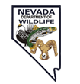
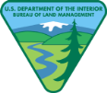

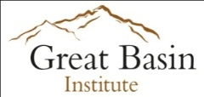

Scan here for the latest position updates

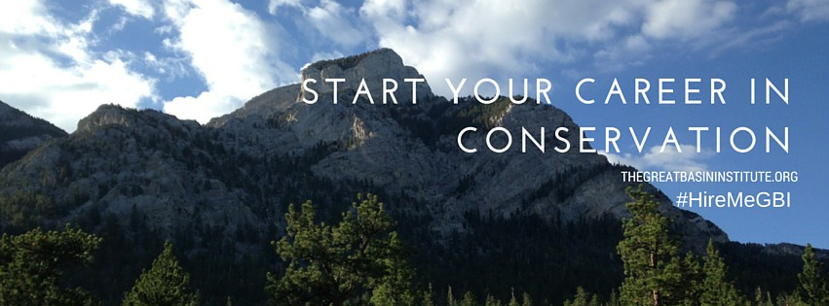

AmeriCorps Positions Announcement 2016
NEVADA
- BLM Land Health Assessment Field Technician (April 4, 2016-September 30, 2016). Various locations in Northern NV Compensation: $13,265 Living allowance and $2,865 education award.
- USFWS Natural Resources Management Plan Aide (24-week term of service beginning in March of 2016), Stillwater National Wildlife Refuge Complex. Compensation: $12,600 living allowance, $2,865 education award and housing provided.
- USFS Wilderness Ranger Intern (April – August, 2016). Spring Mountains, near Las Vegas, NV. Compensation $8560 living allowance, $2182.78 education award.
- USFS Invasive Plant Survey, Mapping and Treatment Technicians (22 and 27 week appointments starting May 2016). Varuous locations throughout NV. Compensation $8,800-$11,000 living allowance and $2,182-$2,865 education award.
- NDOW Vegetation/Habitat Assesment Technicians (April- September 2016). Reno, NV and Ely, NV. Compensation depends on length of appointment: $4500 to $6300 living allowance, $1527.78 to $2200 education award.
- NDOW Lake Tahoe Raptor Survey Field Technician (2 May - 12 August 2016 (15 weeks)). Tahoe Basin, NV. Compensation $6,000living allowance, $1,515.55e education award, field per diem and housing stipend.
NEVADA – GALENA CREEK VISITOR CENTER
- Camp Counselor (June 13, 2016-August 5, 2016). Reno, NV. Compensation: $150.00/week stipend, $1212.44 education award and hosuing provided.
- Environmental Education and Camp Coordinator (35-week appointment begiining ASAP). Reno, NV. Compensation: $10,500 living allowance, a total of $4,380.55 in educati9on awards and hosuing provided.
- Naturalist and Environmental Educator, 15-week (May 2, 2016 – August 12, 2016). Reno, NV. Compensation: $3,000 living allowance, $2182.78 education award and housing provided.
- Naturalist and Environmental Educator, 35-week (February 22, 2016 – October 21, 2016). Reno, NV. Compensation: $8,750 living alliowance, a total of $4,380.55 in education awards and housing provided.
- Visitor Center Naturalist/Host (May 2, 2016-August 19, 2016). Reno, NV. Compensation: $3,200 living allowance, $1,515.55 education award and housing provided.
UTAH
- NPS Orchard Management and Botany Interns (26-week appointment beginning March 20, 2016). Capitol Reef National Park, Torrey, UT. Compensation: $7,344 living allowance and $2,865 education award.
- BLM Travel Management (OHV) Technician (May-October 2016). Monticello, UT. Compensation $10,519.60 living allowance and $2,865 education award and $75/week hosuing stipend.
- BLM Seeds of Success Native Seed Collection Technician (6-month appointment running May 09 - October 28, 2016). Moab, UT. Compensation: $11,390 living allowance, $2,865 education award and $75/week housing stipend.

CALIFORNIA
- USFWS California Condor Monitoring Technicians (6-month appointment beginning March 2016). Compensation: $40/day field per diem, $2,865 education award and housing provided during each 10-day service period.

WYOMING
- BLM Casper Range Technician (May 16, 2016 – August 12, 2016). Compensation: $5,660 living allowance, $1,515.55 education award and $75/week housing stipend.
- BLM Casper Hydrologic Technician (May 16, 2016 – August 12, 2016). Compensation: $5,660 living allowance, $1,515.55 education award and $75/week housing stipend.

For more information, visit our website at www.thegreatbasininstitute.org
Scan here for the latest position updates

