Tierra Seca
University of Arizona Student Chapter
Society for Range Management


College of Agriculture and Life Sciences
School of Natural Resources and the Environment

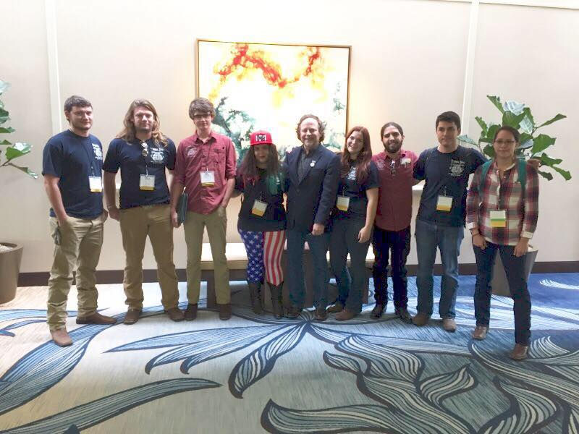
- Tierra Seca Meeting Agenda 2/10/2016

- Call to Order: 2:05 PM
  - Members in attendance:
Leland, Jennifer, Brett, Morgan, James, Sara, Rachel,
and Advisor Dr. Mitch McClaran
- President’s Report:
  - Introductions
  - Semester meeting dates: 2/24, 3/9, 3/23, 4/6, 4/20
2016 URME Team.
From left to right: Josh Sutter, Leland Sutter, Zach Winston, Jenn Hanson, Dr. Larry Howery, Morgan Gourley, Emilio Corella, Joey Dahms, and Natalya Robbins-Sherman
  - Upcoming Events
    - Camping Trip
      - To be determined…
    - Kickball Social
      - Saturday Possibly April 9th with Wildlife Club
    - V Bar V ranch
      - Saturday March 26th tentatively
    - AZ FFA CDE Day March 4th @ the UA Ag Farm
      - What happens: we administer and monitor high school students taking a plant id test and then grade it afterwards.
      - Afterwards we get lunch with Larry Howery
- Vice President’s Report:
  - Beef Council in Contact. To be determined.
- Treasure’s Report:
  - Dues ($10 per semester)
    - Paid dues: Gerry, Leland, Josh, Damien, Morgan, Jenn, James, Rachel
  - Account balances: Checking: $4162.90 ; Savings: $395.10 Cash: $280.00
- Miscellaneous:
  - Presentation on OPM Requirements
    - If you have questions about this or would like to know more you can email Dr. Mitch McClaran or get with your Range Advisor.
  - URME
      - WE PLACED THIRD!!!
      - Everyone did so well and we are very proud of our Team and a special thanks to our Coach, Larry Howery.
      - To know more about the trip please reference the article sent out by Leland Sutter on Feb. 8th.
  - Arroyo Chico Wash cleanup led by Katie Hughes
    - Saturday February 20th
  - Garden Plot: http://tierrasecauofa.wix.com/tierra-seca-garden
    - Contact – Kelsey
  - T-shirt, hat, and sticker orders
  - Tierra Seca items:
    - Stickers $1
    - Koozies $3
    - T-Shirts $10
    - Hats $20
  - SNRE seminars
    - Every Wednesday in S107- ENR2 from 3:00-4:00pm
  - Fundraising
  - Other new business or discussion?
  - Sara’s idea to have a catered mixer for range students.
    - Tentatively Tuesday Feb 23rd 4-6pm
- Adjournment: 2:43 PM

Facebook club link: https://www.facebook.com/uofatierraseca
Advisor: Dr. Mitch McClaran: mcclaran@email.arizona.edu
President: Leland Sutter lelandsutter@email.arizona.edu
Vice President: Rachel Turner rachelturner@email.arizona.edu
Secretary: Morgan Gourley mjgourle@email.arizona.edu
Treasurer: Joey Dahms dahmsjo@email.arizona.edu

