Tierra Seca
University of Arizona Student Chapter
Society for Range Management
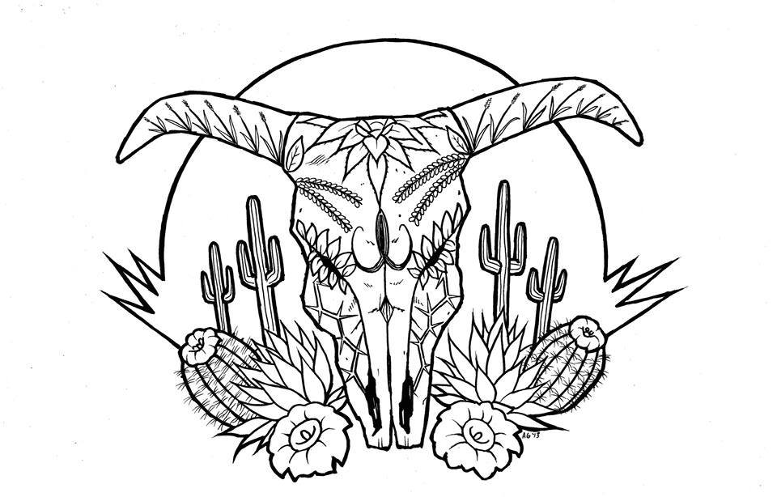

College of Agriculture and Life Sciences
School of Natural Resources and the Environment

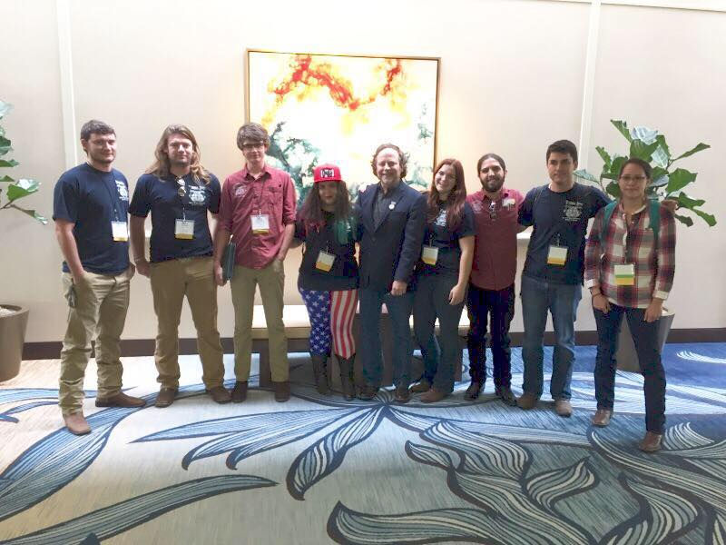
- Tierra Seca Meeting Agenda 2/10/2016

- Call to Order:
  - Members in attendance:
- President’s Report:
  - Introductions
  - Semester meeting dates: 2/24, 3/9, 3/23, 4/6, 4/20
2016 URME Team.
From left to right: Josh Sutter, Leland Sutter, Zach Winston, Jenn Hanson, Dr. Larry Howery, Morgan Gourley, Emilio Corella, Joey Dahms, and Natalya Robbins-Sherman
  - Upcoming Events
    - Camping Trip
    - Kickball Social
    - V Bar V
    - AZ FFA CDE Day March 4th
- Vice President’s Report:
- Treasure’s Report:
  - Dues ($10 per semester)
    - Paid dues: Gerry, Leland, Josh, Damien
  - Account balances: Checking: $3900.93 ; Savings: $395.10 Cash: $429.00
- Miscellaneous:
  - URME
  - Arroyo Chico Wash cleanup led by Katie Hughes
    - Saturday February 20th
  - Garden Plot: http://tierrasecauofa.wix.com/tierra-seca-garden
    - Contact – Kelsey
  - T-shirt, hat, and sticker orders
  - Tierra Seca items:
    - Stickers $1
    - Koozies $3
    - T-Shirts $10
  - SNRE seminars
    - Every Wednesday in S107- ENR2 from 3:00-4:00pm
  - Fundraising
  - Other new business or discussion?
- Adjournment:

Facebook club link: https://www.facebook.com/uofatierraseca
President: Leland Sutter lelandsutter@email.arizona.edu
Vice President: Rachel Turner rachelturner@email.arizona.edu
Secretary: Morgan Gourley mjgourle@email.arizona.edu
Treasurer: Joey Dahms dahmsjo@email.arizona.edu

