Tierra Seca
University of Arizona Student Chapter
Society for Range Management


College of Agriculture and Life Sciences
School of Natural Resources and the Environment

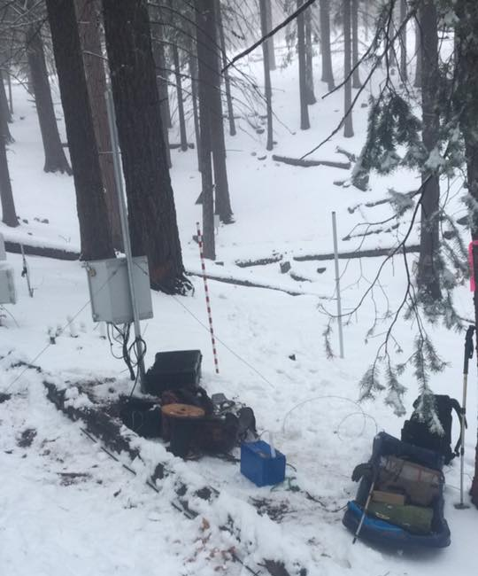
- Tierra Seca Meeting Agenda 1/20/2016

- Call to Order: 2:11 PM
  - Members in attendance: James, Josh, Joey, Natalya, Gerry, Morgan, Brett, Sara, Rachel, Leland
- President’s Report:
  - Introductions – What is everyone’s name, major, year and do you have any pets?
  - Nature is Neat video
  - Semester meeting dates: 2/10, 2/24, 3/9, 3/23, 4/6, 4/20
  - Upcoming Events
    - Kickball Social Saturday January 23rd
Catalina Critical Zone Observatory (CZO) station at Mt. Bigelow, AZ
January 5, 2016
      - Changed this to February 13th
    - Possible V Bar V Monitoring
      - Waiting for the snow to melt
    - Possible Anchor F Visit
    - Possible 47 ranch Visit
- Vice President’s Report:
- Treasure’s Report:
  - Dues ($10 per semester)
    - Paid dues: Gerry, Leland, Josh, Damien
  - Account balances: Checking: $3900.93 ; Savings: $395.10 Cash: $429.00
- Miscellaneous:
  - Seniors graduating in May 2016: Leland, Natalya, Joey, and Jenn
  - URME
  - Garden Plot: http://tierrasecauofa.wix.com/tierra-seca-garden
    - Contact – Kelsey
  - T-shirt, hat, and sticker orders
  - Tierra Seca items:
    - Stickers $1
    - Koozies $3
    - T-Shirts $10
    - Hats: $20
  - SNRE seminars
    - Every Wednesday in S107- ENR2 from 3:00-4:00pm
  - Fundraising
  - Other new business or discussion?
- Adjournment:

Facebook club link: https://www.facebook.com/uofatierraseca
President: Leland Sutter lelandsutter@email.arizona.edu
Vice President: Rachel Turner rachelturner@email.arizona.edu
Secretary: Morgan Gourley mjgourle@email.arizona.edu
Treasurer: Joey Dahms dahmsjo@email.arizona.edu

