Tierra Seca
University of Arizona Student Chapter
Society for Range Management


College of Agriculture and Life Sciences
School of Natural Resources and the Environment

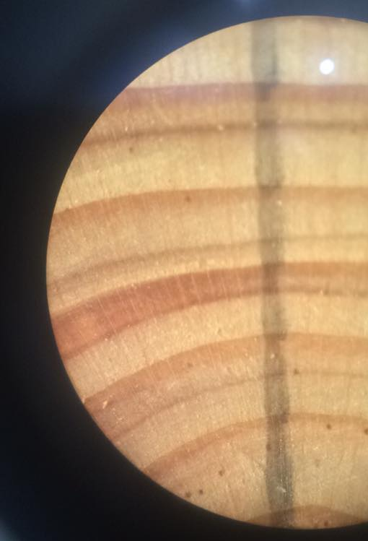
- Tierra Seca Meeting Agenda 12/2/2015

- Call to Order:
  - Members in attendance:
- President’s Report:
  - Introductions
  - Semester meeting dates: Stay tuned for next semester!
Lateral cross-section of Douglas fir (Pseudotsuga menziesii) as seen under a dissecting microscope
  - Upcoming Events
    - Possible V Bar V Monitoring next semester
    - Possible Anchor F Visit
    - Possible 47 ranch Visit
    - Winter SRM Meeting January 7 – 8th
- Vice President’s Report:
  - Rangelands West
- Treasure’s Report:
  - Dues ($10 per semester)
    - Paid dues: Gerry (whole year), Natalya, Angel, Morgan, Leland (whole year), Damien (whole year), Kelsey, Zach, Jenn, Sophie, Brett, Amber,
Rachel, Josh (whole year), Joey (whole year)
  - Account balances: Checking: $2945.04 ; Savings: $395.10 Cash: $318.00
- Miscellaneous:
  - Vote for Public Relations Chair
  - Graduation – December 19th, 9 am, Centennial Hall
    - Volunteers:
  - URME
  - Arroyo Chico Wash cleanup led by Katie Hughes
    - December 12th, January 18th
  - Garden Plot: http://tierrasecauofa.wix.com/tierra-seca-garden
    - Contact – Kelsey
  - Wildlife Photo Contest
  - T-shirt, hat, and sticker orders
  - Tierra Seca items:
    - Stickers $1
    - Koozies $3
    - T-Shirts $10
  - SNRE seminars
    - Every Wednesday in S107- ENR2 from 3:00-4:00pm
  - Fundraising
  - Other new business or discussion?
- Adjournment:

Facebook club link: https://www.facebook.com/uofatierraseca
President: Leland Sutter lelandsutter@email.arizona.edu
Vice President: Rachel Turner rachelturner@email.arizona.edu
Secretary: Morgan Gourley mjgourle@email.arizona.edu
Treasurer: Joey Dahms dahmsjo@email.arizona.edu

