Tierra Seca
University of Arizona Student Chapter
Society for Range Management
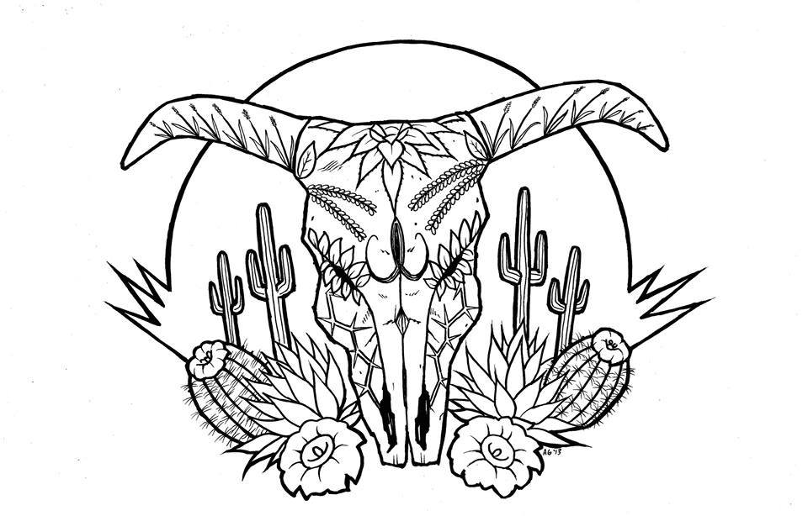

College of Agriculture and Life Sciences
School of Natural Resources and the Environment

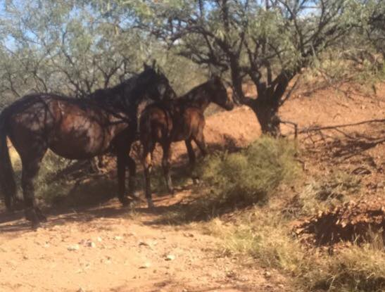
- Tierra Seca Meeting Agenda 11/18/2015

- Call to Order: 12:15
  - Members in attendance: Amber, Kelsey, Gerry, Leland, Jen, Rachel, Joey
- President’s Report:
  - Introductions
  - Semester meeting dates: 11/18, 12/2
Mare and foal at the Elkhorn Ranch. November 13, 2015
  - Upcoming Events
    - Possible V Bar V Monitoring (Friday/Saturday):
12/4 – 12/5
    - Kickball game with the Wildlife Club
      - dead day eve – December 9th
    - Work at the farm
      - Jenn will email us soon!
    - Winter SRM Meeting January 7 – 8th
    - Watch out for email from Leland about registration the 6th through 9th
- Vice President’s Report:
  - Public Relations Position
    - move constitution vote to next meeting
  - December guest speaker!!
  - No hats yet
- Treasure’s Report:
  - Dues ($10 per semester)
    - Paid dues: Gerry (whole year), Natalya, Angel, Morgan, Leland (whole year), Damien (whole year), Kelsey, Zach, Jenn, Sophie, Brett, Amber,
Rachel, Josh (whole year), Joey (whole year), Zach Winston
  - Account balances: Checking: $2945.00 ; Savings: $395.10 Cash: $346.00
- Miscellaneous:
  - V Bar V Ranch Monitoring (Friday/Saturday):
11/6-11/7
  - Elkhorn Ranch Monitoring:
Friday, November 13th
  - Graduation
    - Leland needs people to help him seat people at graduation, contact him if you are interested
  - SNRE GRAD-Undergrad-Faculty Event November 4th – Wednesday
  - URME
  - Arroyo Chico Wash cleanup led by Katy Hughes
    - This Saturday – 11/21 refer to list serv email!
  - Garden Plot: http://tierrasecauofa.wix.com/tierra-seca-garden
    - Contact – Kelsey
  - Wildlife Photo Contest
    - Photos are due on Sunday 11/22!!
  - T-shirt, hat, and sticker orders
  - Tierra Seca items:
    - Stickers $1
    - Koozies $3
    - T-Shirts $10
  - SNRE seminars
    - Every Wednesday in S107- ENR2 from 3:00-4:00pm
  - Fundraising
  - Other new business or discussion?
    - Owl Survey- TBD, possible joint project with wildlife society

- Adjournment: 12:45

Facebook club link: https://www.facebook.com/uofatierraseca
President: Leland Sutter lelandsutter@email.arizona.edu
Vice President: Rachel Turner rachelturner@email.arizona.edu
Secretary: Morgan Gourley mjgourle@email.arizona.edu
Treasurer: Joey Dahms dahmsjo@email.arizona.edu

