
Tierra Seca
University of Arizona Student Chapter
Society for Range Management

College of Agriculture and Life Sciences
School of Natural Resources and the Environment

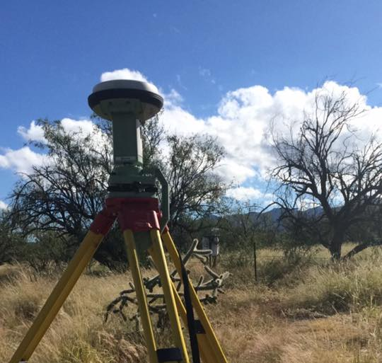
- Tierra Seca Meeting Agenda 10/14/2015

- Call to Order:
  - Members in attendance:
- President’s Report:
  - Introductions
  - Semester meeting dates: 10/14, 10/28, 11/18, 12/2
LIDAR GPS unit at the Sana Rita Experimental Range
  - Upcoming Events
    - V Bar V Ranch Monitoring (Friday/Saturday): 10/16; 11/6-11/7
      - Volunteers for 10/16: Zach M, Josh, Gerry, Morgan, Rachel
      - Volunteers for 11/6-11/7: Joey, Zach W, Damien, Kelsey maybe
    - V Bar V Ranch Monitoring 10/3 – 10/4
    - Rise Symposium 10/17
      - Volunteers: Rachel, Morgan, Kelsey, Jenn, Joey, Angel, Natalya
    - Elkhorn Ranch Monitoring:
      - Friday, November 13th
      - Volunteers on sign-up sheet: Jennifer, Kelsey, Joey, Natalya, Stephen and Morgan (Maybe)
    - Agrilife Council
      - Work at the farm
    - Winter SRM Meeting January 7 – 8th
- Vice President’s Report:
  - T-shirts
  - RISE
- Treasure’s Report:
  - Dues ($10 per semester)
    - Paid dues: Gerry (whole year), Natalya, Angel, Morgan, Leland (whole year), Damien (whole year), Kelsey, Zach, Jenn, Sophie, Brett, Amber,
Rachel, Josh (whole year), Joey (whole year)
  - Account balances: Checking: $4137.33 ; Savings: $395.21 Cash: $195.00
- Miscellaneous:
  - Dean’s Breakfast Burrito Saturday October 24th (homecoming weekend)
    - Volunteers:
  - SNRE GRAD-Undergrad-Faculty Event November 4th – Wednesday
  - URME
  - Arroyo Chico Wash cleanup led by Katy Hughes
  - Garden Plot: http://tierrasecauofa.wix.com/tierra-seca-garden
    - Contact – Kelsey
  - T-shirt, hat, and sticker orders
  - Tierra Seca items: - Rachel
    - Koozies $3
    - T-Shirts $10
  - SNRE seminars
    - Every Wednesday in S107- ENR2 from 3:00-4:00pm
  - Fundraising
  - Other new business or discussion?
- Adjournment:

Facebook club link: https://www.facebook.com/uofatierraseca
President: Leland Sutter lelandsutter@email.arizona.edu
Vice President: Rachel Turner rachelturner@email.arizona.edu
Secretary: Morgan Gourley mjgourle@email.arizona.edu
Treasurer: Joey Dahms dahmsjo@email.arizona.edu

