Rio Grande National Forest

Rangeland Management Specialist GS-0454-11

Outreach

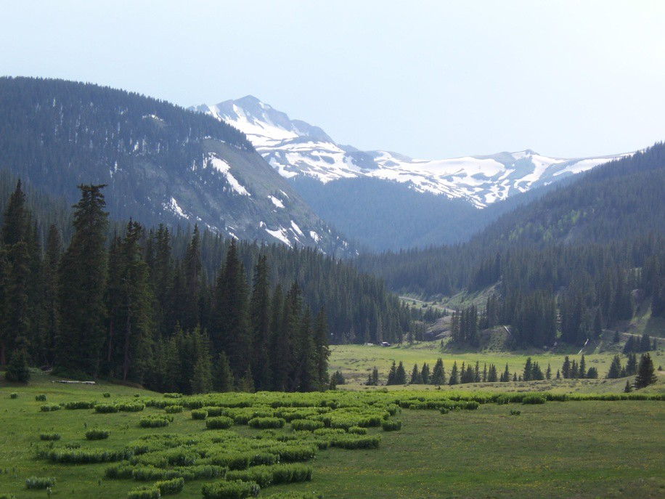

Rangeland Management Specialist GS-0454-11
September 30, 2015 – October 24, 2015

The Rio Grande National Forest will be filling a Rangeland Management Specialist GS-0454-11. This permanent full-time position is located in Del Norte, Colorado. This notification is being circulated to inform prospective applicants of this opportunity.

Major Duties

The incumbent serves as a rangeland management specialist, with responsibility for managing, planning, scheduling, coordinating, reviewing, and reporting on an ecosystem-based rangeland management program on the unit.

Develops an overall ecosystem based rangeland management program utilizing resource management plan goals, objectives and decisions and rangeland project decisions as necessary to implement actions that help achieve land management plan goals and objectives. Consults, coordinates, and cooperates with all affected users, interested publics, and private interests including various environmental groups. Resolves differences among diverse groups with competing goals. Advises landowners and land lessees on principles of rangeland management and the laws, regulations, and policies governing management of range resources. Budgets funds for current fiscal year and plans for outyear funding needs within assigned area of responsibility. Serves as principal contact and negotiator for the District on rangeland resources and activities.

The ideal candidate for this position is:

A person who is extremely motivated, and gets things done

Very goal-driven, and wants to raise the bar every day

Someone keen to learning various types of equipment

A person who works well as part of a team

Someone who incorporates safety in all aspects of work

About the Rio Grande National Forest:

The Rio Grande NF is 1.82 million acres located in southwestern Colorado. The Continental Divide runs for 236 miles along most of the western border of the Forest. The Forest presents a myriad of ecosystems, from the 7,600-ft. alpine desert floor to over 14,300-ft. Mountains in the Sangre de Cristo Wilderness on the eastern side. The Forest embraces the San Luis Valley, a large rural agricultural valley.

The Rio Grande NF includes all or parts of 4 Wilderness Areas (South San Juan, Weminuche, La Garita and Sangre de Cristo), the headwaters of the Rio Grande River and the moonscape wonder of the Wheeler Geologic Area, established by Theodore Roosevelt in 1911. For the outdoor enthusiast, the Rio Grande NF has recreation and adventure opportunities for the heartiest of souls, or enjoys the backcountry from the Cumbres & Toltec Narrow Gauge Railroad, which runs from Antonito, Colorado across the Forest (and the border) to Chama, New Mexico. Whether walking, driving, or riding, the Rio Grande NF has something for everyone. The Rio Grande NF Supervisor's Office is located in Monte Vista, with District Offices in Saguache, La Jara and Del Norte.

Rio Grande Core Values: Respect, Trust, Service, Excellence, Safety and Tradition.

For Information about the position contact: Martha Williamson – (719) 657-6007

** SAN LUIS VALLEY **

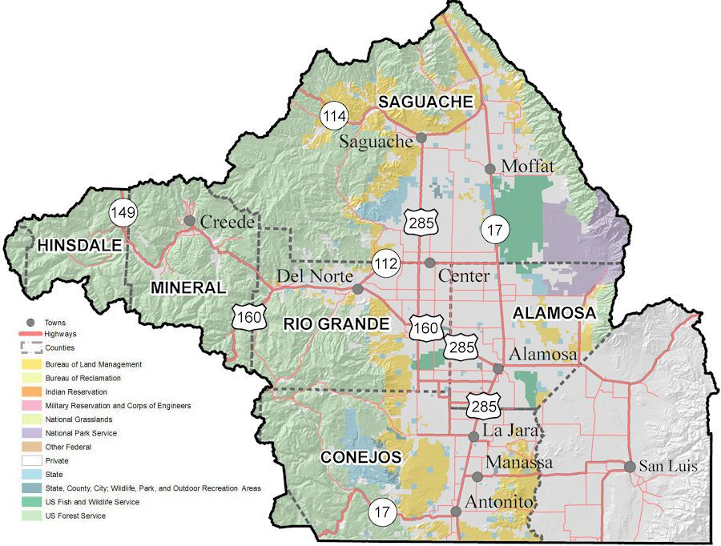

Larger than the state of Rhode Island, the San Luis Valley (SLV) is the largest and highest agricultural alpine valley in the world. The Valley floor rests at 7600'. To the west of the SLV is the San Juan Mountains ecosystem, the headwaters of the Rio Grande River and the Continental Divide. To the east, the majestic Sangre de Cristo Mountain Range, complete with multiple ``14'ers'', stand guard over this incredibly beautiful, very rural and isolated area. Denver is 4-hours north and Albuquerque is 4-hours south when you get the itch to experience some hustle and bustle (Durango, Pueblo, and Colorado Springs are 2-3 hours away). Long summer days in the 80's transition through a colorful and crisp fall. Winters can be somewhat extreme, with temperatures dipping well below zero and, in some years, frequent snows, however the low mountain humidity and abundance of sunshine mitigate the affect.

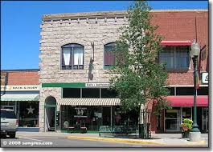

** MONTE VISTA **

https://www.colorado.com/cities-and-towns/Monte-Vista

Supervisor’s Office - Rio Grande National Forest

Monte Vista, 14 miles east of Del Norte and 17 miles west of Alamosa, is home to the Rio Grande NF Supervisor's Office. This rural community of just over 5,000 has amenities and facilities to cover all basic necessities. The downtown shopping area offers a variety of specialty shops, chain stores and service providers. Schools in Monte Vista include an elementary school, junior high school and senior high school. The schools are modern and well-staffed. Agri-business is still the number one employer in the SLV. This area is world famous for high-altitude products, including potatoes, high altitude barley (used by Coors), wheat and many other crops. Price ranges for homes will vary, but start around $70,000 and go up from there. There are numerous local real estate businesses happy to provide current market information.

** ALAMOSA **

http://www.cityofalamosa.org/
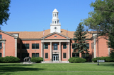

Seventeen miles east of Monte Vista is the hub of the SLV. Alamosa is the largest town in the SLV, boasting a population of nearly 11,000. Alamosa offers the quaint rural downtown shopping area with its specialty stores and the national chain discount stores (Wal-Mart, Penny’s, etc.). A large, modern hospital, with air-evacuation capabilities, stands watch over the community. Adams State University offers Associate, Bachelor and Master’s Degree programs. Trinidad Junior College provides vocational/technical curriculums, with hands-on instruction. Two elementary schools, one junior high school and a new senior high school meet the educational needs of the younger members of the community. Price ranges for homes will vary, but start around $70,000 and go up from there. There are numerous real estate businesses happy to provide current market information. Alamosa is within an hour of smaller SLV communities, and is also frequented by many visitors and shoppers from nearby Northern New Mexico.

** LA JARA **

http://www.conejoscounty.org/

Conejos Peak Ranger District

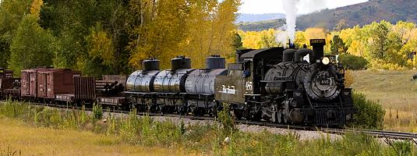
La Jara is a small community with a population of around 896 located in the San Luis Valley of Southern Colorado. It is 14 miles south of Alamosa on Highway 285 and 20 miles north of the New Mexico border. It is bordered on the east by the Sangre de Cristo Mountain Range and on the west by the San Juan Mountain Range. La Jara has a hospital, doctor's clinic, nursing home, and retirement housing, as well as, a library, police and fire department, post office, various grocery stores, a pharmacy, and a fertilizer and potato plant. Schools are also available for K-12, with a 4-year college (Adams State), Trinidad Junior College, and the San Luis Valley Vocational School located in Alamosa. There is a variety of housing available both to rent and to buy either in town or on small farms or ranches in the outlying areas. The elevation is approximately 7,600 feet lending itself to cold winters with frequent, light snow falls and summers of "cool" sunshine (low’s in the 40’s and high's in the mid 80's).

**DEL NORTE **

http://riograndecounty.org

Divide Ranger District

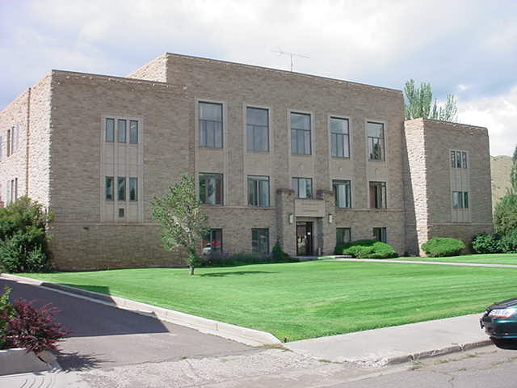

Del Norte, now in its second century, has a population of 1,600 with an additional 300 people in the surrounding farm and ranch area. Its economy is geared to a modern diversification of recreation, travel, farming, ranching, logging, mining, fishing, and hunting. Being the county seat of Rio Grande County, it hosts a mayor and town council. There are schools to accommodate an education for children K-12. There are various stores located in Del Norte to accommodate most shopping needs, including grocery, hardware, clothing, craft, and auto parts. There is also a library, and hospital. Real estate is available for purchase and rentals are also abundant. Costs vary, but usually there will be something available to suit a variety of budgets and tastes. Some say Del Norte is the gateway to the sportsman's paradise with many four season activities just a short drive away. Winter sports include skiing at nearby Wolf Creek Pass, snowmobiling, and hunting to name a few. Summers are ideal for fishing, hiking, and camping. Fall brings out those who love to watch the changing colors on the mountains and spring brings out new color and new life. The opportunities are only limited by one's imagination.

**Creede**

http://www.creede.com/


This historic mining town offers contemporary boutiques for plenty of shopping, but maintains its traditional character through remembrance of its roots. There Underground Mining Museum and old mining tours hint at older times, yet you can still step back into the present by walking down Main Street, and into one of their unique and beautiful art galleries and is home to the Creede Repertory Theatre, come see a play by a company named "one of the top 10 places to see the lights way off Broadway" (USA Today). There are schools to accommodate an education for children K-12 and has a medical clinic. Real estate is available for purchase as well as rentals. Costs vary, but usually there will be something available to suit a variety of budgets and tastes

** SAGUACHE **

http://saguache.org/

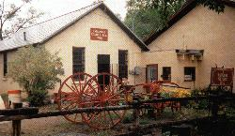
Saguache Ranger District

Saguache has it all, from ghost towns in the west to the Sand Dunes National Park and Reserve in the east. La Garita and Sangre De Cristo Mountains Wilderness Areas are known for their outdoor opportunities, their lakes, and their mountain streams. Saguache is a small limited service community of approximately 600 people located at the north end of the San Luis Valley. Saguache is located on the junction of Highways 285 and 114. Gunnison is approximately 70 miles west of Saguache, Salida is approximately 45 miles north of Saguache and Monte Vista (location of Forest Supervisors office) is approximately 35 miles south of Saguache. The center of commerce for the San Luis Valley, Alamosa, is 58 miles south and east of Saguache. Saguache has a very rural life style with ranching being the predominant occupation. The limited services include: K-12 school system, doctors clinic, grocery store, weekly newspaper, library, police and volunteer fire departments, volunteer ambulance, post office, and a limited number of other small businesses such as feed store and pottery shops. Saguache is also the county seat. Housing is limited with rentals starting around $400 per month and homes for sale starting around $80,000. Several real estate businesses are in the area. Summer temperatures are rarely over 80 degrees and winters can be moderate to extremely cold (-20 or more). Generally Saguache receives only light snowfall. This is a high mountain desert valley with the town elevation around 7800 feet.

Information on the Web:

www.fs.usda.gov/riogrande



Rangeland Management Specialist GS-0454-11, Rio Grande NF Divide Ranger District

USDA Forest Service, R2-Rocky Mountain Region

Please respond by October 24, 2015 to:

Denise M Gomez (719) 657-6034 dmgomez@fs.fed.us

Name: ______________________________________________________________________

Email Address: _________________________________________

Phone Number: __________________________ Work, Home or Mobile?

Employer: USDA FS Unit_____________________ Other _____________________________

Location: ____________________________________________________________________

Type of appointment (if current Federal employee):

Permanent ____ Temporary____ Student/Intern____ Contractor____ Other_____

Current Position Title: __________________________________________________________

Series/grade if Federal Employee: __________________________

How did you hear about this position? _____________________________________________

Agency Contact_____________________________ Other_____________________________

If not a current permanent employee, are you eligible to be hired under any of the following special authorities?

_____ Schedule A (Person with Disabilities)

_____ Veterans Readjustment Act (VRA)

_____ Veterans w/30% Compensable Disability

_____ Veterans Employment Opportunities Act (VEOA) Of 1998

_____ Former Peace Corps Volunteer

_____ Pathways Program (Students and Recent Graduates)

_____ Public Lands Corps (PLC)

_____ Other ________________________________________________

