
Tierra Seca
University of Arizona Student Chapter
Society for Range Management

College of Agriculture and Life Sciences
School of Natural Resources and the Environment

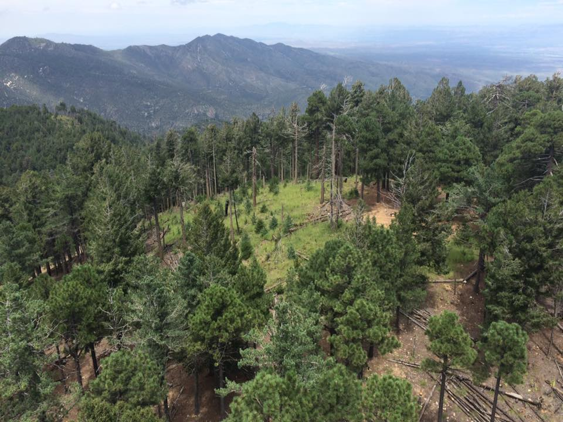
- Tierra Seca Meeting Agenda 09/30/2015

- Call to Order:
  - Members in attendance:
- President’s Report:
  - Introductions
  - Semester meeting dates: 9/30, 10/14, 10/28, 11/18, 12/2
Burn area north of Catalina CZO flux tower
  - Upcoming Events
    - V Bar V Ranch Monitoring (Friday/Saturday): 10/2-10/3; 10/16-10/17; 11/6-11/7
      - Volunteers for 10/2-10/3: Joey, Jenn, Zach, and Morgan
      - Volunteers for 10/16: Zach M, Leland, Josh, Gerry, Morgan, Rachel
      - Volunteers for 11/6-11/7: Joey, Zach W, Damien, Kelsey maybe
    - Rise Symposium 10/17
      - Volunteers: Rachel, Morgan, Kelsey, Jenn, Joey, Angel, Natalya
    - Elkhorn Ranch Monitoring:
      - Friday, November 13th
      - Volunteers on sign-up sheet: Jennifer, Kelsey, Joey, Natalya, Stephen and Morgan (Maybe)
    - Dean’s Excuses
    - Agrilife Council
      - Work at the farm
    - Winter SRM Meeting January 7 – 8th
- Vice President’s Report:
  - SRM Trade Show
  - T-shirts
- Treasure’s Report:
  - Dues ($10 per semester)
    - Paid dues: Gerry (whole year), Natalya, Angel, Morgan, Leland (whole year)
  - Account balances: Checking: $3945.33 ; Savings: $395.21 Cash: $422.00
- Miscellaneous:
  - Parent’s weekend October 9th through 11th
  - Dean’s Breakfast Burrito Saturday October 24th (homecoming weekend)
  - SNRE GRAD-Undergrad-Faculty Event November 4th
  - URME
  - Arroyo Chico Wash cleanup led by Katy Hughes Sunday, September 27th
  - Garden Plot: http://tierrasecauofa.wix.com/tierra-seca-garden
    - Contact - Kelsey
  - T-shirt, hat, and sticker orders
  - Tierra Seca items:
    - Koozies $3
    - T-Shirts $10
  - SNRE seminars
    - Every Wednesday in S107- ENR2 from 3:00-4:00pm
  - Fundraising
  - Other new business or discussion?
- Adjournment:

Facebook club link: https://www.facebook.com/uofatierraseca
President: Leland Sutter lelandsutter@email.arizona.edu
Vice President: Rachel Turner rachelturner@email.arizona.edu
Secretary: Morgan Gourley mjgourle@email.arizona.edu
Treasurer: Joey Dahms dahmsjo@email.arizona.edu

