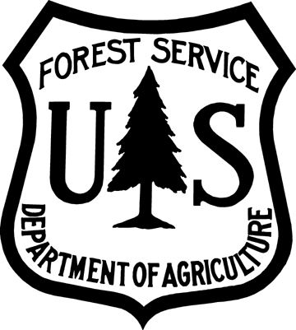
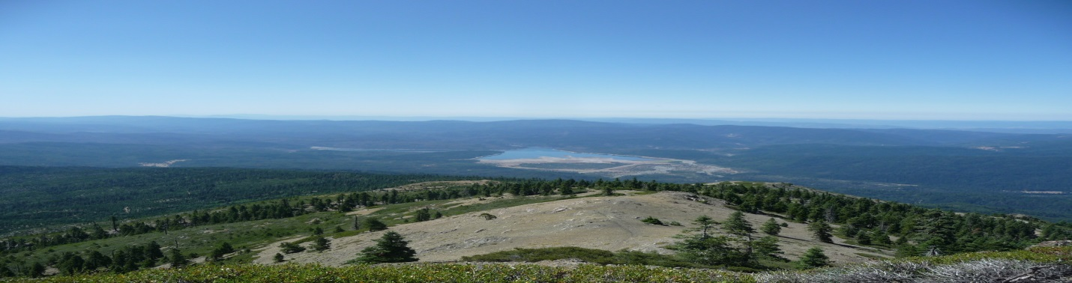
Rangeland Management Specialist, GS-0454-07/09/11
VACANCY ANNOUNCEMENT
Mendocino National Forest
Upper Lake and Covelo Ranger Districts

Merit
Vacancy Announcement: 15-0508-144770G-JA
Open Date: 09/25/2015
Application Deadline: 10/05/2015

You can view the vacancy on the USA Jobs website at http://usajobs.gov/.

Position:
This position is located on the Mendocino National Forest, duty location Upper Lake, CA..

This position will serve as the Rangeland Management Specialist with the Upper Lake and Covelo Ranger Districts. The position will be responsible for managing, planning, scheduling, coordinating, reviewing, and reporting on an ecosystem-based rangeland management program. The work will require regular physical exertion in hiking, riding horses or riding in trucks including 4x4's over rough uneven, mountain terrain. Work is performed in an office and field environment. Field work may include risks of injury from falls, strains, and insect bites as well as exposure to inclement weather.

For additional information about the duties of this position, please contact Michelle Zuro-Kreimer at 707-275-1409 or mzurokreimer@fs.fed.us .

Applicants should review the announcement carefully and ensure that their application is complete and all required documents are filed on or before the closing date of October 5, 2015. You may access the vacancy announcement(s) at the following link(s):

Merit: https://www.usajobs.gov/GetJob/ViewDetails/416798800

