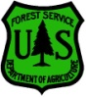
Outreach
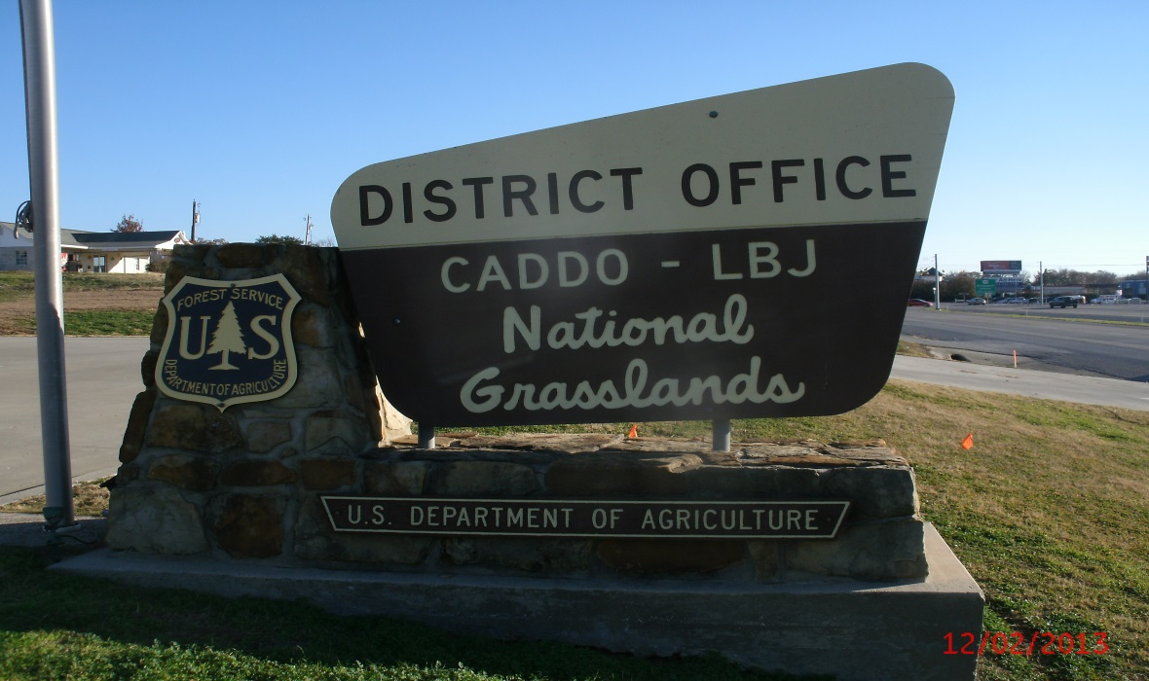
USDA FOREST SERVICE, Southern Region, R8
National Forests and Grasslands of Texas
CADDO-LBJ GRASSLANDS RANGER DISTRICT
Rangeland Management Specialist
GS-0454-5/7/9

This position is for a Recent Graduate under the Pathways Internship Program with a duty station of Decatur, Texas.

The Caddo-LBJ National Grasslands district is outreaching for a GS-454-05/07/09 Range Management Specialist Position. The position is located in Decatur, Texas and works directly for the District Range Management Specialist.
Duties:
The successful applicant will work with a zoned range program across the Caddo and LBJ National Grasslands. Primary duties of this position will include:
- rangeland monitoring, surveys, and inventories
- compilation of data regarding rangeland health, trends, and site potentials
- preparation of specialist reports for NEPA documents
- preparation of livestock management plans
- allotment management, to include communication with permittees
- preparation and modification of annual operating instructions, which are presented at annual meetings with the permittees.
- preparation and implementation of range improvement projects, ensure that current improvements are maintained to standards by permit holders.
- maintenance of range allotments inspection documents, and uses this information for allotment management.
- locates, prescribes, designs, and implements rangeland improvement projects such as fences, pipelines, cattle guards, plant community changes, or prescribed burning
- Team Leader for environmental analysis (NEPA) for projects effecting rangelands.
- Assist with prescribed burning operations
This position requires knowledge of the ecological processes of native plants. The successful applicant will be required to attend public and agency meetings. Communication with grazing permittees, the public, and Forest Service employees is essential. Use of an ATV, 4-wheel drive vehicles, pulling a trailer, and use of horses will be necessary as a regular part of this position. The job also requires hiking across uneven terrain. Biological hazards such as poisonous snakes and poison ivy may be present. Portions of each grassland are remote and will require back country travel.
This position is designed to provide a career-oriented introduction to the background, philosophy, concepts, and scope of the Forest Service Range Management Specialist functions and a practical understanding of the policies of the employing organization. The Recent Graduates Program affords developmental experiences in the Federal Government intended to promote possible careers in the civil service to individuals who have recently graduated from qualifying educational institutions or programs.
Eligibility:
- Recent graduates who have completed, within the previous two years, a qualifying associates, bachelors, masters, professional, doctorate, vocational or technical degree or certificate from a qualifying educational institution.
- Veterans unable to apply within two years of receiving their degree, due to military service obligation, have as much as six years after degree completion to apply.
The Caddo-LBJ National Grasslands will soon be advertising a permanent full-time GS-0454-5/7/9 Rangeland Management Specialist. The Duty Station is located at the District Office in Decatur, Texas. The purpose of this Outreach Notice is to inform the pool of the potential applicants about this employment opportunity. This Outreach will be open for response through October 7, 2015. The vacancy announcement is expected be advertised in USAjobs in late September or October, 2015. All persons responding to this outreach will be notified when the job is posted and open for application.
Please ensure you select Decatur, TX as the Duty Station.
About the Range Program:
The Caddo/LBJ National Grasslands has an active range program with very strong potential. It has the distinction of having the only National Grasslands in Region 8 and receives a majority (53%) of all the region’s range (NFRG) allocated funds. This is due to a large proportion of the region’s active range allotments being on the Grasslands. Currently there are a total of 120 allotments on the district. Out of those allotments, only 50 are currently permitted and managed. The remaining 70 are in need of additional administration, which can be accomplished with proper district range and wildlife reorganization. The reorganized program will increase the amount of work accomplished by increasing the amount of allotments that are permitted, improving planning and NEPA coordination, increasing the amount of in-kind range improvement work with greater permit compliance enforcement and monitoring, and increased capacity to utilize stewardship contracting authority.
About the Grasslands:
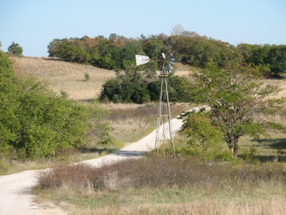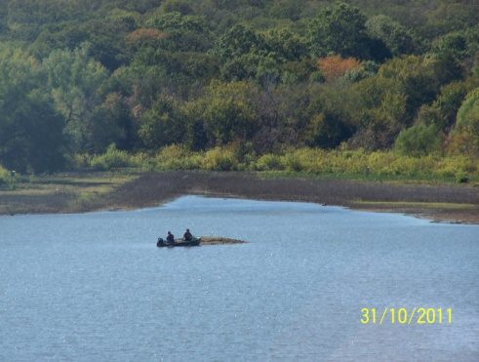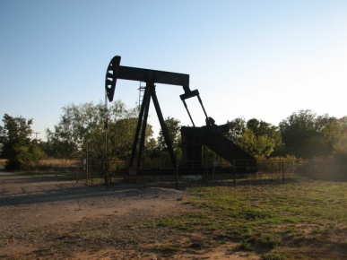
Since the 1930s, Wise, Montague, and Fannin County have been home to a unique natural resource, the Caddo-LBJ National Grasslands (CLBJ). The District hosts a complex plan of work to include 53% of Region 8’s grazing program, a burgeoning oil & gas program, the potential acquisition of a land donation totally nearly 15,000 acres (one of the biggest voluntary land donations in Forest Service history), wildlife habitat improvement projects in partnership with the National Wild Turkey Federation, a National Historic Site, and a very busy recreation program serving the over 7-million people within an hour of both National Grasslands.
The District Office is approximately 240-miles from the Supervisor’s Office in Lufkin, TX. Additionally, the two combined Districts are over 130-miles apart.
The CLBJ is approximately 38,000 acres (LBJ National Grassland = 20,300 + acres, Caddo National Grassland =17,800 + acres). Due to the proximity to the Dallas/Fort Worth metropolis and the small percentage of public lands in Texas, recreation and special uses are exponentially growing programs.
On the LBJ National Grassland, hunters can find whitetail deer, Rio Grande turkey, and small game such as rabbits, squirrel, and a few quail. While much of the acreage is open to hunters, families looking for a place to picnic and camp can venture out to one of the area’s small lakes and ponds. There is over 75-miles of multiple-use trails.
The Caddo National Grassland, located in Fannin County, offers the same recreational opportunities as the LBJ; however, the lakes are much larger in size and the Eastern turkey represented. Paved boat ramps and fishing piers are available from the campground’s parking area. There are over 25-miles of multiple-use trails which see a large amount of use, too.
About the Area:
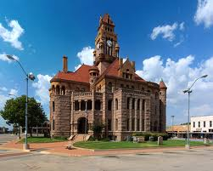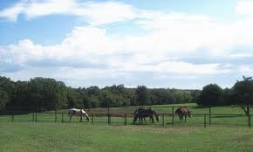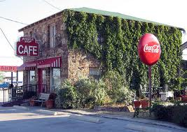
The community of Decatur, Texas is 38 miles north of the Fort Worth, Texas metropolitan area and less than an hour from the DFW International Airport. The population as of 2010 was 6,042, an increase of 25% since 2000. The area is a combination of rural and urban communities which make Decatur’s community culture “out of the ordinary” but an ideal place to call home. Decatur holds dearly to its western heritage as a stop on the famed Chisholm Trail. Decatur is the county seat for Wise County. The county’s current population is 59,127.
Agriculture and the oil and gas industry are the biggest private industries today in the Decatur area but several other major employers make their home in Decatur. Other industries are within a 30-minute commute to Denton, Dallas, or Fort Worth without the hassle of big city traffic.
Traffic problems, violent crime and fear are virtually nonexistent. Children are safe without having to sacrifice a quality education. Families are moving here because of award-winning schools and an outstanding regional health facility. Churches of most denominations are located in Decatur and Wise County. Decatur is home to several major hotel chains with numerous restaurants and fast food chains.
Decatur has experienced phenomenal growth in the past several years. Average prices for a three bedroom, two baths home are $125,000. Rental homes average $900-$1,300 a month and government housing is not available.
The climate in Decatur has relatively moderate winters and warm summers. The average winter temperature is around 45 degrees while the summers average 10-12 days above 100 degrees. The annual average precipitation is 42 inches and average snowfall 3.9 inches. Spring and fall seasons provide beautiful weather. Decatur’s elevation is 1,111 feet above sea level which is the second highest elevated county seat in the state of Texas.
Helpful Links:
National Forests and Grasslands in Texas
http://www.fs.fed.usda.gov/texas

State of Texas
http://www.texas.gov/

City of Decatur
http://www.decatur.org/

Decatur Chamber of Commerce
http://www.decaturtx.com/

Wise County Messenger
http://www.wcmessenger.com

Wise County Directory of Area Churches
http://www.wcmessenger.com/church

Decatur Independent School District
http://www.decaturisd.us/

Wise Regional Health System
http://www.wiseregional.com./

Contact Information:

If you are interested in the position and want to receive more information, please complete the attached form and send it via email to Austin Sewell (rasewell@fs.fed.us) with a cc to Thomas Philipps (tphilipps@fs.fed.us) at the National Forests and Grasslands in Texas-Caddo/LBJ Grasslands Ranger District. You can also call 940-627-5475.

The form may also be mailed to:

National Forests and Grasslands in Texas
Caddo/LBJ Grasslands Ranger District
Attn: Austin Sewell
1400 N. Highway 81/287
Decatur, Texas 76234
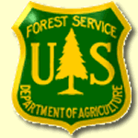
OUTREACH RESPONSE FORM
Range Management Specialist - GS-454-5/7/9
Caddo-LBJ National Grasslands, Decatur, Texas
Email to rasewell@fs.fed.us by October 7, 2015
National Forests and Grasslands in Texas

NAME:

E-MAIL ADDRESS:

MAILING ADDRESS:

TELEPHNE NUMBER:
 | {USFS |  | {BLM |  | OTHER)

AGENCY EMPLOYED WITH:

 | {PERMANENT |  | {TEMPORARY |  | {TERM
TYPE OF APPOINTMENT:

 | {VRA |  | {PWD |  | {OTHER

 | {REGION |  | {FOREST

CURRENT:
{DISTRICT

 | {SERIES |  | {GRADE

CURRENT:
{POSITION TITLE

CURRENT:

ARE YOU A RECENT GRADUATE? WHEN DID YOU GRADUATE WITH A DEGREE? WHAT DEGREE DID YOU GRADUATE WITH?

ARE YOU ELIGIBLE TO BE HIRED UNDER ANY OF THE FOLLOWING SPECIAL AUTHORITIES?

PERSON WITH DISABILITIES

DISABLED VETERANS W/30% COMPENSABLE DISABILITY

VETERANS EMPLOYMENT OPPORTUNITIES ACT OF 1998

FORMER PEACE CORPS VOLUNTEER

Thank you for your interest in our Vacancy!

