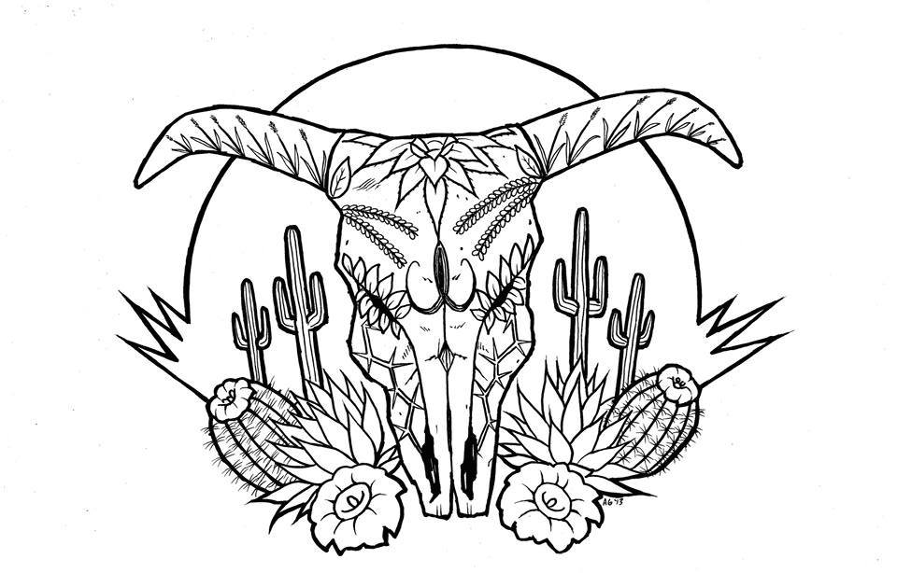
Tierra Seca
University of Arizona Student Chapter
Society for Range Management

College of Agriculture and Life Sciences
School of Natural Resources and the Environment

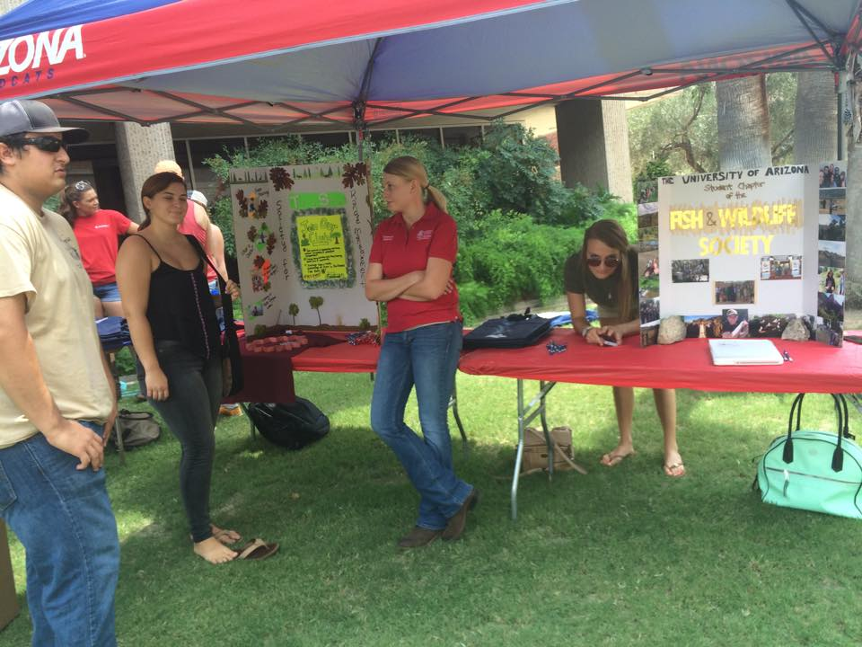
- Tierra Seca Meeting Agenda 09/2/2015
  - Call to order @ 12:00 PM

- Call to Order:
  - Members in attendance: students: Leland, Damien, Natalya, Gerry, Sarah, Angel, Brett, Amber, Josh, Stephen, Larry, Zach, Rachel, Jenn, Toby, Kelsey, Zach, Joey, Morgan
Dr. Mitch McClaran and Dr. Larry Howery

- President’s Report:
  - Introductions
  - Semester meeting dates: 9/2, 9/16, 9/30, 10/14, 10/28, 11/18, 12/2
  - Upcoming Events
    - V Bar V Ranch Monitoring (Friday/Saturday): 10/2-10/3; 10/16-10/17; 11/6-11/7
      - Volunteers for 10/2-10/3: Jenn, Kelsey, Rachel, Zach and Morgan maybe
      - Volunteers for 10/16-10/17: ------------- Conflicts with RISE
      - Volunteers for 11/6-11/7: Joey, Zach, Damien
    - Rise Symposium 10/17
      - Volunteers: Rachel, Morgan, Kelsey, Leland, Jenn, Joey, Angel, Natalya
    - Elkhorn Ranch Monitoring:
      - Friday, November 13th
      - Volunteers on sign-up sheet: Jennifer, Kelsey, Joey, Natalya, Stephen and Morgan (Maybe)
- Vice President’s Report:
  - Elkhorn Monitoring
  - Plant ID
- Treasure’s Report:
  - Dues ($10 per semester)
    - Paid dues: Gerry (whole year), Natalya, Angel, Morgan
  - Account balances: Checking: $3945.33 ; Savings: $395.21 Cash: $330.00
- Miscellaneous:
  - Dean’s Breakfast Burrito Saturday October 24th (homecoming weekend)
    - FREE FOOD
  - URME Introduction: Larry Howery & Jennifer Hanson
    - Interested parties: Jenn, Morgan, Joey, Rachel
  - Arroyo Chico Wash cleanup led by Katy Hughes
  - Garden Plot: http://tierrasecauofa.wix.com/tierra-seca-garden
    - Contact - Kelsey
  - T-shirt, hat, and sticker orders
  - Tierra Seca items:
    - Koozies $5 (ON SALE for $3)
    - T-Shirts $10
  - SNRE seminars
    - Every Wednesday in S107- ENR2 from 3:00-4:00pm
  - Fundraising
  - Other new business or discussion?
- Adjournment: 12:46 PM

Facebook club link: https://www.facebook.com/uofatierraseca
President: Leland Sutter lelandsutter@email.arizona.edu
Vice President: Rachel Turner rachelturnerj@gmail.com
Secretary: Morgan Gourley mjgourle@email.arizona.edu
Treasurer: Joey Dahms dahmsjo@email.arizona.edu

