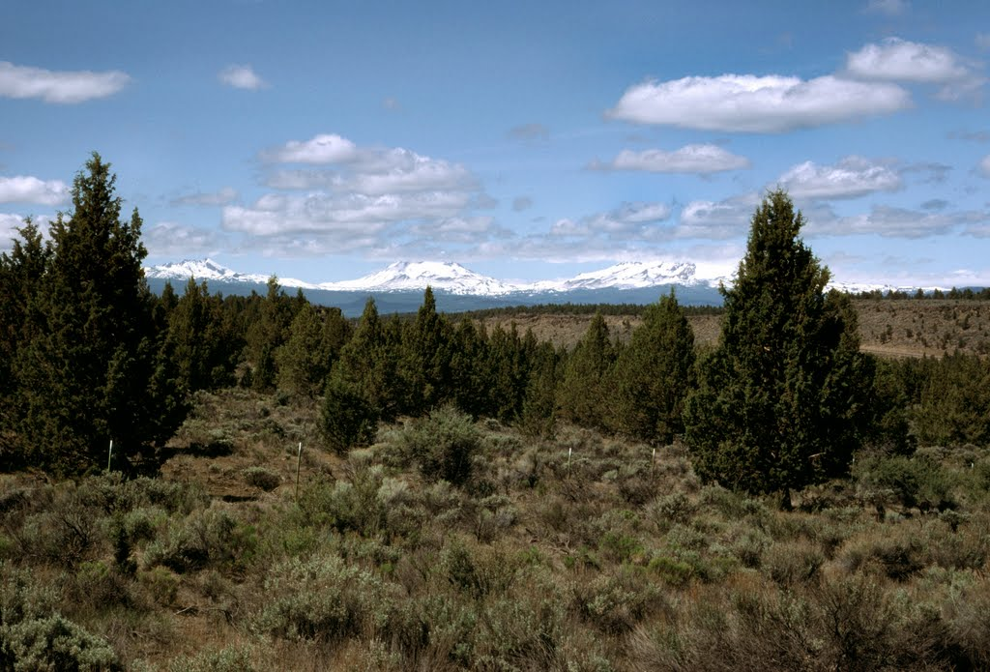

“Caring for the Land and Serving People”

OUTREACH NOTICE

DESCHUTES NATIONAL FOREST

BEND/FORT ROCK RANGER DISTRICT

BEND, OREGON

Rangeland Management Specialist

GS-0454-9

The Deschutes National Forest will be advertising a GS-0454-9 Rangeland Management Specialist position. The position is a permanent appointment, and will be located at the Bend/Fort Rock Ranger District in Bend, Oregon. Only one position will be filled.
The purpose of this Outreach Notice is to determine the potential applicant pool for this position and to establish the appropriate recruitment method and area of consideration for the advertisement. Responses received from this outreach will be relied upon to make this determination. Reply by September 30, 2015
Anyone interested in further information or receiving a copy of the vacancy announcement when it opens is advised to complete and return the attached Outreach Response form.
THE POSITION
This position reports directly to the Bend-Fort Rock Ranger District Natural Resources Team Leader and works closely with the shared Ochoco and Deschutes National Forest range program manager.

This position is responsible for the annual planning and implementation of the Deschutes National Forest range program, which includes three Ranger Districts (Bend-Fort Rock, Crescent, Sisters). The Deschutes range program consists of 8 currently active allotments and 13 vacant allotments with around 2,600 cow calf pairs. Program management activities include expenditure tracking, administering all grazing permits, yearly reporting and monitoring of grazing program, and operation of two significant wells that provide water to range, fire, wildlife, and recreation.

The selected individual will be responsible for reviewing NEPA related range documents to ensure compliance with all relevant rangeland laws, policies, and direction. They also serve as essential IDT representative representing range resources on various projects and are responsible for providing input during project design and authoring all supporting range documents. Ongoing project input through implementation will be essential to ensure compliance with all relevant guidance.

ABOUT THE AREA
The City of Bend (http://www.bend.or.us) is a rapidly-growing metropolitan area located in the central portion of the state, on the east side of the Cascade Mountains. This “High Desert” community is a full-service community that serves as a hub for medical, educational, recreation and entertainment needs for a large geographic area in Central Oregon. Tourism plays an important role in the local economy and regional economy.
COMMUNITY INFORMATION
Elevation: 3,623 feet
Population: City – ~80,000
County: Deschutes
Location: East side of the Cascade Mountains in Central Oregon
20 miles southeast of Sisters, Oregon
15 miles south of Redmond, Oregon
Average Summer Temperatures: 85º/day 44º/night
Average Winter Temperatures: 41º/day 21º/night
Average Annual Precipitation: 12” (mostly in the form of winter snow)
Closest Commercial Airport: Redmond, Oregon (an easy 15-mile drive to the north);
serviced by United, Delta, and Alaska Airlines
SCHOOLS
Bend is served by public and private schools from pre-school through high school. Public schools are administered by the Bend-LaPine School District (http://www.bend.k12.or.us) . College level community education courses and two year degree programs are offered locally in Bend, and at satellite campuses, through Central Oregon Community College (COCC) (http://www.cocc.edu). Additionally, OSU Cascades offers four-year degrees through Oregon State University and the University of Oregon (http://www.osucascades.edu).

HEALTH CARE
Bend is the primary center for high quality health care in Central Oregon with one major hospital (http://www.stcharleshealthcare.org), numerous clinics, and the associated full array of medical support and services. Redmond, located approximately 15 miles north of Bend, also has a community hospital and associated high quality medical support and services.
HOUSING
As a rapidly growing city and region, real estate is readily available. The median sales price for a residential three bedroom home is around $272,965 and 3 bedroom rentals average $1150 per month. Prices in Redmond are typically lower ($177,305 and $950 respectively).
ANNUAL EVENTS
The local area is well known for its many annual events, including: Winterfest (February), Bend Summer (July) and Fall Festivals (October), Arts in the High Desert (August, ranked in the top 15 nationally for fine arts shows), Bend Film Festival (October). Classical music is performed by the Central Oregon Symphony in Bend during the winter months.
Annual athletic and recreational events also take place on forest lands under special use permit. The Pole, Pedal, Paddle race (May) is a well-recognized event in Oregon and surrounding states. The Cascade Cycling Classic (July) a week of professional and amateur races, Mt. Bachelor ski area(http://www.mtbachelor.com) 25 miles, and Hoodoo Ski Area (http://www.hoodoo.com) 40 miles, provide excellent skiing opportunities. Mountain bike trails are abundant, with the Phil’s trail system very highly regarded.

A diversity of other events and concerts are regularly held at the refurbished downtown Tower Theatre (http://www.towertheater.org), as well as outdoor concerts at the Les Schwab Amphitheater (http://www.bendconcerts.com) and Athletic Club of Bend (http://www.athleticclubofbend.com). The nearby communities also offer many festivities, including the Sisters Rodeo and Parade (June), Outdoor Quilt Show (July), Sisters Folk and Jazz Festivals (September), Sunriver Music Festival (August), and free music venues throughout the summer in both Bend and Redmond. The County Fairgrounds in nearby Redmond hosts numerous events, as well as major entertainment on a regular basis.

The U.S. Department of Agriculture (USDA) prohibits discrimination in all its programs and activities on the basis of race, color, national origin, age, disability, and where applicable, sex, marital status, familial status, parental status, religion, sexual orientation, genetic information, political beliefs, reprisal, or because all or part of an individual’s income is derived from any public assistance program. (Not all prohibited bases apply to all programs.) Persons with disabilities who require alternative means for communication of program information (Braille, large print, audiotape, etc.) should contact USDA’s TARGET Center at (202)720-2600 (voice and TDD). To file a complaint of discrimination, write to USDA, Director, Office of Civil Rights, 1400 Independence Avenue, S.W., Washington, DC 20250-9410, or call (800) 795-3272 (voice) or (202) 720-6382 (TDD). USDA is an equal opportunity provider and employer.

Rangeland Management Specialist GS-0454-9

OUTREACH RESPONSE FORM

If you are interested in this position, please complete the information below and return it to:

E-mail: atasler@fs.fed.us
or
Mail: Bend-Fort Rock Ranger Station
ATTN: Andrew Tasler
60395 Deschutes Market Road
Bend, OR 97701

For additional details on the position, you may call Andrew Tasler at (541) 383-4701.

Vacancies will be advertised on USAJobs at https://www.usajobs.gov.

PERSONAL INFORMATION:

Name |  | Date
Address
City |  | State
Zip |  | E-Mail
Phone number(s)
Are you currently a federal employee
If Yes, current agency and location
current title/series/grade
Type of Appointment |  |  | Permanent |  |  | Term | Temporary
Type of Schedule |  |  | Full-time |  |  | Part-time | Intermittent
If you are not a current permanent (career or career conditional) employee, are you eligible for appointment under any of the following special authorities (check the appropriate box):
 | Person with Disabilities
 | Veteran’s Recruitment Act
 | Former Peace Corps Volunteer
 | Disabled Veteran with 30% Compensable Disability
 | Student Intern Program
 | Veterans Employment Opportunities Act 0f 1998
 | Other, please describe:

