Twelfth Annual Symposium

RISE
Research Insights in
Semiarid Ecosystems

Recent research at the USDA-ARS Walnut Gulch Experimental Watershed (WGEW) and the University of Arizona Santa Rita Experimental Range (SRER) and the Region

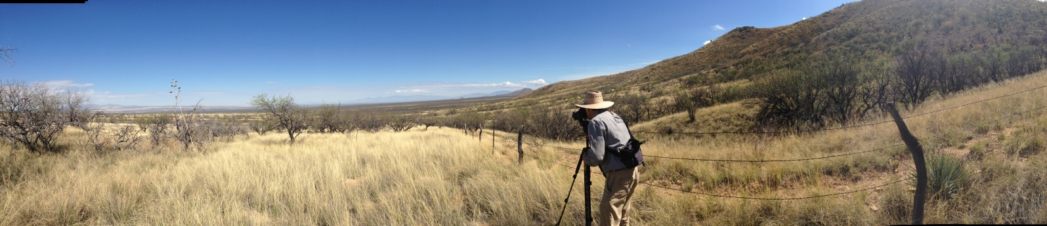

Call for Posters and Registration
including Student Poster Contest

Saturday, 17 October 2015, 8:30 AM to 3:00 PM

University of Arizona, Tucson, Marley Building, Rm. 230
Lunch and Poster Session, 11:15-1:30 PM
Registration Fee: $10 Students; $25 All Others (includes lunch)

Purpose: Share recent results of scientific research at WGEW and SRER, to encourage future research activities at the WGEW and the SRER, and to promote the WGEW and the SRER as outdoor scientific laboratories.

Registration, Posters submission, and Program information is available at http://www.tucson.ars.ag.gov/rise/

Photograph by Kelsey Hawkes, University of Arizona.

