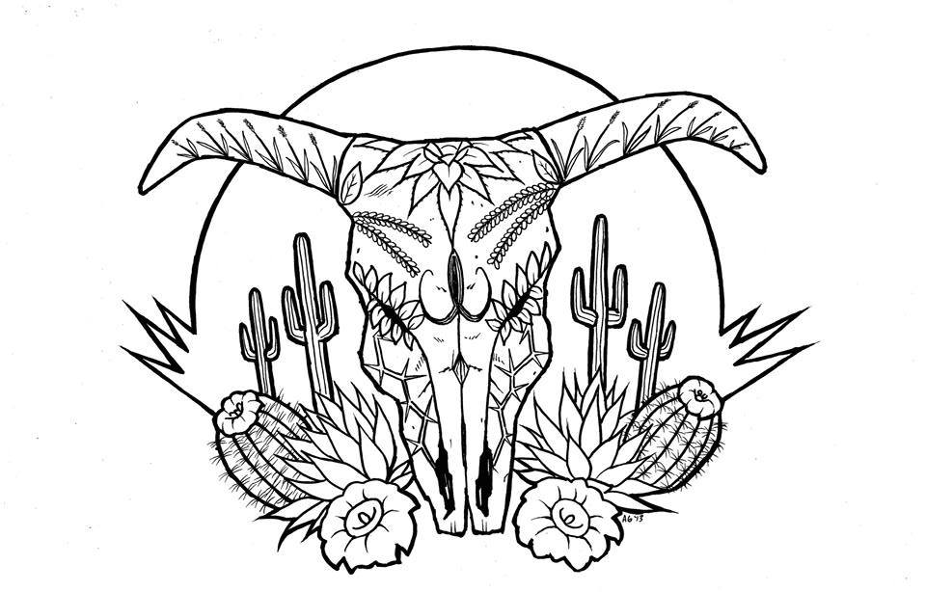
Tierra Seca
University of Arizona Student Chapter
Society for Range Management

College of Agriculture and Life Sciences
School of Natural Resources and the Environment

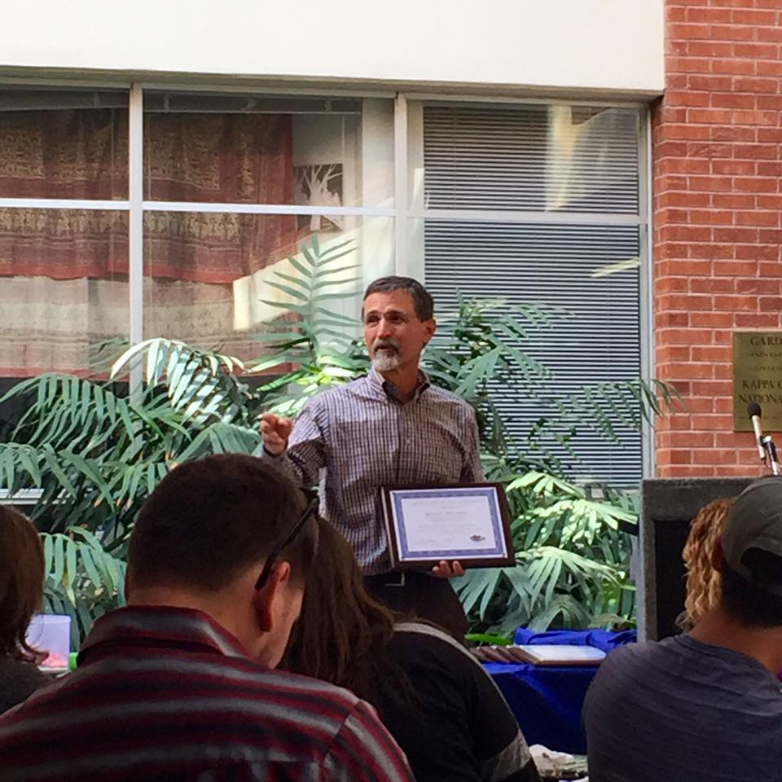
- Tierra Seca Meeting Agenda 04/29/2015

- Call to Order:
  - Members in attendance:
  - Approve meeting minutes from 04/29/2015:
- President’s Report:
  - Introductions
  - Semester meeting dates: Last one. Stay tuned for next semester’s dates!
  - Upcoming Events
    - CALS Graduation Ceremony
      - May 16th, 9 am, Mckale center
      - Volunteers: Leland Sutter, Jennifer Hanson, Zach Madrid
    - Summer SRM meeting
      - August 5th to August 7th
      - Prescott, AZ
      - Need volunteers for our annual burrito breakfast!
    - SNRE BBQ
      - Wednesday, April 29th
      - BSE Courtyard at 4:00pm
    - UAFWS & Tierra Seca Bonfire/Campout
      - May 14th, 2015 Thursday
      - Pena Blanca Lake
- Vice President’s Report:
  - Elkhorn Monitoring
  - Decorate Tierra Seca Display
- Treasure’s Report:
  - Dues ($10 per semester)
    - Paid dues: Gerry Berthelette, Jason Myrand, Jennifer Hanson, Leland Sutter, Emily Pecilunas, Rachel Turner, Trevor Chilcote, Emilio Corella, Zack Madrid, Taylor Ulrich, Neil Dutt, Natalya Sherman, Cassidy Solper, Morgan Gourley, Anna Collins, Sarah Noelle, Joey Dahms, Michelle Gradall, Andy Warnick
  - Account balances: Checking $4,982.00 ; Savings $395.21
- Miscellaneous:
  - 47 Ranch
  - Arroyo Chico Wash cleanup led by Katy Hughes
  - Garden Plot: http://tierrasecauofa.wix.com/tierra-seca-garden
    - Contact Trevor for more info: tchilcote@email.arizona.edu
  - Tierra Seca items:
    - Koozies $5
    - T-Shirts $10
  - Hunter Safety Course
    - http://www.azgfd.gov/i_e/edits/hunter_education.shtml
  - SNRE seminars
    - Every Wednesday in Marley 230 from 3:00-4:00pm
  - Fundraising
    - Aluminum Drive! Cans, tins, foil-anything aluminum! Bins in BSE now
    - Other ideas?
  - Other new business or discussion?
- Adjournment:

Facebook club link: https://www.facebook.com/uofatierraseca
President: Leland Sutter lelandsutter@email.arizona.edu
Vice President: Rachel Turner rachelturnerj@gmail.com
Secretary: Morgan Gourley mjgourle@email.arizona.edu
Treasurer: Joey Dahms dahmsjo@email.arizona.edu

