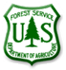
Coronado National Forest
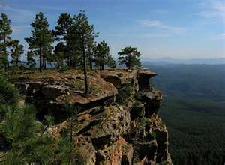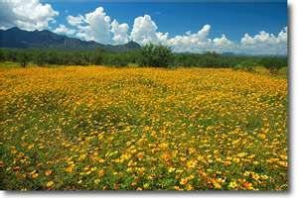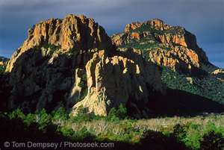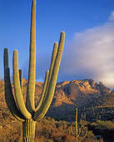

Join our team on the Coronado National Forest!

DISTRICT RANGELAND MANAGEMENT SPECIALIST

GS-0454-05/07/09

Salary: $31,628 - $62,297
Work Schedule: Full-time
Duty Station: Douglas Ranger District in Douglas, Arizona

The Coronado National Forest (CNF) in southern Arizona is advertising a GS-0454-05/07/09 District Rangeland Management Specialist position under the Pathways Recent Graduate Program and additionally the position is open to current federal employees or those meeting specific other requirements. If interested in this position, please apply through the USAJOBS website. Qualification requirements for the GS-0454 position series can be found at the following link: http://www.opm.gov/policy-data-oversight/classification-qualifications/general-schedule-qualification-standards/0400/rangeland-management-series-0454/

Job Announcement Number: 15-0305-9804G-PLK

Job announcement number 15-0305-9804G-PLK is open from Monday, April 13, 2015 to Friday, April 24, 2015 and is open to current permanent Federal employees with competitive status, reinstatement eligibles, persons with disabilities, VEOA/VRA eligibles, certain military spouses, 30% or more disabled veterans, former Peace Corps or VISTA volunteers, CTAP/ICTAP eligibles, Farm Service Agency permanent county employees and those eligible for other Special Hiring Authorities.

Job Announcement Number: 15-RG-0454-119786-PW

Job Announcement Number 15-RG-0454-119786-PW will be open from Monday, April 20 2015 to Friday, April 24 2015 and is open to individuals meeting the eligibility requirements of the Pathways Recent Graduate Program which is further explained below.

MAJOR DUTIES

The position provides professional and technical expertise to a complex Range and Watershed program. The incumbent is responsible for:
- Conducting short and long term monitoring of plant communities and their trends; grazing impacts, precipitation, soil erosion hazards and riparian condition.
- Conducts studies of range conditions, trends and utilization
- Carrying out ecosystem based rangeland surveys and inventories.
- Gathering and assembling data concerning rangeland health, trends, ecological status of vegetation communities, site potential and desired plant community.
- Compiles material and supply estimates and/or oversees the construction and/or maintenance of rangeland projects.
- Makes recommendations for improved rangeland and livestock administration and provides input into the development of subsequent rangeland and livestock management decisions.
- Prepares livestock management plans, determines location and proper stocking and locates, prescribes, designs, and schedules rangeland improvement projects such as fences, pipelines, cattleguards, plant community changes, or prescribed burning.
- Maintains continuing working relationship with permittees and others to ensure compliance with agreed upon plans and desired quality of work, and to advise rangeland users of various activities affecting their use of specific rangeland areas. Prepares and/or revises annual rangeland user instructions. Prepares or initiates action on cooperative agreements for rangeland improvements.
- Assists in the administration of grazing permits by consulting, coordinating and cooperating with permittees and other rangeland users. Determines permittee compliance with permits and makes recommendations to correct discrepancies.
- Determines rangeland readiness for various rangeland uses, inspects rangeland uses for compliance with permits, and monitors the results of the rangeland uses that are permitted or allowed. Prepares rangeland improvement maintenance schedules and keeps records of existing and proposed improvements, maintenance needs, and accomplishments.
- Conducts range allotment inspections, compiles actual use information, and prepares allotment management plans. Determines proper stocking and rotation schemes.
- Performs other duties as assigned.

ABOUT THE CORONADO NATIONAL FOREST
The twelve mountain range units of the Coronado National Forest total 1.7 million acres of public land, and offer an unusual range of vegetative types and climates. In only one hour, a visitor can drive from the hot, arid desert to the cool pines. The forest is exceptionally rich in diversity of flora and fauna.

The Coronado National Forest is made up of five Ranger Districts serving urban and rural populations. The Forest works hard to collaborate with these communities and share critical resources across boundaries.

Employer of Choice
The Coronado National Forest is also dedicated to nurturing and supporting the development of our employees. The Forest does this by encouraging participation in some or all of the following programs:
- Commuter Benefit Program: If you ride your bike to work, or use public transportation, the Forest can help you with the cost of commuting.
- Employee Wellness Program: Do you like to work out? With this program you can choose to be paid to work out up to three hours a week, or be reimbursed for half of your gym membership.
- Aglearn Rosetta Stone: The Coronado National Forest will pay for you to learn a new language! With your supervisor’s permission, you will be able to develop your linguistic skills.
- Mentoring: We all have skills to share, as well as something to learn. Our mentoring program encourages you to develop new skills and to teach the ones you already have.
- Healthy Awards: This program promotes a healthy work/life balance and rewards you for taking care of yourself. When you complete items on the list, you get points. At the end of the year, you redeem the points you’ve earned for either time off or spot award.

ABOUT THE DOUGLAS RANGER DISTRICT
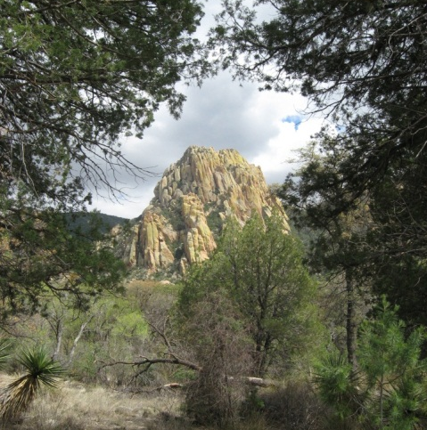
The Douglas Ranger District, one of the five districts of the Coronado National Forest, encompasses three mountain ranges: the Chiricahua Mountains (291,496 acres), the Dragoon Mountains (54,211 acres) and the Peloncillo (Pel-un-see-yo) Mountains (87,986 acres). These mountain ranges are part of the Coronado National Forest “Sky Island” landscape with some of the most diverse wildlife and plant life in Arizona. The District is located in the southeastern corner of Arizona and southwest New Mexico. As the heartland of the Chiricahua Apache, the Douglas District is the custodian of many unique historic and pre-historic cultural resource sites.
Ecological types range from Sonoran and Chihuahuan deserts to spruce-fir forests, as elevations rise from about 4500 feet to over 9700 feet. The monsoon (rainy) season is a very important part of the ecosystem. Running from July through September, the monsoon provides about nine inches of precipitation on average with the remaining 7 inches generally in the winter. Temperatures range from an average low in the low-twenties in winter to average highs in the high-90’s for summer.
During the summer season, the District employs an average of 30 people. There are 20 full time staff, including the fire, range/watershed, wildlife, zoned recreation and law enforcement organizations.

Douglas, AZ Community Information
Douglas, Arizona, is located 118 miles southeast of Tucson (population 486,700) on the US-Mexico border with a population of approximately 15,000. The City of Douglas, as part of the southern Arizona region, has been listed as one of the 100 top places to live in America according to a recent study conducted by Bizjournal.com. Serving as Arizona’s gateway to Mexico, Douglas is full of history, architecture, minerals, artifacts, and fossils.
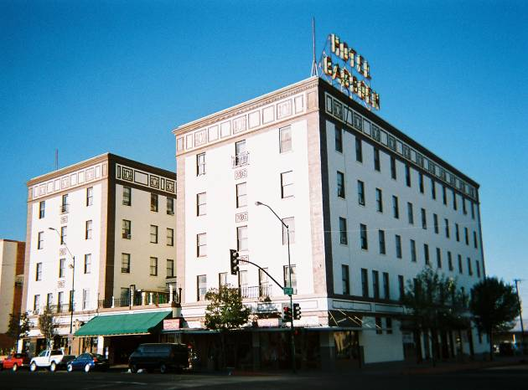
We have five elementary schools, two middle schools and one high school. Douglas also has Charter Schools open for enrollment. Located just 10 minutes outside of town, Cochise Community College has its Douglas Campus. Additionally, The University of Arizona South Facility is co-located at Cochise College Campus. The Cochise Regional Hospital is located 3 miles west of town, and the city boasts a new dialysis center. Private physicians and medical clinics are available in town. Douglas has a full complement of religious congregations, including Roman Catholic, Methodist, Baptist, Lutheran, LDS, Church of Christ, Church of God, and Jehovah Witness. The Elks Lodge, Lions Club, VFW Post and the Bushmasters Club are all active and visible in the community.

Bisbee, AZ Community Information
Bisbee, AZ is located about 20 miles northwest of Douglas and is a popular place to live because of its small town charm and cooler climate (elev. 5,500ft). Bisbee, a once booming copper mining town of over 20,000 people, has transformered itself into a quiet tourist community (pop. 5,600) offering many opportunities to stroll the sidewalks and enjoy the art galleries, restaurants, coffee shops, and local breweries. Today Bisbee is better known for its relaxed quality of life and uncommon blend of creativity, friendliness, and style. 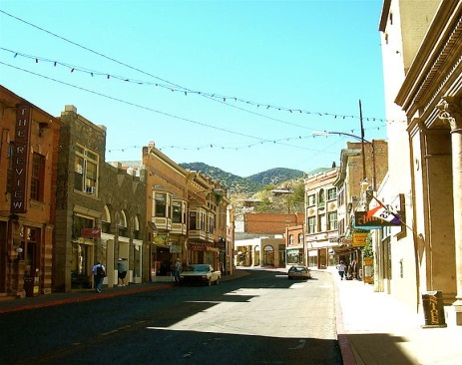

To find more information about the Coronado National Forest and the Douglas Ranger District, visit our website at http://www.fs.usda.gov/coronado/

PATHWAYS RECENT GRADUATE PROGRAM ELIGIBILITY REQUIREMENTS
1. A Recent Graduate is an individual who obtained a qualifying associates, bachelors, master's, professional, doctorate, vocational or technical degree or certificate from a qualifying educational institution, within the previous 2 years or other applicable period provided below.

2. Except as provided in paragraph (3) below, an individual may apply for a position in the USDA Recent Graduates Program only if the individual's application is received not later than 2 years after the date the individual completed all requirements of an academic course of study leading to a qualifying associates, bachelor's, master's, professional, doctorate, vocational or technical degree or certificate from a qualifying educational institution.

3. A veteran, as defined in 5 U.S.C. 2108, who, due to a military service obligation, was precluded from applying to the Recent Graduates Program during any portion of the 2-year eligibility period described in paragraph (1) of this section shall have a full 2-year period of eligibility upon his or her release or discharge from active duty. In no event, however, may the individual's eligibility period extend beyond 6 years from the date on which the individual completed the requirements of an academic course of study.

Recent Graduates who satisfactorily complete the USDA Recent Graduates Program and meet all eligibility requirements for conversion may be non-competitively converted to a term or permanent appointment in the competitive service. Program requirements include:

- Must be a U.S. citizen prior to conversion;
- Successfully completed all the requirements of the USDA Recent Graduates Program;
- Demonstrated successful job performance consistent with the applicable performance appraisal program established under the agency’s approved performance appraisal system that results in a rating of record (or summary rating) of at least Fully Successful or equivalent and a recommendation for conversion by the first-level supervisor; and
- Met the OPM qualification standard for the competitive service position to which the Recent Graduate will be converted.

To be eligible for conversion, the Recent Graduate must:

- Meet the qualification standards for the position to which the Recent Graduate will be converted;
- Have at least 1-year of continuous work experience;
- Receive a satisfactory recommendation by his/her mentor;
- Meet training requirements as specified in the USDA Pathways Programs Training Plan; and perform their job successfully and satisfactory

HOW TO APPLY:
Please read the entire announcement and all the instructions before you begin.
The following instructions outline our application process.
- You must complete this application process and submit all required documents electronically by 11:59 p.m. Eastern Time (ET) on the closing date of this announcement.
- We are available to assist you during business hours (normally 8:00 a.m. - 4:00 p.m., Monday - Friday). Applying online is highly encouraged. If applying online poses a hardship, please contact our office during business hours well before the closing date for an alternate method. All hardship application packages with supporting documents must be submitted no later than noon on the closing date of the announcement in order to be entered into the system prior to its closing.
- This agency provides reasonable accommodation to applicants with disabilities on a case-by-case basis; contact us if you are requesting this.
Step 1: Create a USAJOBS account (if you do not have one) at www.usajobs.gov. It is recommended that as part of your profile you set up automatic email notification to be informed when the status of your application changes. If you choose not to set up this automatic notification, then you will have to log into your USAJOBS account to check on the status of your application.
Step 2: Create a resume with USAJOBS or upload a resume into your USAJOBS account. Customize your resume to ensure it documents duties and accomplishments you have gained that are directly related to this position in order to verify that qualifications are met. Your resume must support your responses to the online questionnaire (you may preview the online questionnaire by clicking on the link at the end of the How You Will Be Evaluated section of the job announcement).
Step 3: Click "Apply Online" and follow the prompts to complete the Occupational Questionnaire and attach any additional documents that may be required.
You can update your application or documents anytime while the announcement is open. Log into your USAJOBS account and click on "Application Status." Click on the position title, and then select "Update Application” to continue.
NOTE: Verify that uploaded documents from USAJOBS transfer into the Agency's staffing system. Once in the Agency's staffing system you will have the opportunity to upload additional documents. Uploaded documents must be less than 3MB and in one of the following document formats: GIF, JPG, JPEG, PNG, RTF, PDF, or Word (DOC or DOCX).

REQUIRED DOCUMENTS:
The following documents are required for your application to be complete. Our office cannot be responsible for incompatible software, illegible fax transmissions, delays in mail service, your system failure or downtime, etc. Encrypted and digitally signed documents will not be accepted. Failure to submit required, legible documents may result in loss of consideration.
- Resume must include: 1) personal information; 2) education; 3) work experience including work schedule, hours worked per week, dates of employment; and title, series and grade if applicable; 4) supervisor's phone number, e-mail address for each work period listed, and whether we may contact for reference checks; and 5) other qualifications.
- College Transcripts if education is required for meeting basic qualifications and/or used as a substitute for specialized experience. An unofficial copy is sufficient; however, if selected, an official transcript will be required prior to entering on duty. Education must have been successfully completed and obtained from an accredited school, college, or university. Foreign education must be evaluated by an approved organization. For additional information, refer to the U.S. Department of Education website at http://www.ed.gov. All transcripts must be in English or include English translation.
You must submit the documents below if you claim any of the following:
- Current Federal Employees: Most recent non-award Notification of Personnel Action (SF-50/equivalent) showing that you are/were in the competitive service, highest grade or promotion potential held on a permanent basis, position title, series and grade AND most recently completed performance appraisal (dated within 18 months) showing the official rating of record, signed by a supervisor, or statement why the appraisal is unavailable. Do not submit performance plan.
- Non-Competitive(held target grade or higher)/Former Federal Employees: Most recent non-award Notification of Personnel Action (SF-50/equivalent) showing that you are/were in the competitive service, highest grade or promotion potential held on a permanent basis, position title, series and grade.
- Current Permanent FSA County Employees: Most recent non-award Notification of Personnel Action (SF-50/equivalent) showing highest grade or promotion potential held on a permanent basis, position title, series and grade.
- CTAP/ICTAP: Certification of Expected Separation, Reduction-In-Force Separation Notice, or Notice of Proposed Removal; AND most recent performance evaluation; AND SF-50 documenting separation or the position separating from. Worker's Compensation Separation: Agency certification of inability to place employee AND Notification of Separation OR Separation SF-50. Disability Annuity Termination: Notification from OPM of disability annuity termination AND Separation SF-50. Military Reserve or National Guard Technician Special Disability Retirement Annuity under 5 U.S.C. 8337(h) or 8456: Certification of special disability retirement annuity from the military or National Guard Bureau AND Separation SF-50.
- Veteran Hiring Authorities: VEOA, VRA and 30% Disabled Veterans: DD-214, Certificate of Release from Active Duty showing dates of service and discharge under honorable conditions. Disabled veterans must include VA letter & SF-15 if claiming 10 pt. preference. Current active duty members must submit certification that they are expected to be discharged or released from active duty under honorable conditions no later than 120 days after date the certification is submitted.
- Schedule A, Persons with Disabilities Appointment: Sch A letter from a physician, local, state or federal rehabilitation office citing eligibility under 5 CFR 213.3102 (u).
- Miscellaneous Authorities Not Regulated by the Office of Personnel Management: (Postal Career Service, Postal Service Commission, GAO, US Courts, etc.) Current Notification of Personnel Action/equivalent that reflects eligibility.
- Certain Family Members Eligible under E.O. 12721: Most recent non-award SF-50 and performance appraisal.
- Certain Military Spouses Eligible under E.O. 13473: Permanent Change of Station (PCS) orders issued within the last 2 years, that lists you as authorized to accompany the military member to the new duty permanent station; OR verification of the member's 100% disability (VA Letter); and/or verification of the member's death while on active duty (DD-1300 and Death Certificate) AND verification of the marriage to the service member (i.e. marriage license or other legal documentation verifying marriage).
- Foreign Service: Most recent Foreign Notification of Personnel Action, under an unlimited, career-type appointment AND have completed at least 1 year of continuous service without a break of a workday under one or more non-temporary Foreign Service appointments.
- Other Special Hiring Authorities: If claiming eligibility under a Special Hiring Authority not listed above submit appropriate supporting documentation.

