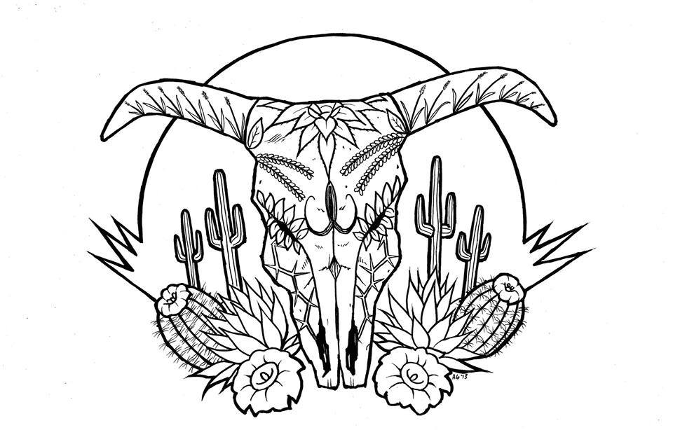
Tierra Seca
University of Arizona Student Chapter
Society for Range Management

College of Agriculture and Life Sciences
School of Natural Resources and the Environment

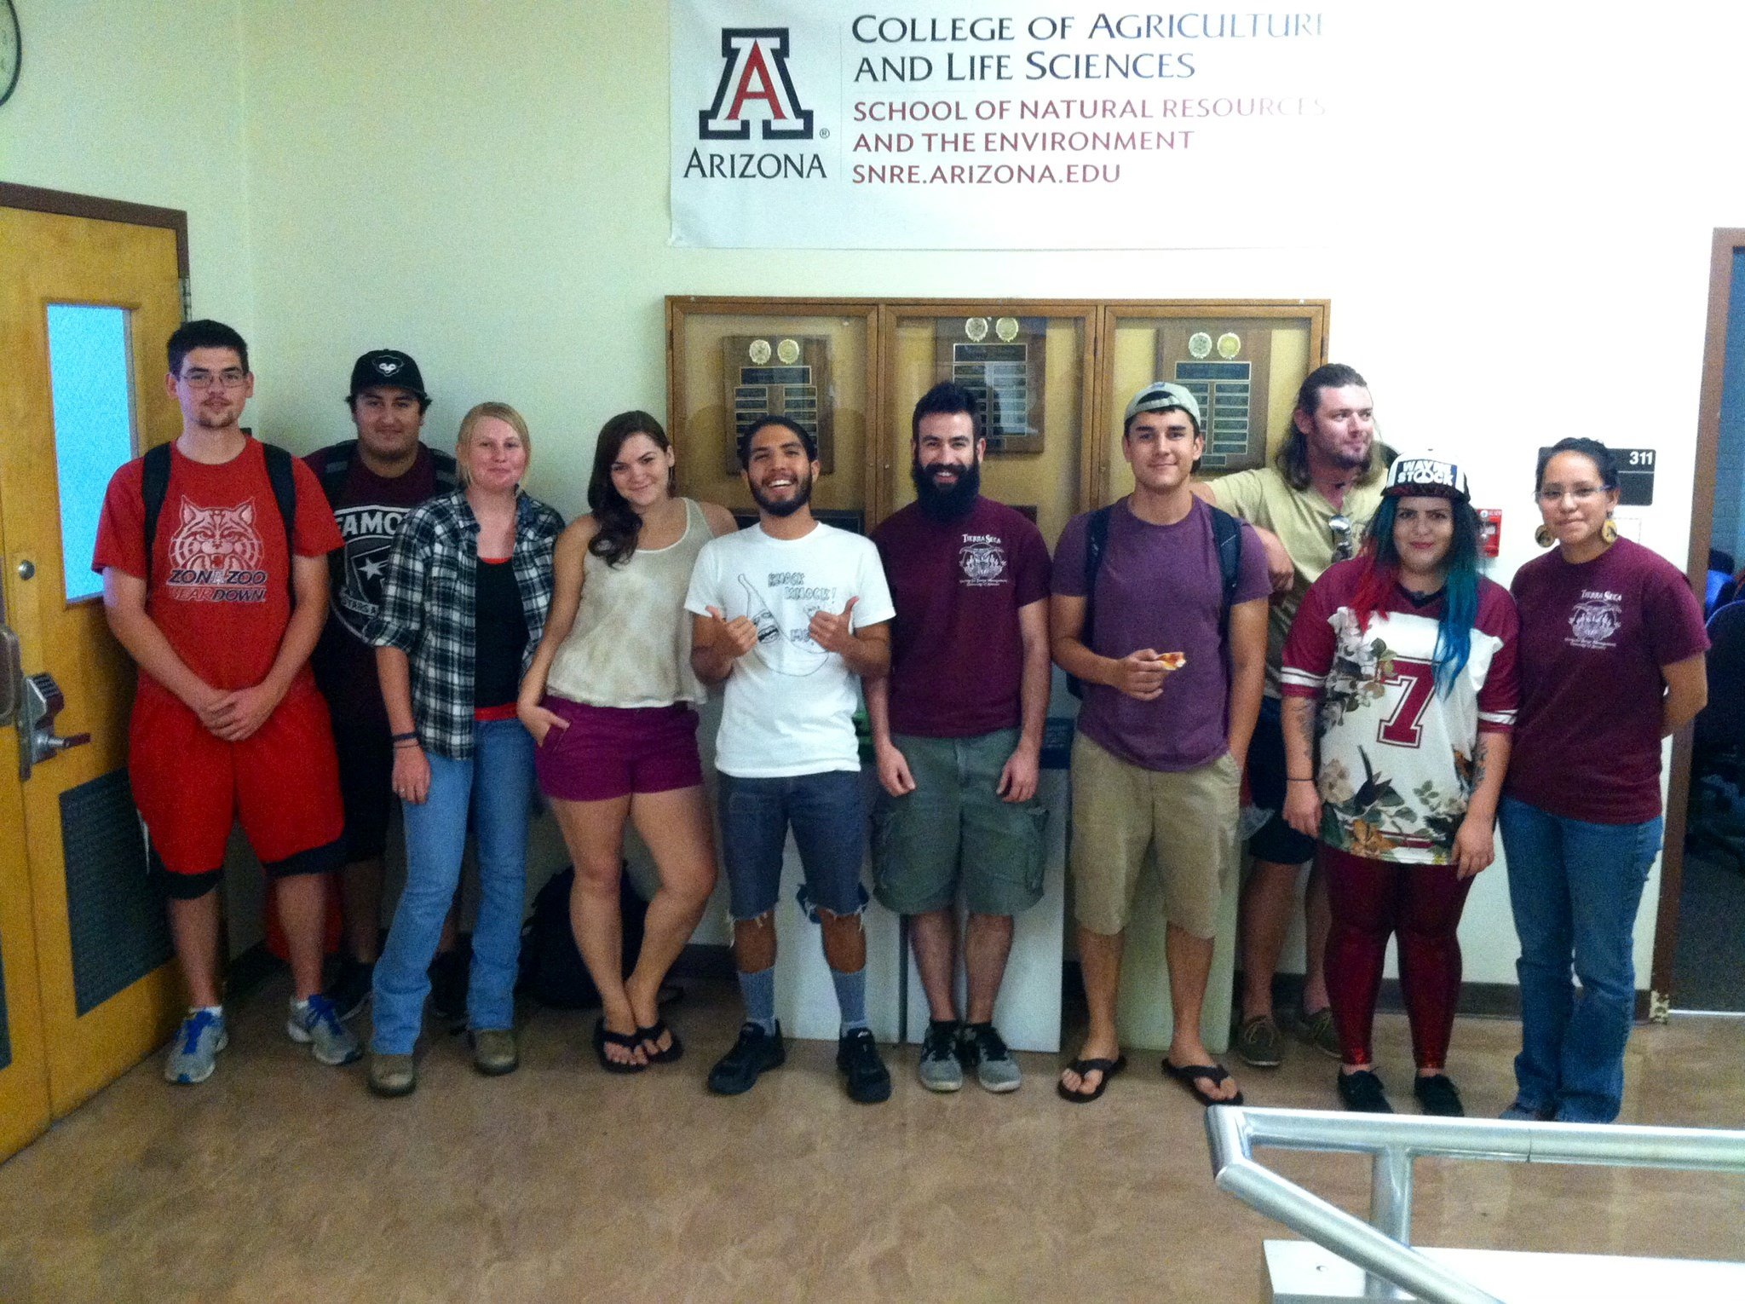
- Tierra Seca Meeting Agenda 04/01/2015

- Call to Order:
  - Members in attendance:
  - Approve meeting minutes from 03/04/2015:
- President’s Report:
  - Introductions
  - Semester meeting dates: 4/29
  - Upcoming Events
    - 47 Ranch
      - Rock Check Dams
      - April 18th –April 19th
      - Emilio (Sun.), Rachel, Jenn, Kelsey, Leland, Toby, Zach, Morgan, Gerry, Andy
    - Invasive grass removal at Saguaro Park
      - Second Saturday 8:00am-12:00pm
      - More info at www.buffelgrass.org
    - SNRE Awards Ceremony
      - Thursday, April 23rd in Saguaro Hall 3:30pm-5:00pm
    - Adopting the Arroyo Chico Wash by SNRE clubs
      - Highland & 14th streets
      - April 26, Sunday (waiting for permit to be approved)
    - SNRE BBQ
      - Wednesday, April 29th
      - BSE Courtyard at 4:00pm
    - UAFWS & Tierra Seca Bonfire/Campout
      - May 14th, 2015 Thursday
      - Pena Blanca Lake
    - Officer Nominations Fall 2015/Spring 2016
      - President: Leland Sutter, Joseph Dahms
      - Vice President: Jenn Hanson, Jason Myrand, Emilio Corella, Rachel Turner
      - Treasurer: Joseph Dahms, Emilio Corella, Zach Madrid, Morgan Gourley,
      - Secretary: Toby Rupel, Zach Madrid, Natalya Sherman, Morgan Gourley
      - 4/29 run the meeting!
      - Descriptions as follows:

Tierra Seca Officer Duties
a. President
i. Coordinate all activities of the organization.
ii. Liaison to the University community.
iii. Official representative of the organization.
iv. Call to order and organize meetings (preparing the agenda, informing members of the meeting time, presiding at meetings).
v. Act as a board member to the Arizona Section of the Society for Range Management.
b. Vice President
i. Assumes duties of president when necessary.
ii. Assists president in coordinating activities.
iii. Assist other officers as needed.
iv. Designs and maintains Tierra Seca displays in BSE foyer and third floor case.
v. Maintains social networking sites including Orgsync and Facebook profiles
vi. Manages listserv subscription
c. Secretary
i. Maintains accurate and current information of the organization and membership.
ii. Assists president and vice-president to coordinate organization activities.
iii. Keep accurate minutes and attendance of each meeting and forwards copies to other officers.
d. Treasurer
i. Liaison to ASUA for the purpose of organizational funding.
ii. Maintains accurate and current account of all organizational funds.
iii. Responsible for dispensing of funds in accordance with goals and programs established by the organization.
iv. Collect membership dues each semester.
v. Completes annual Taxes for non-profit status of our organization.

    - AZ SRM Summer Meeting
      - Wednesday, August 5th-7th
      - Prescott, AZ exact location TBD
      - http://azcowboypoets.org/schedules-2/

- Vice President’s Report:
  - Graduating Seniors
  - Agri-life council
- Treasure’s Report:
  - Dues ($10 per semester)
    - Paid dues: Gerry Berthelette, Jason Myrand, Jennifer Hanson, Leland Sutter, Emily Pecilunas, Rachel Turner, Trevor Chilcote, Emilio Corella, Zack Madrid, Taylor Ulrich, Neil Dutt, Natalya Sherman, Cassidy Solper, Morgan Gourley, Anna Collins, Sarah Noelle, Joey Dahms, Michelle Gradall
  - Account balances: Checking $ ; Savings $_
- Miscellaneous:
  - Garden Plot: http://tierrasecauofa.wix.com/tierra-seca-garden
    - Contact Trevor for more info: tchilcote@email.arizona.edu
  - Tierra Seca items:
    - Koozies $5
    - T-Shirts $10
    - Field Shirts – did everyone order one that wanted one?
  - Hunter Safety Course
    - http://www.azgfd.gov/i_e/edits/hunter_education.shtml
  - SNRE seminars
    - Every Wednesday in Marley 230 from 3:00-4:00pm
  - Fundraising
    - Aluminum Drive! Cans, tins, foil-anything aluminum! Bins in BSE now
    - 50/50 raffle
        - Competition vs. UAFWS club
        - Drawing will be afternoon of SNRE awards (April 23rd)
        - Club who raises least amount of money will sacrifice their President to taking a cow pie to the face
        - $1/ticket, $5/6tickets
    - Other ideas?
  - Other new business or discussion?
- Adjournment:

Facebook club link: https://www.facebook.com/uofatierraseca
President: Emily Pecilunas: epecilunas@email.arizona.edu, (623) 693-1964
Vice President: Leland Sutter lelandsutter@email.arizona.edu
Secretary: Jennifer Hanson jmh7@email.arizona.edu
Treasurer: Cassidy Solper csolper@gmail.com

