
Tierra Seca
University of Arizona Student Chapter
Society for Range Management

College of Agriculture and Life Sciences
School of Natural Resources and the Environment

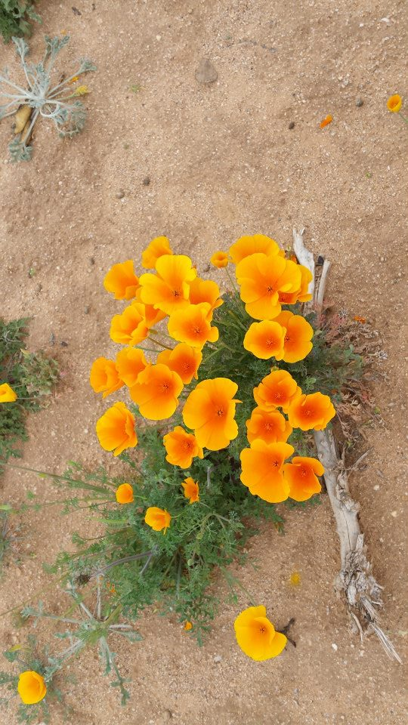
- Tierra Seca Meeting Minutes 04/01/2015

- Call to Order: 12:18
  - Members in attendance: 23 and advisor Mitch McClaran
  - Approve meeting minutes from 03/04/2015: Approved
- President’s Report:
  - Introductions
  - Semester meeting dates: 4/15, 4/29
  - Guest Speaker
    - Tierra Seca/UofA Range Alumni
    - Cameron Becker
    - cbecker@alwt.org
  - Events Report
    - CDE Day – coordinated by Larry Howery, helps with youth outreach – great volunteer turn out & the day was a success!
    - Tucson Festival of Books – Theresa volunteered over spring break, talked to kids and parents about fire ecology, tree rings, gis mapping, wildlife etc.
    - ASUA Club Awards – Leland attended, three nominations: Trevor & Emily nominated for senior leader, Mitch nominated for club advisor
  - Upcoming Events
    - 47 Ranch
      - Rock Check Dams
      - April 18th/19th – Bisbee farmer’s market in morning, working in afternoon, staying over at ranch and then doing work Sunday morning and coming back
      - Emilio(Sun), Emily, Rachel, Gerry, Andy, Kelsey, Leland, Toby, Zach, Morgan
    - Invasive grass removal at Saguaro Park
      - Second Saturday 8:00am-12:00pm
      - More info at www.buffelgrass.org
    - SNRE Awards Ceremony
      - Thursday, April 23rd in Saguaro Hall 3:30pm-5:00pm
      - Nominations! Due April 13th to Ashley Stewart in SNRE biz office
      - Forms available for nominations!
    - Adopting the Arroyo Chico Wash by SNRE clubs
      - Campbell/Kino to almost Park
      - April 26, Sunday (waiting for permit to be approved now)
    - SNRE BBQ
      - Wednesday, April 29th
      - BSE Courtyard at 5:00pm-7:00pm
      - Stop by and say hi!!
    - UAFWS & Tierra Seca Bonfire/Campout
      - Thursday, May 14th, 2015 (last day of finals)
      - Carpooling out to Pena Blanca Lake - more details to come!
    - Officer Nominations Fall 2015/Spring 2016
      - President: Leland, Joey
      - Vice President: Taylor, Jenn, Jason, Emilio, Rachel
      - Treasurer: Joey, Emilio, Zach, Morgan
      - Secretary: Toby, Natalya, Morgan, Theresa, Zach
      - 4/15 elections, 4/29 run the meeting!
      - Descriptions as follows:
Tierra Seca Officer Duties
a. President
i. Coordinate all activities of the organization.
ii. Liaison to the University community.
iii. Official representative of the organization.
iv. Call to order and organize meetings (preparing the agenda, informing members of the meeting time, presiding at meetings).
v. Act as a board member to the Arizona Section of the Society for Range Management.
b. Vice President
i. Assumes duties of president when necessary.
ii. Assists president in coordinating activities.
iii. Assist other officers as needed.
iv. Designs and maintains Tierra Seca displays in BSE foyer and third floor case.
v. Maintains social networking sites including Orgsync and Facebook profiles
vi. Manages listserv subscription
c. Secretary
i. Maintains accurate and current information of the organization and membership.
ii. Assists president and vice-president to coordinate organization activities.
iii. Keep accurate minutes and attendance of each meeting and forwards copies to other officers.
d. Treasurer
i. Liaison to ASUA for the purpose of organizational funding.
ii. Maintains accurate and current account of all organizational funds.
iii. Responsible for dispensing of funds in accordance with goals and programs established by the organization.
iv. Collect membership dues each semester.
v. Completes annual Taxes for non-profit status of our organization.
    - AZ SRM Summer Meeting
      - Wednesday, August 5th-7th
      - Prescott, AZ, exact location TBD
      - Arizona Cowboy Poets Festival happening at the same time
        - http://azcowboypoets.org/schedules-2/

- Vice President’s Report:
  - Graduating Seniors – Trevor, Cassidy, Michelle, Anna, Rachel, Emily, Andy
  - Campus farm – Planting for Frank Santiago, giving money back to club and guaranteed vehicles for next year’s URME – volunteering details to come!
  - Dr. Pearson – UA Alumni, lots of internships opening for poultry industry. Any interest, email Leland at lelandsutter@email.arizona.edu
- Treasure’s Report:
  - Dues ($10 per semester)
    - Paid dues: Gerry Berthelette, Jason Myrand, Jennifer Hanson, Leland Sutter, Emily Pecilunas, Rachel Turner, Trevor Chilcote, Emilio Corella, Zack Madrid, Taylor Ulrich, Neil Dutt, Natalya Sherman, Cassidy Solper, Morgan Gourley, Anna Collins, Sarah Noelle, Joey Dahms, Michelle Gradall
  - Account balances: Checking $___4982.00____; Savings $____395.21___
- Miscellaneous:
  - Garden Plot: http://tierrasecauofa.wix.com/tierra-seca-garden
    - Contact Trevor for more info: tchilcote@email.arizona.edu
    - Peas, carrots, cilantro, green onions available now!
  - Tierra Seca items:
    - Koozies $5
    - T-Shirts $10
    - Field Shirts – Orders are being processed now!
  - Hunter Safety Course
    - http://www.azgfd.gov/i_e/edits/hunter_education.shtml
  - SNRE seminars
    - Every Wednesday in Marley 230 from 3:00-4:00pm
  - Fundraising
    - Aluminum Drive! Cans, tins, foil-anything aluminum! Bins in BSE now
    - 50/50 raffle
        - Competition vs. UAFWS club
        - Drawing will be afternoon of SNRE awards (April 23rd)
        - Club who raises least amount of money will sacrifice their President to taking a cow pie to the face
        - $1/ticket, $5/6tickets
    - Other ideas?
      - Kelsey – working on nominations for awards if anyone wants to work on them together, can nominate different people for same category etc.
      - Hannah – possible Salt River tubing trip later in the semester. Details to come!
  - Other new business or discussion?
- Adjournment: 12:49

Facebook club link: https://www.facebook.com/uofatierraseca
President: Emily Pecilunas: epecilunas@email.arizona.edu, (623) 693-1964
Vice President: Leland Sutter lelandsutter@email.arizona.edu
Secretary: Jennifer Hanson jmh7@email.arizona.edu
Treasurer: Cassidy Solper csolper@gmail.com

