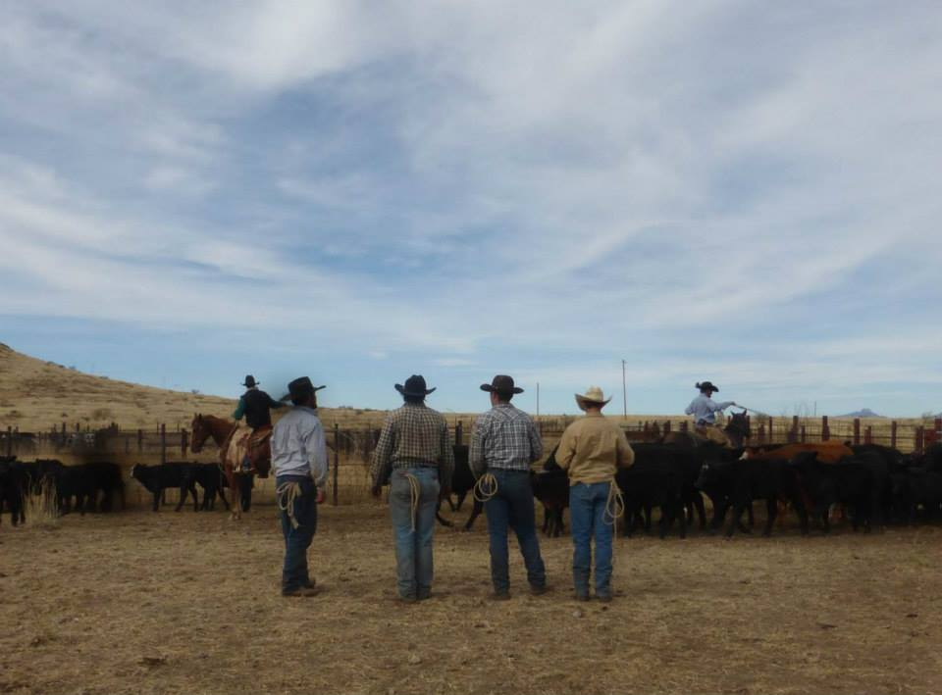
Tierra Seca
University of Arizona Student Chapter
Society for Range Management

College of Agriculture and Life Sciences
School of Natural Resources and the Environment

- Tierra Seca Meeting Agenda 2/4/2015

- Call to Order:
  - Members in attendance:
Oak Ranch photo by: Alanna Riggs
  - Approve meeting minutes from 1/21/2015
- President’s Report:
  - Introductions
  - Semester meeting dates: 2/18, 3/4, 4/1, 4/15, 4/29
  - Guest Speaker
    - Dr. Stuart Marsh, Director SNRE
  - Upcoming Events
    - Horsin’ Around
      - Hereford, AZ
      - Volunteer with rescue horses
      - Waiting to set up a date-will reference doodle poll
    - 47 Ranch
      - Sheep tagging and castrating
      - Waiting to hear back from Dennis, a weekend in March
    - CDE Day
      - Volunteers needed!
      - Help AZ high school FFA chapters
    - Invasive grass removal at Saguaro Park
      - Second Saturday OR 1/31, 2/28, 3/7, 3/21
      - 8:00am-12:00pm
      - We didn’t receive much availability so no official event will be organized, but please try to go if you can!
      - Meet at Rincon Mountain Visitor Center (East) 3693 South Old Spanish Trail
      - Groups or individuals
      - More info www.buffelgrass.org
    - UAFWS & Tierra Seca Camping Trip
      - Saturday April 25-April 26 (tentatively)
      - More details to come!
    - Officer Elections Fall 2015/Spring 2016
      - President, Vice President, Treasurer, Secretary
      - 4/1 nominations, 4/15 elections, 4/29 run the meeting!
- Vice President’s Report:
  - Student Involvement fair – February 10th from 9:00am-2:00pm on the UA Mall
- Treasure’s Report:
  - Dues ($10 per semester)
    - Paid dues: Gerry Berthelette, Jason Myrand, Jennifer Hanson, Leland Sutter, Emily Pecilunas, Rachel Turner, Trevor Chilcote, Emilio Corella, Zack Madrid, Taylor Ulrich, Neil Dutt, Natalya Sherman
  - Account balances: Checking _____; Savings $_____
- Miscellaneous:
  - Garden Plot: http://tierrasecauofa.wix.com/tierra-seca-garden
    - Speedway/Mountain.
    - Kale, brussel sprouts, beans
    - Contact Trevor for more info: tchilcote@email.arizona.edu
  - Tierra Seca items:
    - Away at the SRM meeting
  - Hunter Safety Course
    - http://www.azgfd.gov/i_e/edits/hunter_education.shtml
  - SNRE seminars
    - Every Wednesday in Marley 230 from 3:00-4:00pm
  - Fundraising
    - Aluminum Drive! Cans, tins, foil-anything aluminum! Bins in BSE now
    - 50/50 raffle
        - Competition vs. UAFWS club
        - Drawing will be evening of SNRE awards
        - Club who raises least amount of money will sacrifice their President to taking a cow pie to the face during the joint camping trip
        - $1/ticket $5/6tickets
    - Other ideas?
  - Other new business or discussion?
    - Tucson Rodeo Feb 21st-March 1st
- Adjournment:

Facebook club link: https://www.facebook.com/uofatierraseca
President: Emily Pecilunas: epecilunas@email.arizona.edu, (623) 693-1964
Vice President: Leland Sutter lelandsutter@email.arizona.edu
Secretary: Jennifer Hanson jmh7@email.arizona.edu
Treasurer: Cassidy Solper csolper@gmail.com

